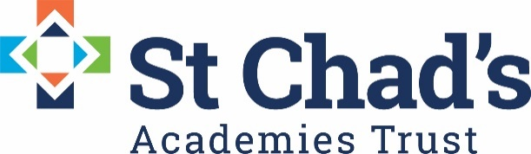

CALENDAR DATES FOR EYFS QUALITY LEARNING CIRCLE 2020/21

DATE | TIME | VENUE | EVENT
Thursday 24th  September  2020 | 9.30-12.30 | Virtual Teams Meeting | EYFS QLC
Tuesday 10th  November  2020 | 9.30-12.30 | Virtual Teams Meeting | EYFS QLC
Wednesday 6th  January  2021 | 9.30-12.30 | Virtual Teams Meeting | EYFS QLC
Tuesday  25th  May  2021 | 9.30-12.30 | Reeve Room St Marys House | EYFS QLC

