
Year 3/4 Summer Term 24-25
Welcome back to the summer term in Y3/4! We hope everyone has had a well-earned break and children are feeling refreshed and ready for another busy term. We have another fantastic term ahead of us with plenty of trips and activities scheduled. This term our key curriculum driver is geography, with Y3 studying volcanoes and tectonic plates and Y4 investigating the Amazon rainforest and how it compares to native forests here in the UK.
Key Dates
30th April – Y3 Chinese Whispers Concert
5th May – May Day bank holiday (School closed)
6th May – 16th May - Y4 Swimming lessons
8th May – VE Day Celebrations
12th May – Y6 SATs week
21st May – Y34 Time Tables Rockstar Day!
23rd May – Break up for half term
2nd June – School opens for summer term 2
2nd June -16th June – Multiplication Table Check window for Y4
4th June – Year 4 Countryside and Farming Day trip (limited to 30 places)
19th June – Y34 Sports Day @ CPPS (morning)
1st July – Y4 Trip to Dalby Forest
3rd July – Y3 Trip to Magna
7th July – Transition day in school
14th July – KS2 Awards (afternoon)
18th July – Family picnic (school closes)
General
-PE day is on a Monday. Your child can come to school wearing the correct PE kit: trainers, white t-shirt, black shorts and a CPPS PE hoody or plain black/navy hoodie.
-Jewellery: One pair of single stud earrings is permitted. (These must be removed on PE days.)
- Children should not wear necklaces or bracelets but can wear a watch.
Clubs
Mrs Williams will be starting her Mindfulness club for Y4s starting Thursday 5th June.
Safe in the Sun!  A reminder that sun glasses are not permitted in school. However, children can bring a cap to wear at playtimes. Sun cream should be applied before school.   | The three Bs  ‘Book, bottle & bag’: please encourage your child to remember the three Bs in a morning to ensure they are ready for the day’s learning!      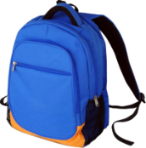
Times Tables Rockstars Day!
On the 21st of May, we will be hosting our annual TT Rockstars day! Children are invited to come to school dressed as a rockstar for a day of inter-class times tables battles!
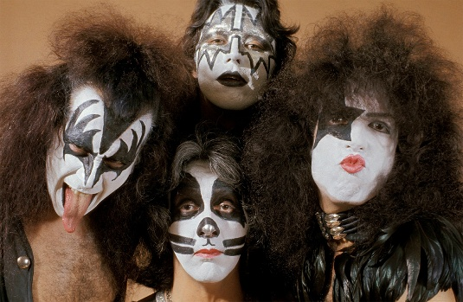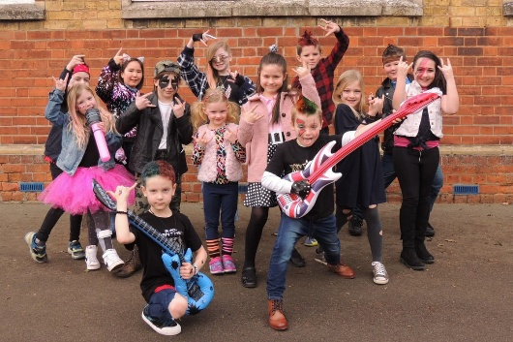

Swimming  Y4 Swimming starts on Tuesday 6th May.  Please ensure permission slips are coming back. If you have any queries, please get in touch with Mr Morgan or Mrs Williams   | Year 4 Multiplication Check  This term, Y4 pupils will take their official MTC at some point between 2rd and 16th June.  Please encourage your child to keep practising and learning their times tables at home.  Please inform your child’s teacher ASAP if you have any scheduled holidays during these two weeks to ensure your child completes their MTC.  
Easter Service  A huge thank you for supporting children at their Easter service. They all worked so hard to perfect their singing and learn their lines. They had a great time performing to parents and the school.  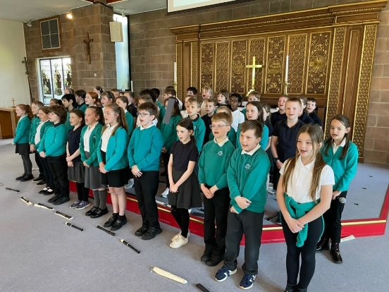 | Parent Readers  We are always on the lookout for parents and carers who can come and listen to children read. Could you spare any time on a Wednesday afternoon? If so, please get in contact with your child’s teacher for further information.  
Being safe online: Is your child gaming safely? Follow the link for a useful FAQ from the UK Safer Internet Centre about games consoles and how parents can ensure children are being safe whilst playing online computer games. https://saferinternet.org.uk/guide-and-resource/parents-and-carers/games-consoles

