Home School Diary
What a lovely first week back after half term. We loved hearing the children’s news from the holiday, and it sounds like some of you did some really nice things.
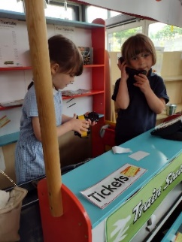
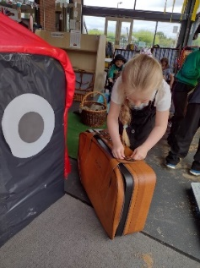
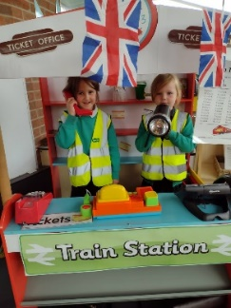
We have started our new book this week, The Train Ride. So, it has been all about trains in the classroom this week. These children have been working in the ticket office and the train station, as well as getting their suitcases ready for a trip on a train. We talked about what we would need in our case for different types of holidays.

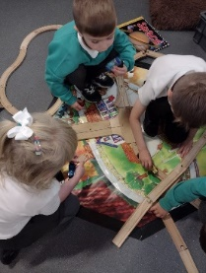
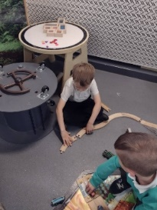
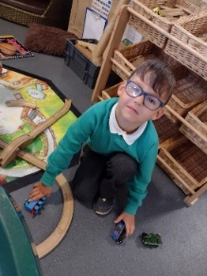
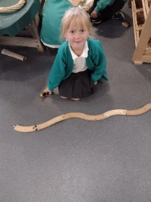
We’ve also had some mini engineers building tracks for us. The planning and ideas were great to listen to. The children had to think carefully about the pieces they needed as well as the direction they went in.

We can’t wait for our own train ride next week. Remember to send the children in their uniform, with a packed lunch.

We’ve also started our Pre-Pedal training this week. For the next 6 weeks we will be doing cycling skills with some lovely coaches.
We learnt all about being safe this week.

For the home task this week, we’d love to hear about times when you have been on a train ride, or maybe a car ride for a long journey.

