Humber Education Trust

Special educational needs policy

This policy was reviewed by the HET Curriculum & Standards Committee: October 2021
This policy was agreed and adopted by the Trustees: December 2021

Graeme Brook Chair of Trustees
This policy will be reviewed annually on or before: October 2022

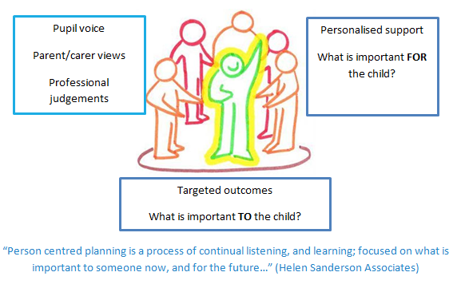

- Aims

  - All schools within the Trust share common values and an ethos that adheres to inclusive principles. The schools in the trust work collaboratively to endeavour to meet the needs of all learners in the trust.
  - To cater for the broad range of needs the trust recognises the benefits of following a person-centred approach, working collaboratively and in employing an inquiry mind-set to identify and implement provision to address a pupil’s learning needs. Our support for all children within our care extends to those children with additional needs that require assistance to help them fulfil their potential.
  - Each school within Humber Education Trust shall ensure that:
  - the special educational needs of pupils will be addressed and pupils will not be labelled or disadvantaged by any policy or procedure operated within the Trust;
  - it works in partnership with parents and appropriate external agencies to support students with special educational needs and will use its best endeavours ensure that appropriate provision is secured for any student with special educational needs in order to achieve agreed outcomes;
  - it has a Special Educational Needs Co-ordinator (SENCO). The SENCO will maintain and regularly review the SEN record held in respective of an individual pupil and co-ordinate support. However, it will be the responsibility of all staff to support individual pupils, to implement strategies suggested by the SENCO and generally be responsible for ensuring that pupils receive provision appropriate to their needs and agreed outcomes; and
  - children and young people with SEN engage in the activities of the school alongside pupils who do not have SEN
  - All support provided and decisions taken have regard to these general principles as well as the legal framework set out in the Children & Families Act 2014, the SEND Regulations 2014 and the SEND Code of Practice 2015.
- Definitions
  - Under the Children & Families Act 2014, a child/young person will have SEN if they have a learning difficulty or disability which calls for special educational provision to be made for them.
  - A Child or Young Person will have a learning difficulty or disability if they have:
  - A significantly greater difficulty in learning than the majority of others of the same age; or
  - A disability that prevents or hinders them from making use of facilities that are generally provided for others of the same age in mainstream schools in England.
  - Special Educational Provision is education or training that is additional to, or different from, that made generally for other children/young people of the same age by mainstream schools
- Roles & Responsibilities
  - The implementation of this policy will be monitored by the Trust Board and remain under constant review by the Headteacher/Principal.
  - Each school will appoint a governor with responsibility for SEN. The SEN Governor will raise SEN issues at governing board meetings; monitor the quality and effectiveness of SEN provision within the school and work with designated senior leaders to develop the SEN policy and provision.
  - The Principal/Head Teacher will work with the SENCO and SEN Governor to develop the SEN policy and provision within the school. The Principal/Head Teacher has overall responsibility for the provision and progress of learners with SEND.
  - The SENCO will co-ordinate the school’s approach to SEND provision and will undertake those duties set out in chapter 6 of the SEND Code of Practice 2015.
  - Class teachers are responsible for the progress and development of every pupil in their class and will work with the SENCO and TAs to ensure the “assess plan do review” cycle is appropriately implemented to support any pupil student with SEND.
  - The school will work in partnership with pupils, teachers, parents and, where appropriate, other external agencies to ensure that individual learning needs are addressed within the context of the school curriculum.
  - Parents of SEN pupils will be able to discuss the needs of their child with their child’s class teacher or the SENCO.
- Identification & Assessment of SEN
  - Humber Education Trust is committed to the early identification and support of all pupils in the trust. Schools in the trust have a clearly defined graduated response which takes account of quality first teaching, interventions and further provision.

Our graduated response:

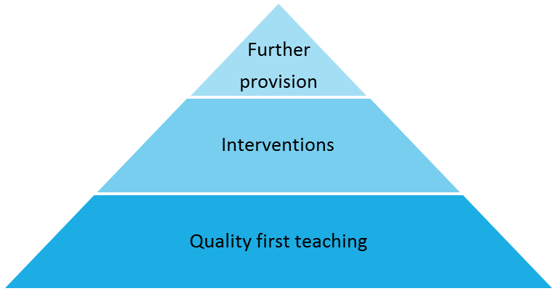
  - The professional judgement of practitioners in the school, alongside the views and wishes of pupils and parents plays an important role in the assessment and review of pupils’ needs. Where required we liaise with other professionals including those from health, social work or voluntary sectors to provide additional assessment information.
  - Information about previous special educational needs will usually accompany pupils upon entry to the school and this will be used by the SENCO to make sure appropriate provision is continued.
  - This information is collated from the transfer of school files from the previous school or early years setting and during transition meetings which are held with all the feeder schools or early years settings, in the summer term, before students start at the school. If necessary a strategy sheet will be drawn up for each student with SEN.
  - Ongoing identification is also completed alongside the school reporting process as data is collected and analysed in all subject areas by the Headteacher/Principal. If a pupil has not made expected progress then interventions will be put in place regardless of need. If a member of staff identifies a pupil whose special educational needs are not met by the normal differentiated programme of study, then the class teacher will work with the pupil setting clear targets and providing greater differentiation. If the situation improves then no further action is needed. If there is no improvement the SENCO will be informed.
  - At this point information will be gathered. The class teacher will inform the parents about the issue and there will be consultation and discussion around the proposed additional support for the pupil. Parents, and the pupil where appropriate, will be involved in sharing information and agreeing outcomes. It will be decided whether it is appropriate to further monitor the student. A strategy sheet will be drawn up by the SEN team with copies shared with all staff concerned with the pupil’s progress.
  - If a parent/carer refers their child to the school as they believe their child has special educational needs they should contact the SENCO, who will undertake investigations and appropriate assessments (with input from the relevant teachers) to see if they are achieving expected levels of progress. If the pupil is not making appropriate levels of progress then internal support will be implemented in accordance with paragraphs above.
  - In all cases, where internal support is not effective in supporting the pupil, a referral to the Educational Psychologist or other relevant specialist will be completed with the parents’ knowledge and information and strategies for support shared with all staff.
  - If there are no concerns regarding the pupils’ academic progress then the school will ensure appropriate differentiation continues in the classroom and interventions are put in place if appropriate.
  - Contact details for professionals who are able to assess will be provided for parents/carers so they can consider a private assessment. Whenever special educational provision is being made, parents and students will be involved in developing and reviewing support plans/strategies.
  - All staff teaching pupils on the SEN record will be made aware of the individual needs. Leaders and the Special Needs team will help teachers when required to develop techniques to support differentiation and ensure that appropriate resources are available as part of the school’s Professional Development Programme.
- Reviewing
  - All pupils regardless of needs are set targets. Data collated during the school reporting process is analysed and strategies are put in place to support that that are not achieving as expected. All SEN interventions delivered outside the classroom have Specific, Measurable, Achievable Targets (SMART) set to ensure that progress is made. These are recorded using Individual Education Plans (IEPs) and are monitored and reviewed against a time frame, agreed within the plan. If expected progress is not made then the SENCO may refer to a specialist services such as an Educational Psychologist.
  - If a pupil has an Educational Health Care Plan an annual review is held in accordance with legal requirements.
  - If, as a result of appropriate progress, a pupil is removed from the SEN record. The pupil will continue to be monitored through the school’s structured reporting programme by the Headteacher/Principal.
- Policy Links
This policy should be read in conjunction with:
  - SEN Information Report (updated annually)
  - Equality Policy & Objectives
  - Accessibility Plan

