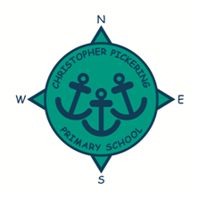
OCTOBER 2021
NEWSLETTER
Dear Parents, Carers, Governors, Friends, Staff and Pupils,

Here we are at the end of the first half term - I am sure you will agree that the past few weeks have flown by! It has been an exciting and very busy half term; the children have settled very well into their new year groups and it has been lovely to see such fabulous work happening across the school. It was great to see so many of you at our stay and read sessions and our parents’ evenings.

I would like to thank all the children and staff for their excellent efforts this half term and for supporting each other.

Everyone definitely deserves some well-earned rest and relaxation over half term.

Thank you for your support.
Kind regards

Jane Marson

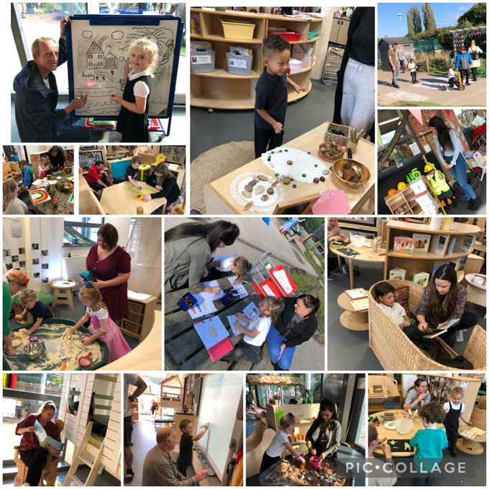
F2 Stay and Play session

This week we have been busy…
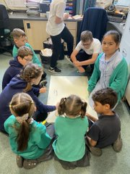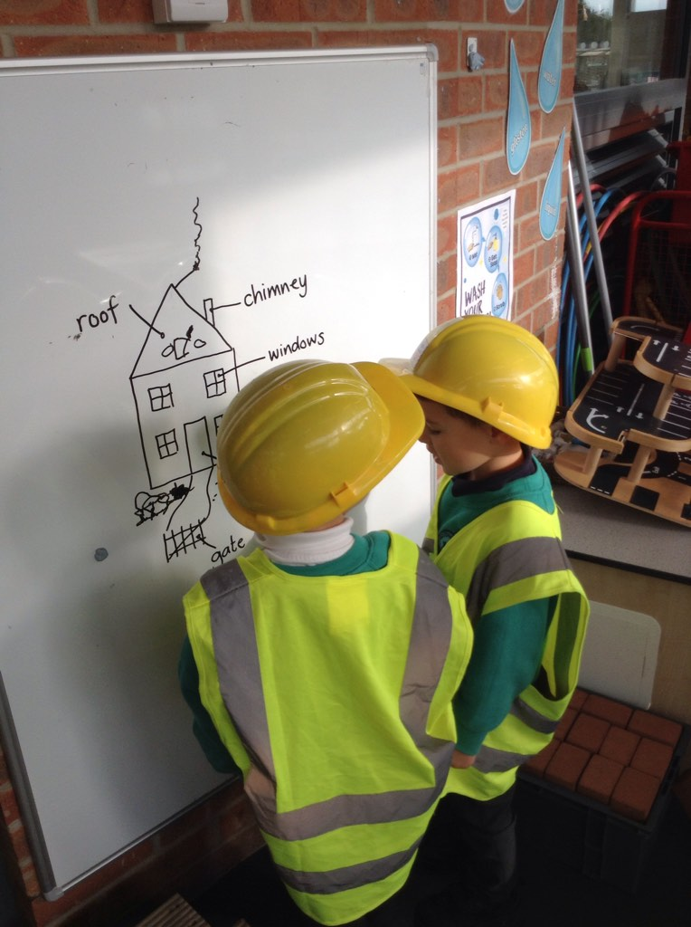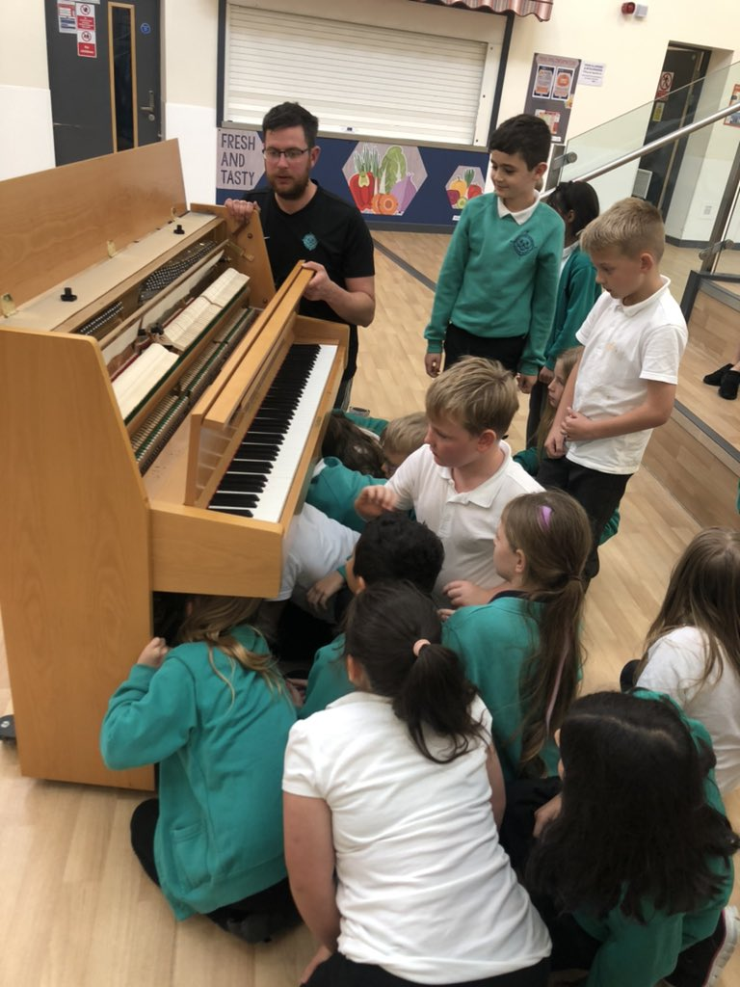

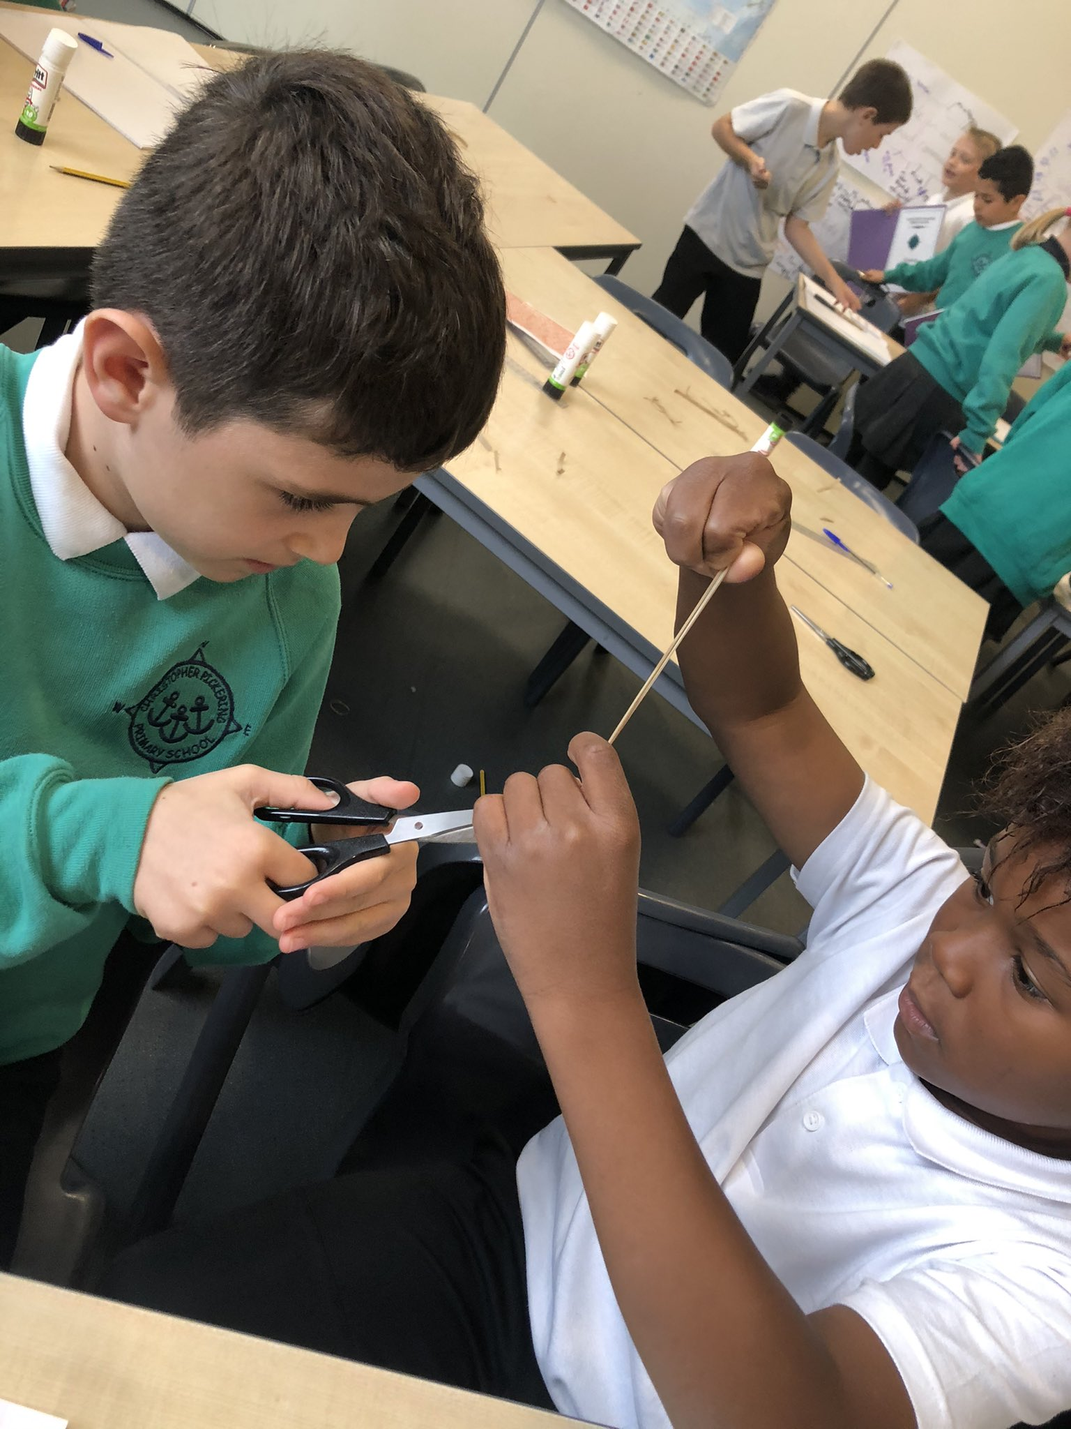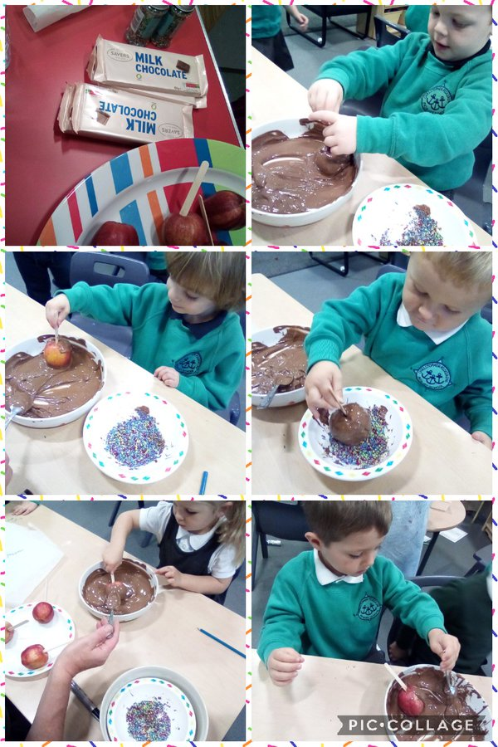

Make sure you check Twitter regularly as there are lots of tweets from all class teachers about what your children have been doing at school!

Alternatively please check out the blogs on the school website!

Follow us on Twitter!

@CPickeringPri

SPORTING NEWS

We have had a fantastic return to sport this term. We have held a whole-school cross country run, attended the inter-school cross country championships and took part in a 'rainbow run' event at Beverley racecourse.
In football both the boys and girls teams both won their qualifying event for the Humberside seven-a-side championships and will now represent Hull at the county finals. In the league, our boys’ team remain undefeated and top of the league after three games.

PARKING
The school has been approached by residents in neighbouring properties on Anlaby Park Road South, concerned about the standard of parking at the beginning and end of the school day. As some pointed out, it would be extremely difficult for an emergency service vehicle to reach their properties with so many vehicles partially blocking the road. Families are welcome to park in our visitor carpark at drop off and pick up times.
We thank you in advance for parking responsibly.

SCHOOL LUNCHES
The Humber Education Trust are delighted to outsource our catering contract to North Yorkshire Education Services.

NYES catering service has been operational for over 40 years and operates in more than 240 education sites in and around Yorkshire. They are knowledgeable, continuously evolving and changing in-line with the up-to-date trends and requirements – whilst always committing to great quality and nutritionally balanced food.

Their brilliant three-weekly menu focus on a hot meal or grab and go option, dependent on the school and age, and is served with a selection of healthy side dishes, bread and a well-stocked salad bar where requested.

 | Week 1 | Week 2 | Week 3
 | w/c 15th Nov, 1st Dec | w/c 1st & 22nd Nov, 13th Dec | w/c 8 & 29th Nov
Monday | Beefburger in a bun  Vegetable sausage in a bun  Chipped potatoes  Peas & carrots  Sticky date & apple bars with custard  Fresh fruit or fruit yoghurt | Chicken quesadilla and rice  5 veggie pasta  Sweetcorn and green beans  Sultana & oat cookie  Fresh fruit or yoghurt | Minced beef & dumpling  Bean & veggie tortilla baots  ½ jacket potato  Mixed vegetables  Chocolate crispy  Fresh fruit or yoghurt
Tuesday | Quorn rainbow cottage pie  Macaroni cheese  Green beans & sweetcorn  Cheese & crackers  Fresh fruit or fruit yoghurt | Pasta bolognaise  Crunch topped cauliflower and brocolli cheese  Mixed greens and carrots  Cheese & crackers  Fresh fruit or fruit yoghurt | Quorn dippers and potato wedges with tomato ketchup  Cheese and tomato pasta  Green beans & sweetcorn  Cheese & crackers  Fresh fruit or fruit yoghurt
Wednesday | Roast chicken with sage and onion stuffing & gravy  Vegetable roast with sage and onion stuffing & gravy  Roast potatoes  Medley of vegetables  Fruit muffin  Fresh fruit or yoghurt | Sausage toad in the hole with onion gravy  Vegetable casserole & dumplings  Creamed mashed potatoes  Brocolli and swede  Fruit mousse  Fresh fruit or yoghurt | Roast loin of pork with apple sauce  Falafel burger  Creamy mashed potaoes and gravy  Broccoli & carrots  Forest fruit roly poly & custard  Fresh fruit or fruit yoghurt
Thursday | Mexican tortilla boats  Vegetabel curry  Savoury rice  Carrots and brocolli  Fresh fruit or yoghurt | Cheese and tomato pizza  Veggie fajita  Diced potatoes  Crunchy veg sticks  Apple and berry crumble & custard  Fresh fruit or yoghurt | Chicken korma & rice  Cheese, leek and potato bake  Green beans and cauliflowe  Fresh fruit or fruit yoghurt
Friday | Fishcake  Cheese and onion quiche  ½ jacket potato  Baked beans and peas  Chocolate banana sponge & chocolate sauce  Fresh fruit or yoghurt | Fish fingers  Cheesy pastry  Tomato ketchup  Chipped potatoes  Carrtos and peas  Fruit shortcake  Fresh fruit or yoghurt | Harry Ramsdens battered fish  Roast vegetable parcel  Chipped potatoes  Peas & sweetcorn  Iced swiss bun  Fresh fruit or fruit yoghurt

Free School Meals

How do you claim FREE school meals?

Many of our families could get Free School Meals but do not claim for them.

Parents are now able to apply for free school meals online at Hull City Council’s My Schools portal:
https://emsonline.hullcc.gov.uk/CitizenPortal_LIVE/

Applications can be made from any device with online access and will provide you with an immediate provisional decision based on information held with the Department of Works and Pensions.

Applications are fast-tracked when made through this site.

PLEASE APPLY if you are eligible, unsure whether you’re eligible, or if your child is currently in Reception – Y2; even if your child currently gets Universal Infant Free School Meals (Foundation Stage, Y1 & Y2) as the school will still receive additional funding.

If you are unable to apply on line then please pop into school to collect an application form.

HARVEST FESTIVAL
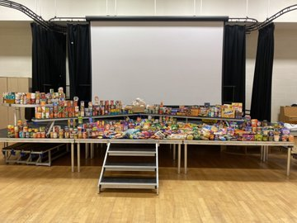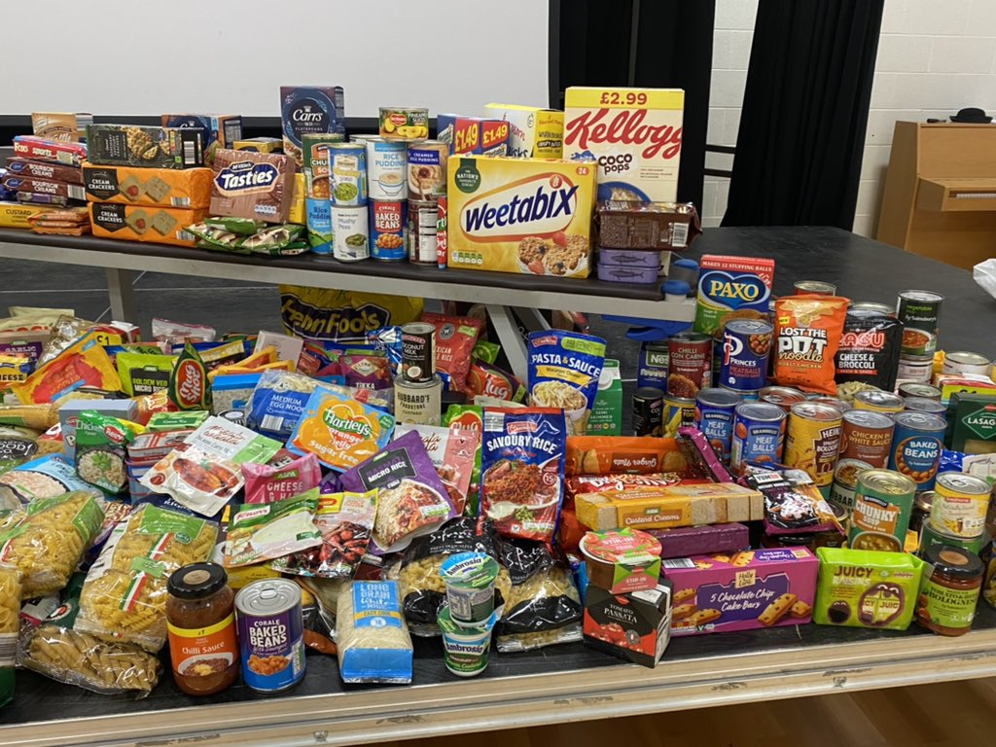

A huge thank you to you all for your kind donations for our Harvest Festival last week. We donated all of the food and produce to Hull Womens Aid.

Dates for your diary
Date: | What: | Time:
Friday 22nd October | Break up for half term
Monday 1st November | Back to school
Monday 6th December | Christmas Fair | 2-4pm
Wednesday 8th December | Y2 Christmas Nativity at the church | More information to follow
Friday 10th December | Christmas Dinner day
Monday 13th December | FS/Y1 nativity | Am/pm  More information to follow
Tuesday 14th December | FS/Y1 Nativity | Am/pm More information to follow
Friday 17th December | Break Up for Christmas

ATTENDANCE NEWS
Well done to everyone who is working really hard to come to school every day. We know how important it is to have regular attendance and to be punctual. We understand that this can be difficult if your child is unwell. Our attendance target is 96% and our current Autumn term attendance is 95%.

Year Group | Attendance
F1 | 91%
F2 | 93%
Y1 | 94%
Y2 | 95%
Y3 | 96%
Y4 | 96%
Y5 | 96%
Y6 | 97%

COVID 19 IMPORTANT SAFETY INFORMATION!
Unfortunately, we are seeing a rise in positive cases of Covid 19 again within our school community. We continue to implement our Covid 19 risk assessment in an attempt to limit any potential spread and keep everyone safe in school.

A huge thank you to those of you who have been affected by this over this half term – we appreciate that our current situation is not ideal and affects us all, but we are committed to trying to keep all our children, families and staff as safe and healthy as we can.

If your child, you or any household member displays symptoms of Covid, you/they need to isolate, get a PCR test and ring the School office on 01482 352245 to inform us. We will need prove of the test result. Children cannot return to school if they test positive, however children can still attend school if any other member of their household is positive.

Thank you for your support with this.

School Holiday Dates
Autumn Term 2021 | School opens | 8th September 2021
 | School closes for half term | 22nd October 2021
 | School opens | 1st November 2021
 | School closes for Christmas | 17th December 2021
Spring Term 2022 | School opens | 5th January 2022
 | School closes for half term | 18th February 2022
 | School opens | 28th February 2022
 | School closes for Easter | 8th April 2022
Summer Term 2022 | School opens | 26^{h} April 2022
 | BANK HOLIDAY CLOSED | 2nd May 2022
 | School closes for half term | 27th May 2022
 | School opens | 6th June 2022
 | School closes for Summer | 22nd July 2022

*please note we have 2 training days to be confirmed.
ON LINE SAFETY
Cyber-bullying and online concerns are being reported to school more often recently.

Due to the age limits on social media sites and certain games, primary-aged children should have limited opportunities to be bullied or view inappropriate imagery online, however we are aware from talking to our children and parents that many of our children are accessing sites for older children/adults and are at risk. Children are reporting to us that they are on WhatsApp groups with their friends – please be aware that the minimum age for a WhatsApp group is now 16 years old. Please remember to be vigilant when your children are online or accessing social media.

If you would like any further information, please access the following websites:

https://www.net-aware.org.uk/ https://www.ceop.police.uk/Safety-Centre/

https://www.thinkuknow.co.uk/parents/articles/is-my-child-ready-for-social-media/

We have also been made aware of a series on Netflix called Squid Game that some of our older children are talking about – again this has a minimum age rating of 15 as there are inappropriate scenes for children throughout.

For further information and advice, please access the following website:

https://ineqe.com/2021/10/08/squid-game/

SAFEGUARDING IS EVERYONE’S RESPONSIBILITY
Please speak to a member of the Safeguarding Team if you have any concerns.

Mrs L Leeman, Miss D Garner, Mrs C Isgate
01482 352245

