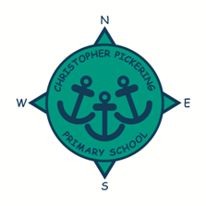
APRIL 2021
NEWSLETTER
Dear Parents, Carers, Governors, Friends, Staff and Pupils,

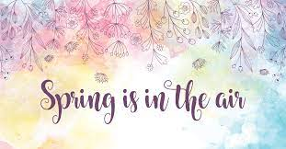

I hope you all had a relaxing and restful Easter. It is hard to believe we are now beginning the Summer Term and the year seems to have flown by! There seems to be brighter times ahead and Spring seems to be in the air!
Day by day things are starting to return to normal; it has been great to see shops, gyms and hairdressers reopen.
In school we are now beginning to restart many of our lunchtime and after school clubs and are hopeful that we may get the opportunity to play some intra-school sport competitions again before the end of the year.
We have also penciled in some tentative plans to hold our usual sports day at Costello with parents in attendance, if the restrictions are fully released as planned on June 21st. It will be great to see parents and carers back at events in school as soon as it is safe to do so.
The summer term is always a busy time in school, although the SATs tests for KS1 and KS2, and the phonic screening tests for Year 1 pupils have been cancelled, however our children are working incredibly hard with their Catch Up Curriculum. It is also a busy time for events and activities across all year groups. We are currently planning many lovely events, which I have shared with you in the date’s section.
Take care and stay safe.

Jane Marson



This week we have been busy…
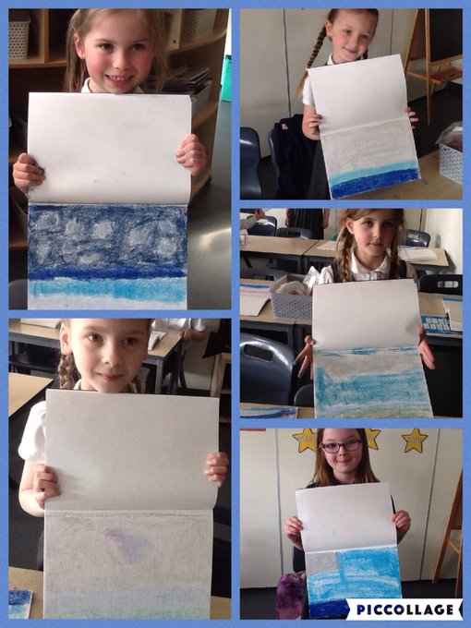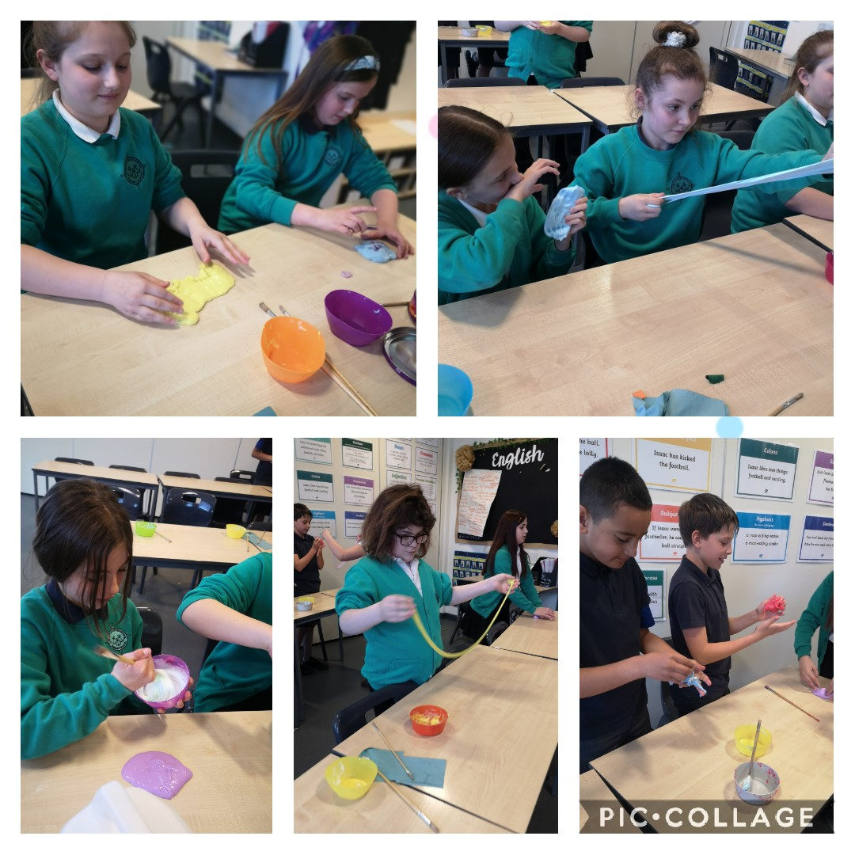

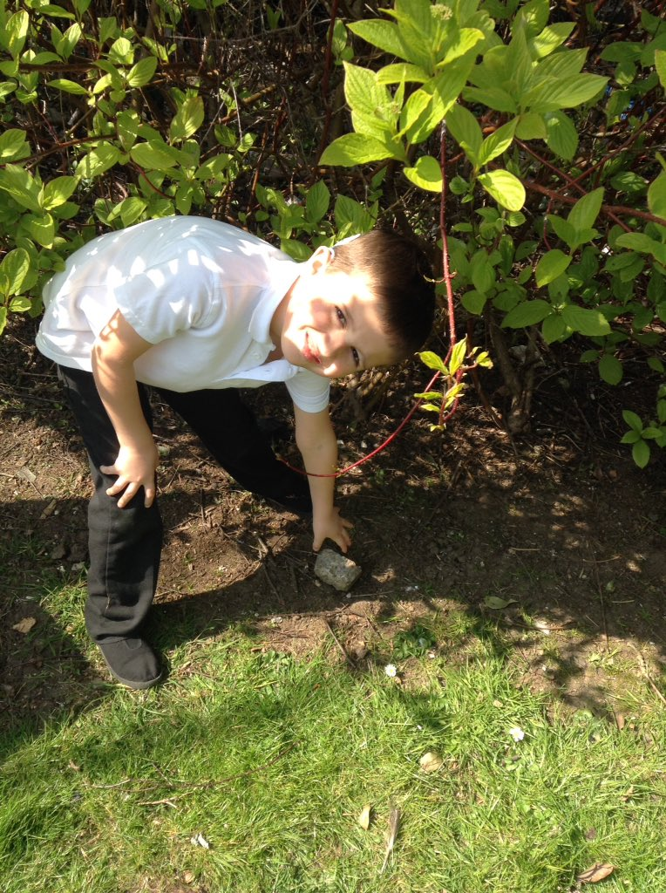

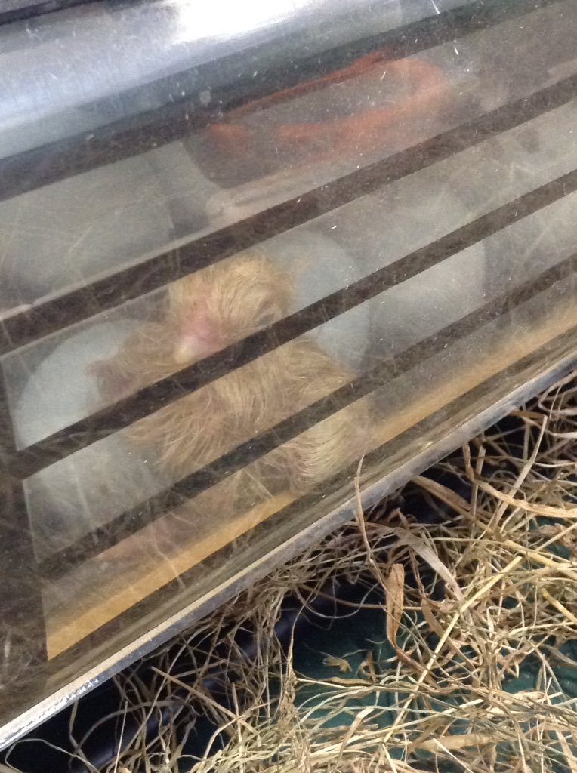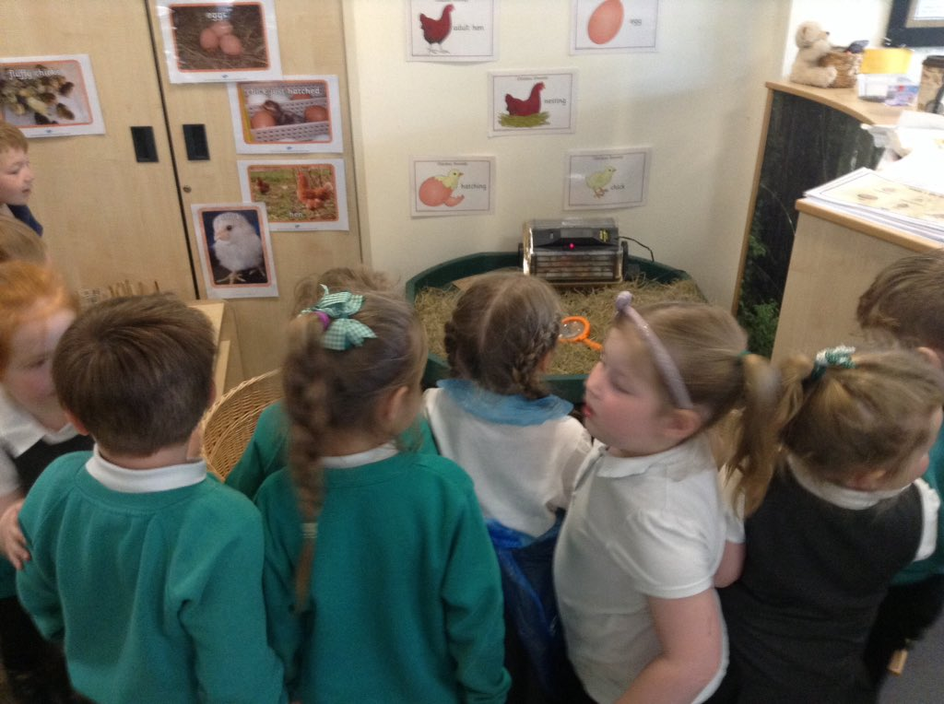

Follow us on Twitter!

Baby News!
I am pleased to report that Mrs Buss gave birth to a baby girl over the Easter holiday. Both Mum and baby are doing well. We send them all of our love and cannot wait to meet her!

Provisional dates for your diary
We have provisionally booked in the events below. These are all subject to the easing of restrictions and relevant Covid safety guidance. We will let you know more as restrictions begin to lift. Fingers crossed they can all go ahead!


24th June | Sports Day
5th July 2021 | Summer Fair
7/8th July | Y6 Production
9th July 2021 | Reports out to parents
w/c 12th July | Y6 Transition week
12^{th/13th} July 2021 | Transition days in school – children to meet their new class teacher
19th July 2021 | Awards
21st July 2021 | Y6 Ball
22nd July 2021 | Y6 Leavers assembly
23rd July 2021 | Family picnic

A reminder
As mentioned in our last newsletter, the school will be closed on Tuesday 4th May for staff training. The children will NOT be in school on this day.

COVID 19 IMPORTANT SAFETY INFORMATION!
Parents and Grandparents can now order lateral flow tests to test themselves for coronavirus twice a week. These tests can be ordered from https://www.gov.uk/order-coronanvirus-rapid-lateral-flow-tests The test is straight forward and can be administered at home.
All staff in school are currently testing themselves twice a week to help ensure we can all stay safe.

Please keep school informed if you have a child in school and you or a household member display symptoms of Covid, accesses a test or receives a test result by ringing The School office on 01482 352245. Children cannot return to school if: they test positive, a member of the household is positive, they or members of the household have symptoms.

Thank you for your support with this.

School Holiday Dates
Autumn Term 2020 | School opens | 9th September 2020
 | School closes for half term | 23rd October 2020
 | School opens | 2nd November 2020
 | School closes for Christmas | 18th December 2020
Spring Term 2021 | School opens | 5th January 2021
 | School closes for half term | 12th February 2021
 | School opens | 22nd February 2021
 | School closes for Easter | 26th March 2021
Summer Term 2021 | School opens | 13th April 2021
 | BANK HOLIDAY CLOSED | 3rd May 2021
 | TRAINING DAY – SCHOOL CLOSED | 4TH May 2021
 | School closes for half term | 28th May 2021
 | School opens | 7th June 2021
 | School closes for Summer | 23rd July 2021

