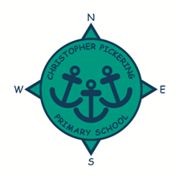
MARCH 2021
NEWSLETTER
Dear Parents, Carers, Governors, Friends, Staff and Pupils,

I just wanted to write to you to tell you how proud we are of your children.
This week has been quite a significant week in your child’s education, whether they have been at home remote learning so far in 2021, or whether they have been in school but taught in different groups and by different teachers. The children have returned to school with smiles on their faces and enthusiasm to work hard and try their best; they really are an absolute credit to you.
The staff have been so happy to have all the children back in their classes, and there really is a sense that we are all back together again as Team CP! It has been lovely to see the children outside playing with their friends and the classrooms have had the lovely buzz of children’s chatter and excitement again. What momentous times we have all lived through this past year … and although it has been challenging, the children now seem raring to go to begin to get back to some sense of normality.
Our focus between now and the Easter holidays is the children’s emotional wellbeing and ensuring that they enjoy being in school once again. Alongside this, the staff will be busy assessing the children’s learning and identifying any areas where the children need support to ‘catch up’. This will be done very sensitively so that children know we are here to help them reach their potential, rather than them worrying that they have fallen behind and need to ‘catch up’ or ‘recover’ from the lockdown.
We hope your child has had a lovely first week back. Please talk to them about all the positive things about returning to school, and as always, if you have any concerns, please speak to your child’s class teacher or contact us via email or phone.

Jane Marson

This week we have been busy…
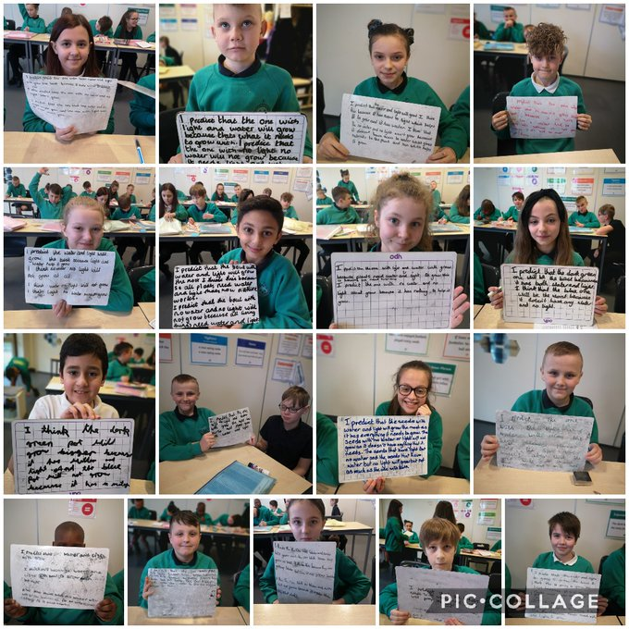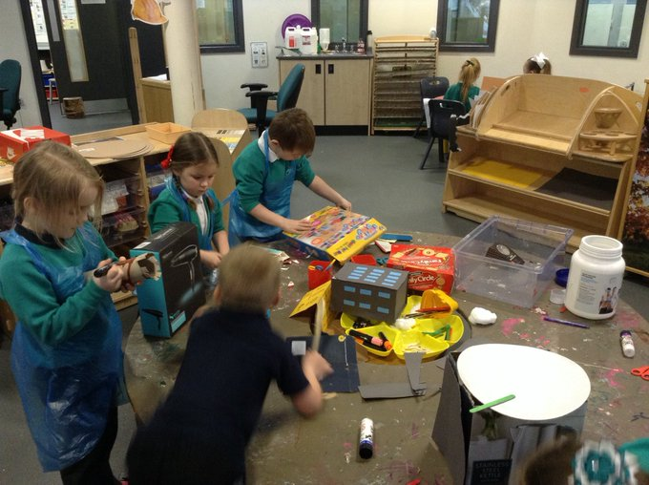

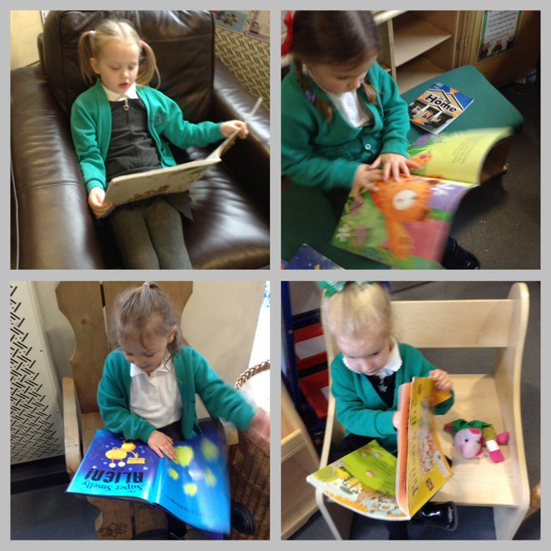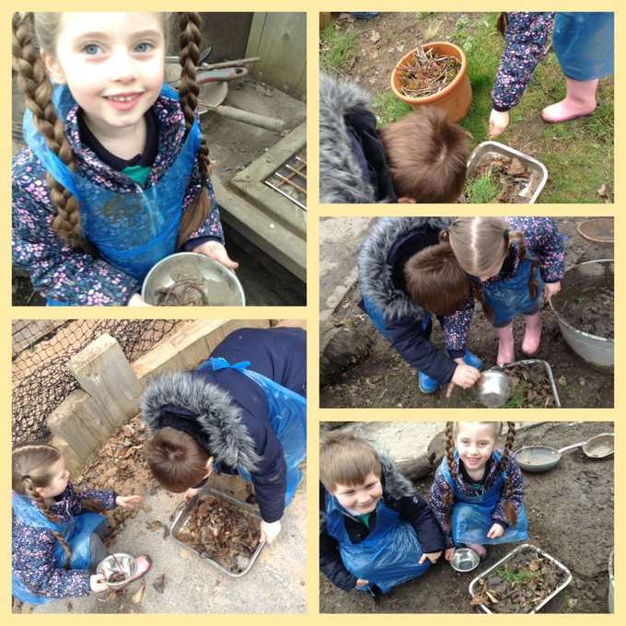

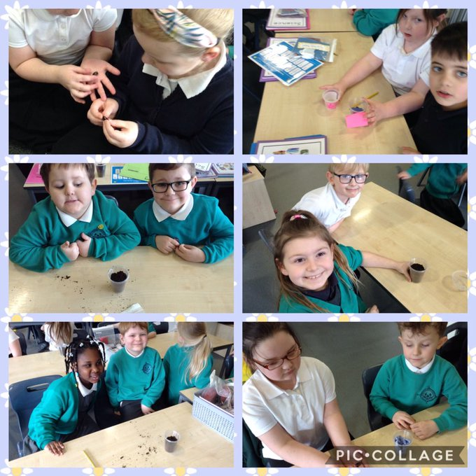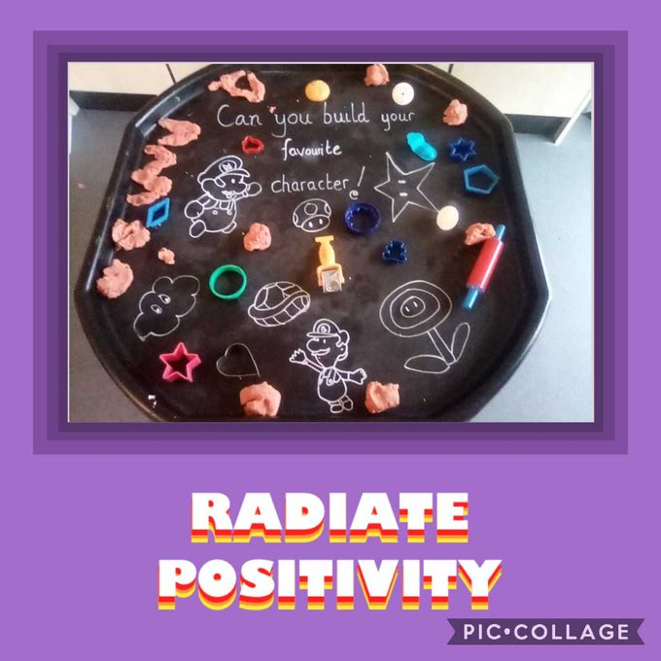

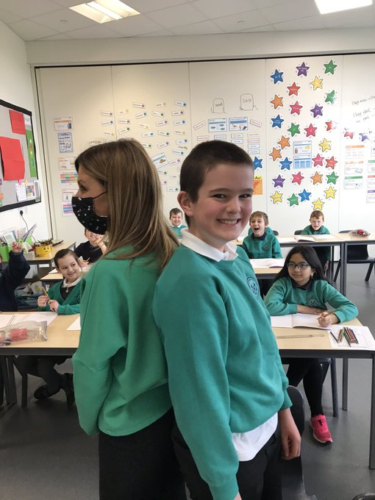

Follow us on Twitter!

Parents’ Meetings
We will be holding phone call parents meetings again after the Easter holidays (w/c 19th April). More details to follow.

Comic Relief
Red Nose Day is back on Friday 19th March and this year it’s never felt more important to have some fun and raise money to support people living incredibly tough lives.
The theme is ‘Superheroes’ so we are asking children to come dressed as a super hero, donations of a £1 can be made through the link below. Please do not send money to school.

https://www.justgiving.com/fundraising/christopherpickeringcr

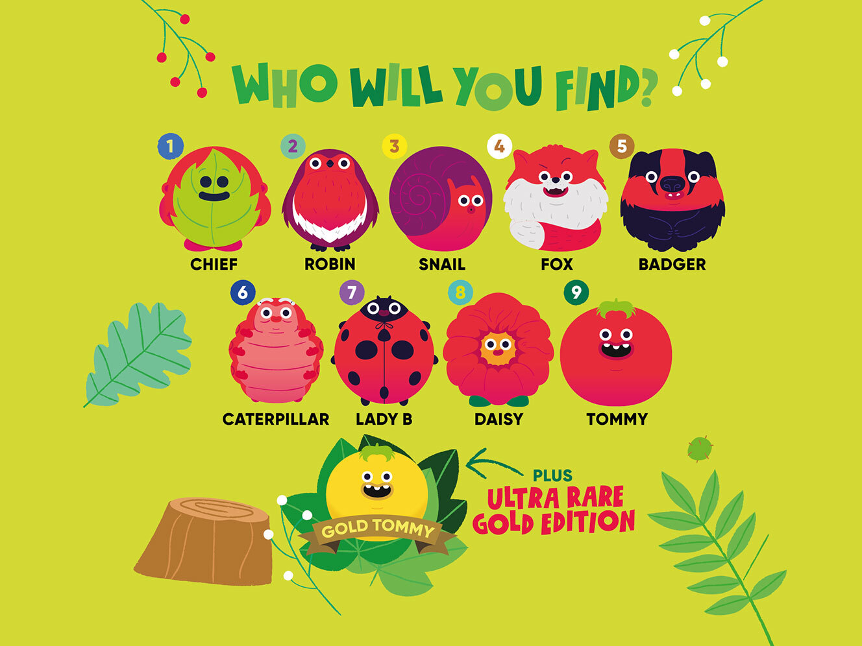

New Dates for your diary
As you will be aware from previous newsletters we had 1 training day to still be arranged. We will be using this training day on Tuesday 4th May. The children will NOT be in school on this day.

We are also planning events such as Sports Day, Y6 production, Summer Fair and the Y6 ball – fingers crossed for the end of covid restrictions and we will be able to give you some more details regarding these events.

COVID 19 IMPORTANT SAFETY INFORMATION!
Please keep school informed if you have a child in school and you or a household member display symptoms of Covid, accesses a test or receives a test result by ringing The School office on 01482 352245. Children cannot return to school if: they test positive, a member of the household is positive, they or members of the household have symptoms.
Thank you for your support with this.

School Holiday Dates
Autumn Term 2020 | School opens | 9th September 2020
 | School closes for half term | 23rd October 2020
 | School opens | 2nd November 2020
 | School closes for Christmas | 18th December 2020
Spring Term 2021 | School opens | 5th January 2021
 | School closes for half term | 12th February 2021
 | School opens | 22nd February 2021
 | School closes for Easter | 26th March 2021
Summer Term 2021 | School opens | 13th April 2021
 | BANK HOLIDAY CLOSED | 3rd May 2021
 | TRAINING DAY – SCHOOL CLOSED | 4TH May 2021
 | School closes for half term | 28th May 2021
 | School opens | 7th June 2021
 | School closes for Summer | 23rd July 2021

