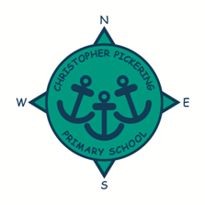
FEBRUARY 2021
NEWSLETTER
Dear Parents, Carers, Governors, Friends, Staff and Pupils,

When I wrote to you in December, I imagined that we would all be coming back to school in 2021 in a much better place than we were throughout the Autumn Term. Sadly, things rapidly changed over the Christmas holidays, and we found ourselves in the position of a lock down again.

However, all of you have adapted brilliantly to the situation we now face and have fully supported the staff here at school with the remote learning. It has been fabulous to see the independence now developing in our children with regards to learning from home, right from Foundation to Year 6.

The staff in school have also pushed themselves out of their comfort zones with regards to delivering lessons online. Their commitment stems from their absolute dedication to the children of Christopher Pickering, both those at home and at school. Watching the lessons, it is easy to see the joy on the faces of the children, seeing their friends and teachers means so much to them.
With your support over the next few weeks we will continue to offer our remote learning offer until we can all safely be back together again.

If you need any support, please do not hesitate to contact the school. We will always try our best to support every family at this difficult time.

Jane Marson

Remote Learning
Thank you to all of you who have sent messages of support and gratitude to the teachers and staff at Christopher Pickering for their efforts to teach the curriculum in lockdown remotely. We would also like to say a huge well done to all the parents and carers at home because your efforts have been fantastic in also helping to maintain pupils’ focus and concentration from this challenging time. We appreciate that it is quite a juggling act but we are very glad that the children’s learning is able to continue throughout this time. We are so proud of our entire community.

We know how hard supporting home learning can be. So please do not get frustrated if you have a challenging day, you are doing a brilliant job. Keep going and remember having a bit of fun and laughter is just as important.

Nearly all pupils who are at home are now accessing lessons across the day. This is wonderful! Our provision is developing week by week, and small improvements are being made to our provision as staff grow in confidence. I can honestly say that staff at CPPS have been absolutely fantastic, the willingness to learn new skills to ensure our pupils receive the best possible teaching has been incredible.

Top Ten Tips For Parents and Carers.
- Remember that your best is good enough!
- Know that your child/children benefit from all that you do.
- Treat Monday to Friday as normal school days: get up, dress and have breakfast before beginning learning.
- Find a calm space away from distractions for learning.
- Make sure your child has what they need for the lesson.
- Work out what your child needs help with and what they can do on their own.
- Take screen breaks and get outside when you can.
- Praise your child as much as possible.
- Plan rewards and treats that you can share together

Keyworker provision update
The number of children accessing our keyworker provision still remains amongst the highest in the city. During the first lockdown, on average, only 14 pupils accessed the provision on a regular basis. The numbers of pupils at school during this lockdown are far higher, close to 200 when all year groups are in school and not isolating.

The government have recently began a media campaign to encourage us all to stay at home if at all possible to protect the NHS from becoming overwhelmed. They have made clear that parents and carers who are critical workers ‘should keep their children at home if they can’ People must make this judgement themselves.

This week all staff who work in Primary Schools across the country have been issued with Lateral Flow Test kits. These have been allocated so that asymptomatic carriers of Covid-19 can be identified more quickly; therefore staff at CPPS will be testing themselves twice a week for Covid-19. This is a positive development, however, it could identify more instances of the virus than what has been previously possible which again could lead to increased periods of isolation.

I must stress that everyone at CPPS is fully committed to supporting all keyworker parents through this difficult time and we are managing the high numbers as best we can. However, I am also duty bound to try to protect all pupils, staff and their families from contacting Covid-19 from transmission in school. Clearly, the risk of this is lower, if the number of pupils in school is lower. Class numbers are set so that children can sit socially distanced and that staff can move around the classroom safely. With this restriction in place we are now full however we do have a waiting list for key worker children.

CPPS Gallery
Take a look at some of the things we have been doing...
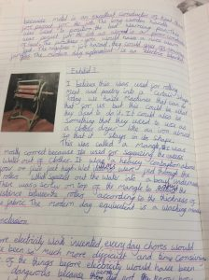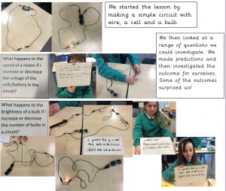

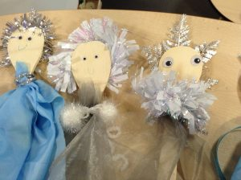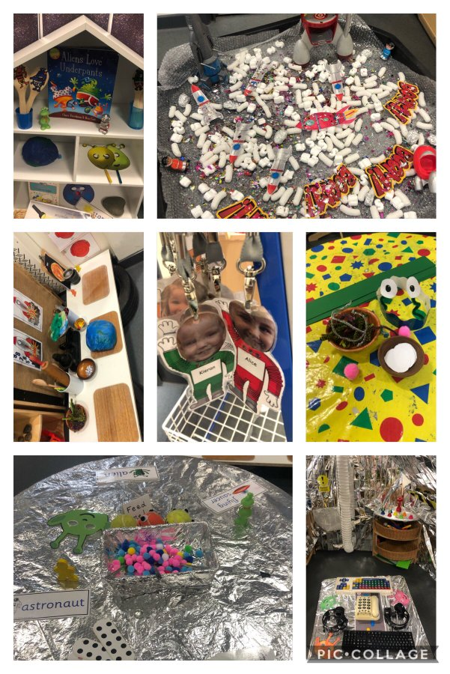

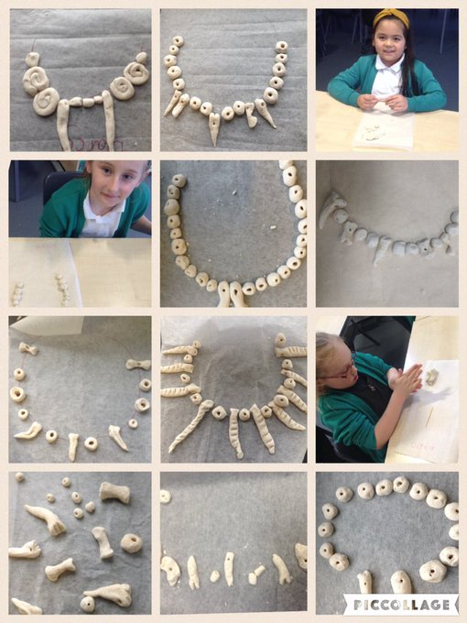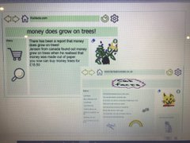

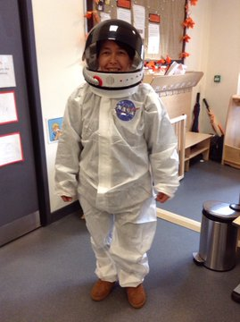

Parents’ Evening
We have made the decision to postpone our parents’ evening until after Easter. Dates for the parents’ evening will be shared, once further information has been received regarding the wider opening of schools.

Twitter
Please share your home learning photos on Twitter and tag @CPickeringPri as we love to see what the children are getting up to.
Maintaining fitness during lockdown
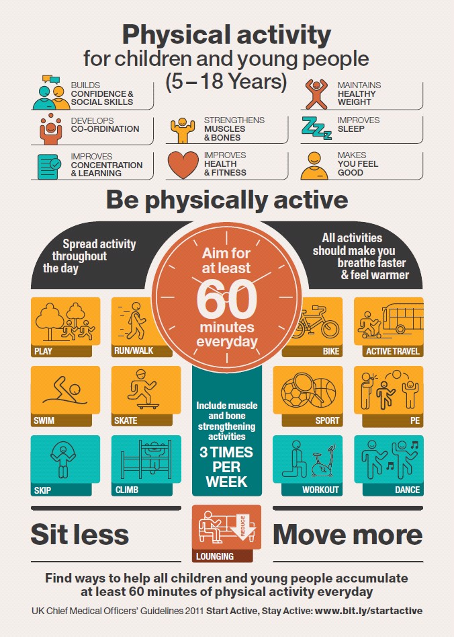

Children’s mental health week
Let your child know that if they are worried about something, they should always talk to an adult they trust. It could be you, someone in your family, a teacher or someone else in their school. If you’re worried about your child’s mental health you can talk to your GP or someone at your child’s school. You can also find a list of organisations that provide support and advice on the website: place2be.org.uk/help

COVID 19 IMPORTANT SAFETY INFORMATION!
Please keep school informed if you have a child in school and you or a household member display symptoms of Covid, accesses a test or receives a test result by ringing The School office on 01482 352245. Children who have a place in school cannot return to school if: they test positive, a member of the household is positive, they or members of the household have symptoms.
Thank you for your support with this.

Care Packages
We are very grateful for the generosity of people in Hull who enable Ginny Dobson to organise these wonderful care packages for some of our school community.
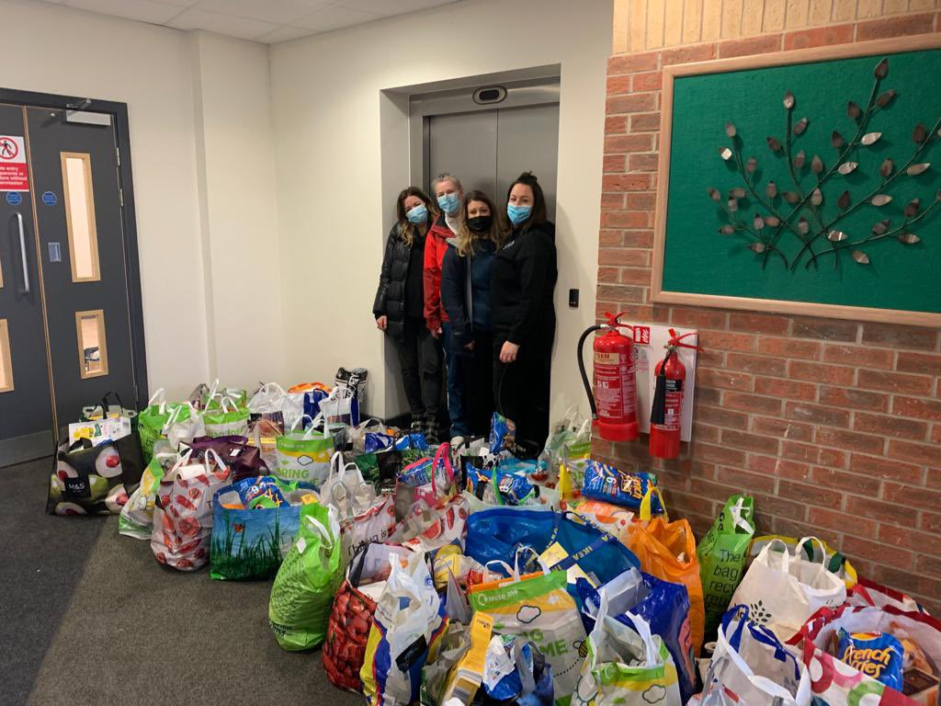
Thank you
School Holiday Dates
Autumn Term 2020 | School opens | 9th September 2020
 | School closes for half term | 23rd October 2020
 | School opens | 2nd November 2020
 | School closes for Christmas | 18th December 2020
Spring Term 2021 | School opens | 5th January 2021
 | School closes for half term | 12th February 2021
 | School opens | 22nd February 2021
 | School closes for Easter | 26th March 2021
Summer Term 2021 | School opens | 13th April 2021
 | BANK HOLIDAY CLOSED | 3rd May 2021
 | School closes for half term | 28th May 2021
 | School opens | 7th June 2021
 | School closes for Summer | 23rd July 2021

*please note we have 1 training day to be confirmed.

