Today can you please find three newspaper articles that you are interested in.
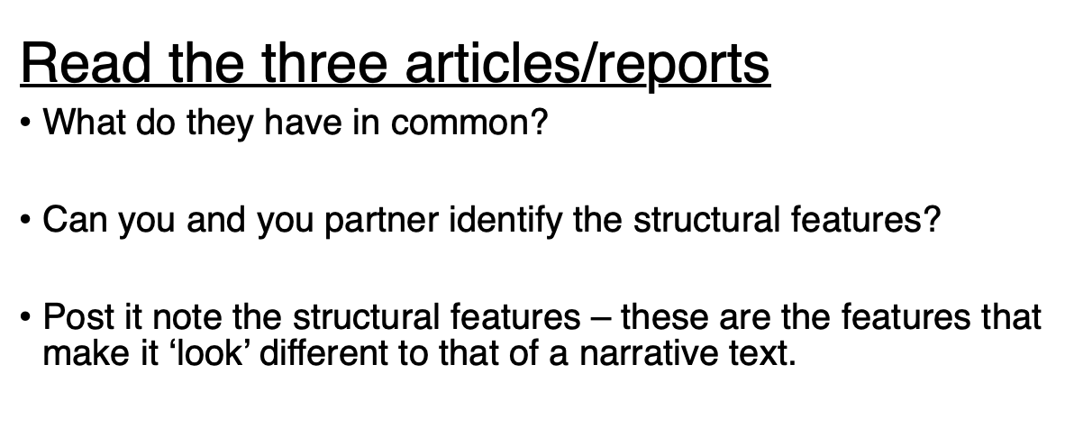

Can you identify:

A headline?
A sub-heading?
A lead paragraph (like and introduction)?
A picture?
A caption (this tells you about the picture)?
A quote from someone who is part of the story?
A quote from someone giving their opinion?
Past tense verbs ?
Any evidence of the present or future tense?

