Humber Education Trust
SEND Policy 2020

To be reviewed September 2021

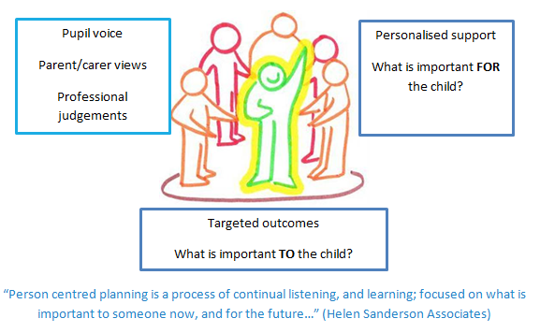
Our Vision
The trust adheres to inclusive principles and the schools in the trust work collaboratively to endeavour to meet the needs of all learners in the trust.

Context
The Humber Education Trust is a diverse multi-academy trust made up of mainstream primary schools and special schools and as such within the trust there are a wide range of learners’ needs.

To cater for the broad range of needs the trust recognises the benefits of following a person-centred approach, working collaboratively and in employing an inquiry mind-set to identify and implement provision to address a pupil’s learning needs.

Aims and purpose
The aims of this policy are:
- to create an environment that meets the special educational needs of each child
- to ensure that the special educational needs of children are routinely identified and assessed and provided for
- to exemplify person-centred practice and make clear the expectations of all partners in the process
- to identify the roles and responsibilities of all staff in providing for children’s special educational needs
- to enable all pupils to have full access to all elements of the school curriculum

The purpose of this document is to ensure that all stakeholders in the Humber Education Trust, including parents, teaching staff and governors understand and use a consistent approach in implementing support for young people with special educational needs and disabilities (SEND). Whilst provision is primarily evaluated dynamically by staff working with the pupils in conjunction with parents and pupils themselves, school governors and senior leaders play an important role in evaluating the effectiveness of the school’s wider SEND provision.

What do we mean by SEND?
In the Special Educational Needs and Disability (SEND) Code of Practice (2014) the definition of SEN remains the same:
“A pupil has SEN where their learning difficulty or disability calls for special educational provision, that is provision different from or additional to that normally available to pupils of the same age.” (Nasen, 2014)
The trust adheres to a social model of disability, which aims to address societal attitudes and culture:
“The model says that people are disabled by barriers in society, not by their impairment or difference. Barriers can be physical, like buildings not having accessible toilets. Or they can be caused by people's attitudes to difference, like assuming disabled people can't do certain things. The social model helps us recognise barriers that make life harder for disabled people. Removing these barriers creates equality and offers disabled people more independence, choice and control.” (Scope, 2019)

How does the trust address the graduated approach?
The Humber Education Trust is committed to the early identification and support of all pupils in the trust. Schools in the trust have a clearly defined graduated response which takes account of quality first teaching, interventions and further provision.
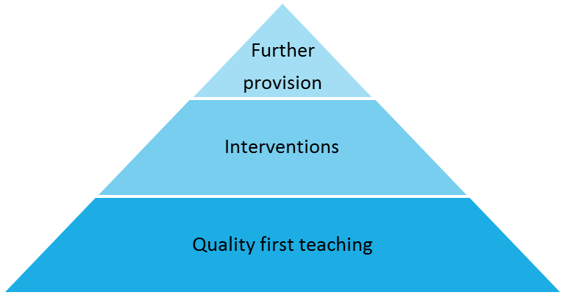
The professional judgement of practitioners in the school, alongside the views and wishes of pupils and parents plays an important role in the assessment and review of pupils’ needs. Where required we liaise with other professionals including those from health, social work or voluntary sectors to provide additional assessment information.

Provision offered
The trust puts in place provision for a wide range of learning needs, as defined by the outcomes pupils are working towards.
Pupils’ provision is based upon the adaptations they require to learn effectively. Reasonable adjustments may be identified through person-centred planning means, when discussing outcomes, for instance.
The effectiveness of pupil provision will be discussed in relation to progress against pupil outcomes and will be discussed in line with the views and wishes of pupils and parents.
The Humber Education Trust is an inclusive trust and as such all pupils are supported to take part in activities alongside peers who do not have SEND. Reasonable adjustments and adaptations to provision are made to ensure this is the case.

Curriculum
The identification and delivery of work and support towards outcomes is of paramount importance in ensuring success for children and young people. By using person-centred planning methods the trust ensures that contributions from pupils and families are sought and acted upon.

The trust employs a person-centred planning approach when defining curriculum and support arrangements for pupils, taking note of the learning priorities identified by parents, school staff, other professionals and the pupils themselves. It places upmost importance on pupils’ final outcomes and as such outcomes planning focuses incrementally towards markers to support pupils’ independence.

We recognise that pupils’ learning needs to be presented in a way that is developmentally accurate to their level of development. Our trust understands that engagement is crucial in supporting pupils’ understanding and as such schools in the trust offer a broad and vibrant curriculum to ease access and to spark interest in learning.
We aim to be outward looking, up to date and innovative in our approach and operate a highly effective professional development programme for all staff including teachers, teaching assistants and support staff on special educational needs. Staff seek training from outside support agencies when necessary, although the trust ascribes to the view that ‘good practice exists in the system’ and as such draws significantly upon knowledge within individual schools and the trust more broadly.

Arrangements for Co-ordinating Provision for Children with Special Educational Needs:
Roles and Responsibilities at Christopher Pickering Primary School, Humber Education Trust

- The Governing Body
The Governing Body in each Humber Education Trust school, in co-operation with the HET Governing Body and the HET CEO and each school’s Head teacher/Head of school, determine the school’s general policy and approach to provision for children with SEND. The Governing Body must report to parents annually on the school’s policy on SEND. The Governing Body will nominate one governor with responsibility for SEND. The Governing Body of maintained mainstream schools must ensure that there is a qualified teacher designated as SENDCO for the school. The SEN Governor will liaise regularly with the SENDCO and report back to the School Committees.
- The Head Teacher
The Head teacher has responsibility for the day-to-day management of all aspects of the school’s work, including provision for children with SEND. The Head Teacher should keep the Governing Board fully informed and also work closely with the SENDCO.
- The SENDCO
The SENDCO has an important role in advising the Head teacher and Governing Body, in determining the strategic development of SEND policy and provision in the school and is a member of the Management Team. The SENDCO has day-to-day responsibility for the operation of SEND policy and coordination of specific provision made to support individual pupils with SEND, including those who have EHC plans. The SENDCO provides professional guidance to colleagues and works closely with staff, parents and other agencies. The SENDCO should be aware of the provision in the Local Offer and be able to work with professionals providing a support role to families to ensure that pupils with SEND receive appropriate support and high quality teaching.
Key responsibilities are:
• Overseeing the day-to-day operation of the school’s SEND policy
• Co-ordinating provision for children with SEND
• Liaising with the relevant Designated Teacher where a looked after pupil has SEND
• Advising on the graduated approach to providing SEND support
• Advising on the deployment of the school’s delegated budget and other resources to meet pupils’ needs effectively
• Liaising with parents of pupils with SEND
• Liaising with early years providers, other schools, educational psychologists, health and social care professionals, and independent or voluntary bodies
• Being a key point of contact with external agencies, especially the local authority and its support services
• Liaising with potential next providers of education to ensure a pupil and their parents are informed about options and a smooth transition is planned
• Working with the Head teacher and school governors to ensure that the school meets its responsibilities under the Equality Act (2010) with regard to reasonable adjustments and access arrangements
• Ensuring that the school keeps the records of all pupils with SEND up to date
• Managing Teaching Assistants.
• Overseeing the records of all children with SEND.
• Contributing to the in-service training of staff.
4. The Teachers
Staff within the trust receive a high level of ongoing training and demonstrate a high degree of expertise in their care, support and teaching of pupils with a broad range of needs. This document highlights the importance of correct, efficient, fluent use of teaching strategies, tailored to support individual pupils.
The trust takes action to remove barriers to learning and actively promotes staff to employ an enquiring mind-set when working with our pupils. The Humber Education Trust recognises the importance of finding out about how our pupils learn and making valued professional judgments, so that we may best support their learning.

Teachers are responsible and accountable for:
• The progress and development of the pupils in their class, including where pupils access support from teaching assistants or specialist staff
• High quality teaching which is differentiated for individual pupils All teachers are aware of the procedures for identifying, assessing and making provision for pupils with SEND, and are actively involved in the review process.

5. The Achievement Support Assistants (ASAs) and the Teaching Assistants (TAs)
The ASAs and TAs work with the class teacher and SENDCO in providing support for children with Special Educational Needs across the school, maintaining records of the children they work with, and attending reviews and meetings as requested.
6. Pupil Participation
The Humber Education trust places significant importance on pupils’ capacity to communicate in order to stay safe, express their views and understand information. The trust ascribes to the mantra ‘no decision about me, without me’.
Pupils with SEND often have a unique knowledge of their own needs and circumstances, and their own views about what sort of support they would like to help them make the most of their education. They will be encouraged to participate in the decision-making processes including the setting of learning outcomes and contributing to their outcomes. This will be achieved through a variety of different approaches as appropriate to the age of the child.
These include:
- Pupil interviews
- Questionnaires
- Self-evaluation (pictures, written answers)
- Pupil set outcomes
- The Role of Parents of Pupils with SEND
Humber Education Trust recognises the significant contribution parents can make to the education of their child and as such the trust seeks to work in full partnership with parents and carers. The Code of Practice (2015) emphasises the importance of excellent partnerships between the school and the views, wishes and feelings of the child and their parents. This is what underpins the principles of the Code of Practice (2015), which are designed to support:

• The participation of children, their parents and young people in decision making
• The early identification of children and young people’s needs and early intervention to support them
• Greater choice and control for young people and parents over support
• Collaboration between education, health and social care services to provide support
• High quality provision to meet the needs of children and young people with SEND
• A focus on inclusive practice and removing barriers to learning
• Successful preparation for adulthood, including independent living and employment
The school endeavours to foster positive working relationships with parents, provides user-friendly information and strives to ensure that they understand the procedures and are aware of how to access advice and support. Frequently asked questions from parents can be found on each school’s website under parent pages/SEND. Parents will be supported and enabled to:
• Recognise and fulfil their responsibilities as parents and play an active and valued role in their child’s education.
• Have knowledge of their child’s entitlement within the SEND framework.
• Make their views known about how their child is educated.
• Have access to information, advice and support during assessment and any related decision making processes about Special Educational provision.
We encourage active participation of parents by providing guidance on how they can support their child’s learning at home. We value the contribution that parents make and the critical role they play in their child’s education.
All parents of children with SEND have access to the SEN Information Report and Local Offer, which gives additional information about Special Educational Needs and Disability. This also provides information about the Parent Partnership service. This is a free service, which supports parents of children with SEND. Links to the SEN Information Report and The Local Offer can be found in the SEND section of each school’s website.
Additional information and/or leaflets are available from the SENDCO on request. Parents are encouraged to contact the child’s class teacher and/or the SENDCO as needed either by telephone or appointment.

Pupils with Medical Needs
Pupils with medical needs will be provided with a detailed Health Care Plan, compiled by the school in partnership with parents and, if appropriate, the pupil themselves.

Staff who administer medicine complete training and are approved by the school as competent.

All medicine administration procedures adhere to the Trust’s Policy Supporting Pupils Medical Conditions in School & Administration of Medicines (2017) and DfE guidelines included within Supporting pupils at school with medical conditions (DfE) 2014

This policy complies with the statutory requirement laid out in the SEND Code of Practice 0-25 (September 2014) 3.65 and has been written with reference to the following guidance and documents:
- Equality Act 2010: advice for schools DFE February 2013
- The Children and Families Act 2014
- The SEND Code of Practice 0-25 2014
- Schools SEN Information Report Regulations (2014)
- Statutory Guidance on Supporting Pupils in School with Medical Conditions April 2014
- The National Curriculum in England: Key stage 1 & 2 Framework (December 2014)
- Teaching Standards (2012)

