Year 6 Long Term Plan
 | Autumn | Spring | Summer
Driver/POD | Ancient Mayan Civilization  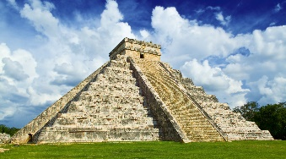 | Crime and Punishment  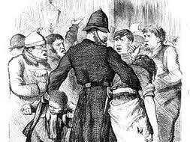 | Deserts
Trips | VR Experience  Visit a mosque | York Dungeons  Prison me? No way! | Year 6 Residential Trip
Overall Enquiry Questions | Who were the Maya? | Have people always been sent to prison? | Does anything grow in the desert?
Science | Electricity  Light | Animals including Humans | Evolution and Inheritance  Living things and their Habitats
History | Ancient Mayan Civilizations  A non-European society that provides contrast with British history | Crime and Punishment  A study of a theme in British history extends chronological knowledge beyond 1066 | Migration and Immigration
Geography | Geography of Central America  Locational Knowledge  Identify the position and significance of the geographic coordinate system  Use maps, globes and atlases and digital mapping  Describe and understand features of physical and human geography comparing a region in the UK and a region in the America’s  Use the eight points of a compass and six figured grid references | Geography of the UK  Locational Knowledge  Counties, cities and topographical features of the UK  Describe and understand features of physical and human geography | Deserts and Third World Countries  Locational Knowledge  Identify the position and significance of the geographic coordinate system  Counties, cities and topographical features of the UK  Describe and understand features of physical and human geography  Understand geographical similarities and differences between the UK and a region within South America  Use maps, globes and atlases and digital mapping  Use the eight points of a compass and six figured grid references
Art | Clay Sculpture and Printing | TBA | TBA
D&T | Cooking – Make a Gift box with some chocolate | Construction – Design and make an alarm system | Textiles – Upcycle a piece of clothing for a fashion show
Computing | Unit 6.1 – Coding  Unit 6.2 – Online Safety  Unit 6.3 – Spreadsheets | Unit 6.4 – Blogging  Unit 6.5 – Text Adventures | Unit 6.6 – Networks  Unit 6.7 – Quizzing
Music | Autumn 1 – Recorder Skills – Charanga  Autumn 2 – Christmas songs using recorder skills | Spring 1 – Recorder Improvisation – Charanga  Spring 2 – Music Technology | Summer 1 – Music from Different Cultures  Summer 2 – Composing using recorders to popular music – Pharell Williams
PE | Dance, Gymnastics (matching and mirroring), Net Games (Badminton), Invasion Games (Football), Outdoor and Adventurous Games, Sports hall athletics, Fitness | Dance, Gymnastics (counter balance and tension), Invasion Games (basketball, dodgeball and rugby) | Dance, Athletics, Gymnastics (holes and barriers), Striking and Fielding (rounder’s and Danish long ball)
RE | Is it fair? | What gives a sense of identity and belonging? | What is life about?
PSHCE | Being me in my world  Celebrating Differences | Dreams and Goals  Healthy me | Relationships  Changing Me

