Year 5 Long Term Plan
 | Autumn | Spring | Summer
Driver/POD | Ancient Greece  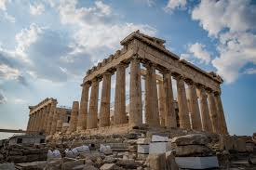 | Anglo Saxons, Scots and Vikings  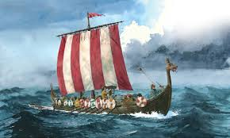 | Rivers  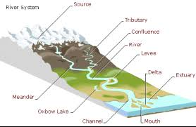
Trips | Visit a Buddhist Temple | Yorkshire Museum of Farming – Viking Day  VR Experience | Visit River Hull  Trip to Magna
Overall Enquiry Question | Who were the Greeks? | How did life in England change when the Vikings raided? | Why are rivers so important?
Science | Earth and Space  Forces | Properties and Changes in Materials | Animals including Humans  Living things and their Habitats
History | Ancient Egypt  The achievements of the earliest civilizations | Anglo Saxons, Scots and Vikings  The Roman Empire and its Impact upon Britain 42AD – 410AD | The British Empire
Geography | Geography of Egypt  Locational Knowledge  Identify the position and significance of the geographic coordinate system  Use maps, globes and atlases and digital mapping  Describe and understand features of physical and human geography | Settlements during the Anglo Saxon and Viking Era  Locational Knowledge  Counties, cities and topographical features of the UK  Describe and understand features of physical and human geography  Identify the position and significance of the geographic coordinate system | Rivers and the Water Cycle  Locational Knowledge  Counties, cities and topographical features of the UK  Describe and understand features of physical and human geography  Understand geographical similarities and differences between the UK and a region within South America  Use maps, globes and atlases and digital mapping  Identify the position and significance of the geographic coordinate system
Art | Sketching and Sculpture | TBA | TBA
D&T | Textiles – Make a pair of sandals | Cooking – Make Anglo Saxon Bread | Construction – Pulley System for getting water out of a well
Computing | Unit 5.1 – Coding  Unit 5.2 – Online Safety | Unit 5.3 – Spreadsheets  Unit 5.4 – Databases | Unit 5.5 – Game Creator  Unit 5.6 – 3D Modelling  Unit 5.7 – Concept Maps
Music | Autumn1 – Recorder Skills – Charanga  Autumn 2 – Famous Modern Composers – Glockenspiel accompaniment | Spring 1 – Hip Hop Rap  Spring 2 – Rock Music | Summer 1 – National Anthems of the World  Summer 2 – Music Technology
PE | Gymnastics (counter balance and counter tension), Invasion Games (netball and football), Health related Exercise | Dance (the circus), Invasion Games (rugby and hockey), OAA (orienteering) | Striking and Fielding (rounders and cricket), Net and Wall Games (tennis), Athletics
RE | How do people of faith express their faith? | What inspires people to follow a faith and what is the cost? | Why do people of faith make a pilgrimage?
PSHCE | Being me in my world  Celebrating Differences | Dreams and Goals  Healthy me | Relationships  Changing Me

