Year 4 Long Term Plan
 | Autumn | Spring | Summer
Driver/POD | Ancient Egypt | Romans  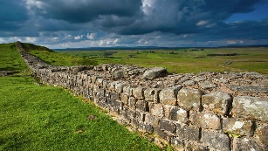 | Rainforests  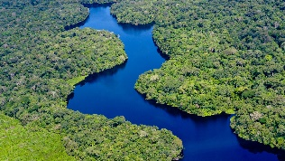
Trips | Visit Willerby Synagogue  Hands on History Museum | VR Experience | Yorkshire Wildlife Park
Overall Enquiry Questions | 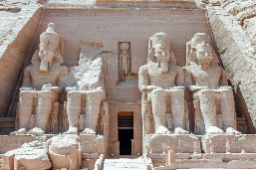  Who were the Egyptians and what did they do? | Who were the Romans and what did they do for us? | Does it always rain in the rainforest?
Science | Sound  Electricity | Animals Including Humans | States of Matter  Living things and their Habitats
History | World War II  A study of an aspect of British history that extends pupil’s chronological knowledge beyond 1066 | The Romans  The Roman Empire and its Impact upon Britain 42AD – 410AD | History of Native Citizens
Geography | Geography of Hull and the UK  Locational Knowledge  Counties, cities and topographical features of the UK  Use maps, globes and atlases and digital mapping  Describe and understand features of physical and human geography | Settlements during the Roman Empire  Locational Knowledge  Counties, cities and topographical features of the UK  Understand geographical similarities and differences between the UK and a European country  Describe and understand features of physical and human geography | Rainforests  Locational Knowledge  Identify the position and significance of the geographic coordinate system  Understand geographical similarities and differences between the UK and a region within South America  Use maps, globes and atlases and digital mapping  Describe and understand features of physical and human geography
Art | Portraits, Observational Drawing and Multimedia | TBA | TBA
D&T | Construction – Make up a light up display for an Egyptian museum | Textiles – Make a Roman purse | Cooking – Make cookies from ethically sourced products from the Rainforest
Computing | Unit 4.1 – Coding  Unit 4.2 – Online Safety | Unit 4.3 – Spreadsheets  Unit 4.4 – Writing for different purposes | Unit 4.5 – Logo  Unit 4.6 – Animation  Unit 4.7 – Effective Search  Unit 4.8 – Hardware Investigators
Music | Autumn 1 – Glockenspiel – Charanga  Autumn 2 – Christmas songs on Glockenspiel | Spring 1 – Famous Composers of the past  Spring 2 – Writing Music | Summer 1 – Music from another Culture  Summer 2 – Influential Music – The Beatles – Charanga
PE | Dance (cats), OAA (problem solving), Invasion Games (basketball and football) | Dance (space), Gymnastics (Bridges), Invasion Games (netball), Net and Wall Games (tennis) | Invasion Games (hockey and tag rugby), Striking and Fielding Games (cricket), Athletics
RE | What does it mean to belong to a faith? | What makes a hero? | What do religions teach us about the world?
PSHCE | Being me in my world  Celebrating Differences | Dreams and Goals  Healthy me | Relationships  Changing Me

