Year 3 Long Term Plan
 | Autumn | Spring | Summer
Driver/POD | World War II  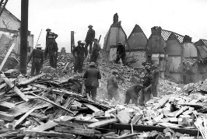 | Stone Age, Bronze Age and Iron Age  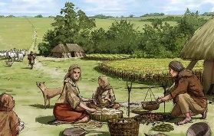 | Volcanoes and Earthquakes  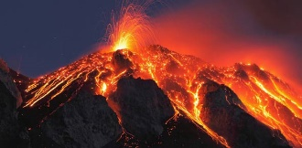
Trips | Trip to the Church  Visit the Cenotaph | VR Experience | Trip to Eureka
Overall  Enquiry Question | What was life like during WWII? | What was life like in the Stone Age? | How does the earth move?
Science | Light | Animals including Humans  Plants | Rocks  Forces and Magnets
History | Focus on famous and influential people of Hull  A study of an aspect of British history that extends pupil’s chronological knowledge beyond 1066 | Stone Age-Iron Age  Changes in Britain from the Stone Age to the Iron Age 8,000BC – 43AD | History of World Disasters
Geography | Geography of Hull and the UK  Locational Knowledge  Counties and topographical features of the UK  Use maps, globes and atlases and digital mapping  Use eight points of a compass and six-figure grid references and symbols  Use fieldwork to measure and record features of the local area  Describe and understand features of physical and human geography | Settlements in the Stone Age  Locational Knowledge  Counties and topographical features of the UK  Describe and understand features of physical and human geography | Volcanoes  Locational Knowledge  Identify the position and significance of the geographic coordinate system  Understand geographical similarities and differences between the UK and a European country  Use maps, globes and atlases and digital mapping  Describe and understand features of physical and human geography
Art | Drawing, Painting, Sculpting and Printing | Graffiti and Printing | TBA
D&T | Cooking – War-time soup | Textiles – Iron Age Tunic | Construction – Earthquake proof building
Computing | Unit 3.1 – Coding  Unit 3.2 – Online Safety  Unit 3.3 – Spreadsheets | Unit 3.4 – Touch Typing  Unit 3.5 – E-mail | Unit 3.6 – Branching Databases  Unit 3.7 – Simulations  Unit 3.8 – Graphing
Music | Autumn 1 – Wartime Music – Vera Lynn  Autumn 2 – Glockenspiel – Charanga | Spring 1 – Reggae Music – Bob Marley – Charanga  Spring 2 – Famous Composers – past v modern | Summer 1 – Bringing us together – Charanga  Summer 2 – Nursery Rhymes – improvising and composing
PE | Group A - Swimming  Group B - OAA (Communication and Tactics), Dance (wild animals), Gymnastics (Symmetry and Asymmetry, Invasion games (netball) | Group B - Swimming  Group A - OAA (Communication and Tactics), Dance (wild animals), Gymnastics (Symmetry and Asymmetry, Invasion games (netball) | Invasion Games (rugby), Net and Wall Games (tennis), Athletics, Striking and Fielding (cricket)
RE | Why Remember? | Who are the faith founders and what do they teach us? | What makes a place sacred?
PSHCE | Being me in my world  Celebrating Differences | Dreams and Goals  Healthy me | Relationships  Changing Me

