Year 1 Long Term Plan
 | Autumn | Spring | Summer
Driver/POD | Antarctica | Enchanted Woodland  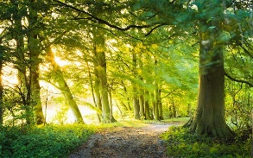 | Travel and Transport to the Seaside  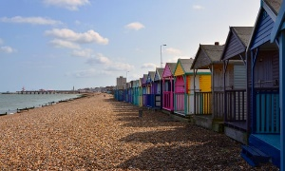
Trips | VR Experience  Pickering Park – Seasonal changes | Bainton Woods  Pickering Park – Seasonal changes | Bridlington Beach  Pickering Park – Seasonal changes
Overall Enquiry Question | Why do we not live in Antarctica? | Why is the woodland so important? | How did people holiday in the past?
Science | Animals including Humans  Seasonal Changes | Everyday Materials  Seasonal Changes | Plants  Seasonal Changes
History | Lives of significant individuals  Events beyond living memory  Significant historical events, people and places in own locality | Lives of significant individuals  Events beyond living memory | Changes within living memory  Events beyond living memory
Geography | Locational Knowledge  Human and Physical features of contrasting localities  Location of hot and cold locations around the world  Use simple compass directions  Use maps, globes and atlases  Use aerial photographs to recognise landmarks and basic human and physical features | Locational Knowledge  Use maps, globes and atlases  Use simple compass directions  Use aerial photographs to recognise landmarks and basic human and physical features  Devise a simple map with a key  Study the geography of the school and surrounding area | Locational Knowledge  Human and Physical features of contrasting localities  Seasonal and daily weather patterns in the UK  Location of hot and cold locations around the world  Use simple compass directions
Art | Working with Colour and Painting | Creating Ideas, Drawing and Printing with Clay | Working with Colour, Painting and Digital Art
D&T | Mechanisms – Slides and Levers | Construction – Making a Bug Hotel | Cooking – Make a Fruit Salad
Computing | Unit 1.1 Online Safety and Exploring Purple Mash  Unit 1.2 Grouping and Sorting  Unit 1.3 Pictograms  Unit 1.4 Lego Builders | Unit 1.5 Maze Explorers  Unit 1.6 Animated Story Books | Unit 1.7 Coding  Unit 1.8 Spreadsheets  Unit 1.9 Technology outside school
Music | Autumn 1 – Hey You – Charanga  Autumn 2 – Body Percussion | Spring 1 – Nursery Rhymes/Songs  Spring 2 – Charanga – Your Imagination | Summer 1 – Introduction to Boom Whackers  Summer 2 – Writing a Boom Whackers Song
PE | Gymnastics (wide, narrow, curled and body parts), Locomotion (running), FMS (ball skills – hands) | Dance (Growing and the zoo), FMS (ball skills – feet and hands) | Locomotion (jumping), Games for understanding, Health and Wellbeing
RE | What makes us special? | How can we keep the world special? | What is a festival?
PSHCE | Being me in my World  Celebrating Differences | Dreams and Goals  Healthy Me | Relationships  Changing Me

