Parts of a lighthouse
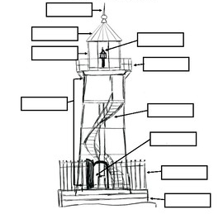
Use the words below to fill in the boxes

Lightening rod | Lantern room | Stairwell
Light | Gallery | Lighthouse wall
Fence | Entrance | Cupola

