SPRING TERM 2018
Foundation Stage
Made in Hull… Let’s build!
Welcome!
Wishing all of our Foundation Stage families a very Happy New Year and welcome to the Spring Term.

This half term our area has been transformed into a building site. Our Winter Garden is becoming the hub of all activity as our construction site, but many children will be found having a ‘cup of tea’ in the builder’s staff room and attending to first aid injuries.

Thank you for all your support during the Autumn term; with our dress up days, party days and for the lovely activities you have done with your children in their home school diaries. Thank you to those of you who have taken care of our ‘Home bear’ for the weekend too. We love hearing what he has been up to!

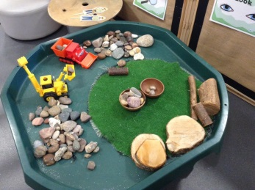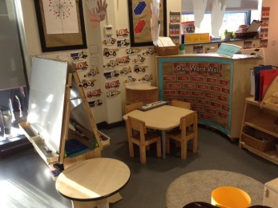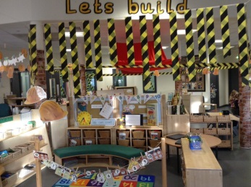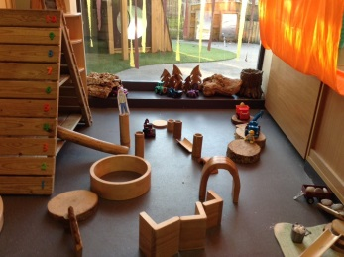

Curriculum Information
Reading
Please ensure that your child brings their reading book into school on their reading day and that they put it into the reading basket located on the side opposite the trays.
PE
Unfortunately, due to the nativity practices last half term some PE session in the hall were missed. We are back with PE on a Tuesday afternoon, starting next week. We are lucky to have the Tigers Trust delivering PE for the next term. They will be delivering the fundamentals of movement for one half of the session then the children will be doing dance with Mrs Wilkinson for the other half of the session. F2 children also need to have a full PE kit labelled. (White t-shirt, black shorts and sandshoes.)
If you would like to get active with your children at home, you can access our ‘cybercoach’ from home. Go to www.cyber-smart.co.uk, click on ‘log in now,’ our cybercoach@cpickering.hull.sch.uk and the password is HU47EB.

Outdoor play
Now the weather is turning very cold please ensure your child has a suitable warm, waterproof coat, with their name clearly labelled. Hats, scarfs and gloves are also welcomed as all children do go outside for part of the day. We do provide wellies and waterproofs for outdoor play in our water area. By all means please send your child with their own wellies if you prefer. Also, if you have any old unwanted wellies at home and would like to donate to school, that would be great!

Snack and baking plea
Please could we ask you for a voluntary contribution of 50p a week to enable us to bake and taste a variety of foods with your children. The money box and tick sheets are kept above the children’s drawers.

WOW Stars
We really love hearing about any WOW moments your children have at home. This can be really valuable when making assessments of your children as sometimes they show a new skill at home rather than at school. Remember you can collect a WOW star from above the children’s drawers and you can email us a picture of video to wowstars@cpickering.hull.sch.uk.

Dates
Tuesday 8th January | Builder dress up day.
Wednesday 9th January | Walk around the local area.
Thursday 10th January | Walk around the local area.
Monday 14th January | Flu team in for children who were absent last time.
Thursday 17th January | Flex dance taster day (no PE kit required.)
Thursday 24th January | Nursing team in for height and weight checks.
Monday 4th February | Hull FC player visit.
Tuesday 5th February | E-safety day.
Tuesday 12th February | Parents evening.
Wednesday 13th February | Parents Evening.
Friday 15th February | Break up for half term.
Monday 25th February | Back to school.
Friday 1st March | First, ‘First steps’ balance bike session. 3:30 – 4:15pm, 6 week course. (More information to follow)
Thursday 7th March | World book day. (Book character dress up day.)
Friday 15th March | Comic relief. (More information to follow.)
Date to be confirmed | Easter bonnet parade.
Friday 5th April | Break up for Easter holidays.

General
Beginning and the end of the school day
Please make sure that siblings are with you at all times. The outdoor play equipment should not be used before or after school, we appreciate your co-operation to ensure the safety of all of our children and families.

Breakfast club and after school club
F2 children have the opportunity to attend breakfast club from 8am each morning. If you would like your child to attend, please see Mrs George in the office for a booking form. F2 children can now attend our after school club from the end of the school day until 6pm. Please contact the office for more information.

Indoor/Outdoor shoes
Please can you make sure that your child has a pair of indoor shoes (sandshoes) and a pair of outdoor shoes, this helps keep our school environment clean and tidy. Velcro fastenings/slip ons are encouraged unless your child can tie their laces themselves.

LOST PROPERTY
If your child has lost anything please check our lost property box above the children’s tray. Please ensure ALL of your child’s belongings are labelled as then we can return any items to your child without it having to go into the lost property box.

