November 2018
NEWSLETTER
Christopher Pickering Remembers…
Dear Parents, Carers, Governors, Friends, Staff and Pupils,

The centenary of Armistice was marked at CPPS by all year groups. The Year 3/4 children prepared a poppy display which has now taken pride of place in the hallway at school to mark the sacrifice made. We held a Remembrance Assembly on Monday 12th November and created a giant human poppy on the playground.

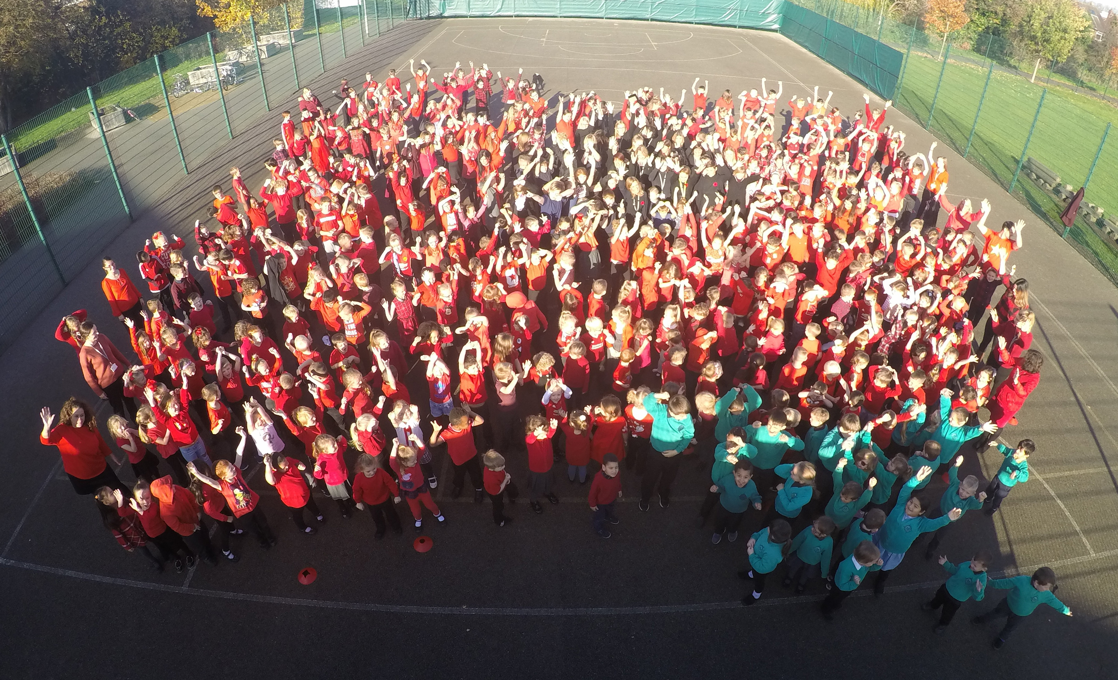

We have now turned our thoughts to the festival of Christmas and all the joy that it brings! Please note the dates for all of the different celebrations.

Jane Marson

Information
Autumn/Winter in full swing!
Inevitably the trees have been shedding their leaves and have been making our footpaths and steps slippery. Please take extra care and keep us all safe and healthy!

Harvest Festival
Thank you all for supporting our Harvest Festival. The charities –Emmaus, Age Concern and Humbercare Features Project who received the donations of food were overwhelmed with your generosity.

Children in Need
We had a great day on Friday raising money for Children in Need. Yet again you were very generous with your donations and we raised the grand sum of £430. Thank you!

A Polite Reminder
Please can all parents/carers ensure that appropriate language is used on the school site at all times. This includes on the school playground and when in school. Thank you.

Starting School in 2019
Do you have a child aged between 3 to 4 years old? Was your child born between September 1 2014 and August 31st 2015? If so, then he/she should start school in September 2019. You can apply for a place online NOW using the electronic form on the council’s website www.hull.gov.uk or you can get an application form from the Admission Team. Application forms are available now. The deadline for receiving applications is January 15th 2019.

Tree Planting
We had an extremely successful tree planting day this week, as we are embarking on a long-term project to create our own forest school and reduce excessive surface water on our school field. To do this we will plant several hundred trees across the school site, including a large woodland with a camp fire at its centre. A big thank you to all the parents who came in to help us with this.

Countdown to the Christmas Fair – Donations Welcome at Any Time
On Monday 3rd December the PTA will be hosting the annual Christmas fair. This is, as most of you know, one of the biggest fundraising events the PTA hold and, once again, we are asking for your help to make it a resounding success. There will be lots of old favourites including Santa’s grotto, tombola, chocolate tombola, reindeer food and many more. The PTA will be extremely grateful for any items for the tombola stalls.

One of the obvious benefits of the work of the PTA are the contributions they make to school trips but the PTA have purchased so much more including reading books and maths mastery materials. The difference the PTA makes to the learning, happiness and wellbeing of your children is immense.

CPPS Sporting Achievements
First in Hull to Achieve Platinum!
At the start of our school year we were very proud to achieve the prestigious School Games Mark Platinum Award. This is awarded to schools who have maintained consistently high standards with their school sport provision and, after 5 years of successive gold awards, the completion of an extended application and submission of a detailed case study we were lucky enough to receive the award. We are now the first in the City to achieve this level of recognition.

School Sport
We’ve had another fantastic start to the sporting year with Hull Active Schools and Tigers Trust:
- 2nd in tag rugby qualifiers (4th in Grand final)
- 1st in 7 a side football (qualifying for Humberside finals)
- 2nd in Boccia
- Cross Country – 2nd Girl’s ‘A’ team. 2nd Girl’s ‘B’ individual, 1st Girl’s ‘B’ Team, 3rd Girl’s ‘B’ Team, 1st Boy’s ‘B’ Team, 2nd Boy’s ‘B’ team, 2nd Boy’s ‘B’ individual (4 children through to county finals).
- 2nd in Girl’s 7 a side football.
- 1st, 2nd & 3rd in Tigers Trust bench ball
- 2nd & 3rd in team timed Badminton Championships (qualifying for Hull final)
- Progressed to the next round in the Humberside 9 a side cup

Enrichment & Lifestyles
We have continued to enrich our PE & Sport provision with our Fencing Day, courtesy of ‘FITfence’, and have introduced our Fitbit challenge (in partnership with the Premier League and Tigers Trust). Our House Captains have attended a ‘Showing Racism the Red Card’ workshop which uses international sporting bodies to spread awareness about racism and a number of Y5/6 children completed the ‘Hull-timate Challenge’ obstacle course – check our YouTube channel to see Archie racing KCFM around the course!

Outside of School
We love to hear how our children have been keeping active during weekends and holidays; please keep sharing their success stories with us. We’ve had children completing dance exams, attending rugby camps, starting elite-level football training, football tours and boxing bouts - please keep these success stories coming in so we can celebrate your child’s talents.

School Dates
Monday 3rd December | Christmas Fair
Tuesday 4th December | Christmas Carol Concert
Wednesday 5th December | Flu Vaccinations (FS2-Y5)
Tuesday 11th December | FS Nativity (9:30am)  KS1 Nativity (1:30pm)
Wednesday 12th December | FS Nativity (1:30pm)
Thursday 13th December | KS1 Nativity (9:30am)
Friday 14th December | Christmas Dinner & Jumper Day
Monday 17th December | Y3/4 Christmas Party
Tuesday 18th December | Y1/2 Christmas Party
Wednesday 19th December | FS Christmas Party
Wednesday 19th December | Christmas Disco
Thursday 20th December | Y5/6 Christmas Party
Friday 21st December | School closes for Christmas holiday

School Term Dates
Autumn Term 2018 | School opens | Wednesday 5th September
 | School closes for half term | Friday 26th October
 | School opens | Monday 5th November
 | School closes for Christmas | Friday 21st December
Spring Term 2019 | School opens | Tuesday 8th January
 | School closes for half term | Friday 15th February
 | School opens | Monday 25th February
 | School closes for Easter | Friday 5th April
Summer Term 2019 | School opens | Tuesday 23rd April
 | School Closed for Bank Holiday | Monday 6th May
 | School closes for half term | Friday 24th May
 | School opens | Monday 3rd June
 | School closes for Summer | Friday 19th July

