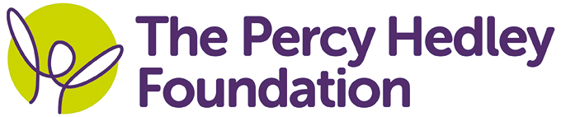

MEDIA RELEASE
For immediate release

AWARD WINNING NORTHERN RAIL DONATE PRIZE MONEY TO THE PERCY HEDLEY FOUNDATION

Northern Rail has boosted a local charity by donating the prize money they received after scooping a national award.
Earlier this year, Northern Rail’s Heaton Train Maintenance Depot, were triumphant at the Northern Rail Pride Awards when they took home the Safety and Environment Award and they have chosen to donate their £500 prize to The Percy Hedley Foundation.
Based in Newcastle and North Tyneside, the Foundation relies heavily on donations from businesses and the public to continue their work supporting and improving the lives of disabled children and adults.
“The team has been looking for a charity to support for a while now and The Percy Hedley Foundation came up because some of the team live near the school,” said John Alexander, District Maintenance Manager.
“The fundraising team kindly invited us in for a tour of the school and it was great to see all the amazing work they do.
“We are looking at ways to continue our support of Percy Hedley in the future and can’t wait to take part in some team bonding at fundraising events.”
The team, based at Northern’s Heaton depot, was shown around by fundraiser Maria Hallett, who was over the moon when John, along with colleagues Garry Roseby and Geoff Smith, presented the cheque.
“We are absolutely delighted to be chosen by Northern Rail to receive the prize money from their national award and are looking forward to developing our relationship with them in the future.”
Ends
Picture: Geoff Smith, Garry Roseby and John Alexander from Northern Rail present a cheque for £500 to Maria Hallett from The Percy Hedley Foundation
CONTACT:
For further information contact:
Name: Steph Clark
Contact telephone number: 0191 2381325 / 07808775079
Email address: steph.clark@percyhedley.org.uk
Notes to Editors
The Percy Hedley Foundation is a registered charity that works to help meet the needs of disabled children and adults.
The charity provides a wide range of high quality, specialist and personalised care and education support to over 1,000 families each year.

