Five Ways to Well-being Drop in Session
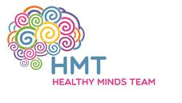
We are hosting a 2-hour workshop for parents/carers and children to help support and offer suggestions to improve well-being.
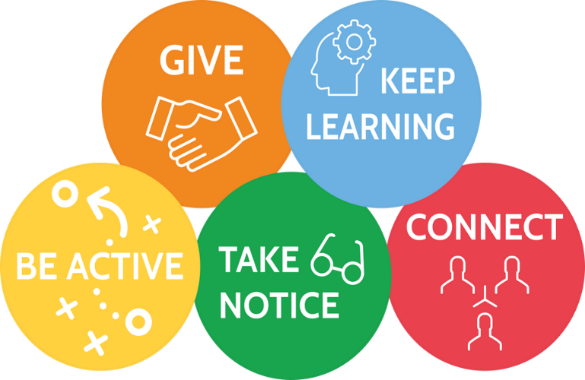

We will look at each of the five ways to well-being, participate in activities and support you with being able to implement these into your life to boost your wellbeing.
We are hosting 2 separate sessions; you do not need to attend both.

Date: 15.08.2024
Time: 10:00 – 12:00
Location: Bede Family Hub
Date: 01.08.2024
Time: 10:00 – 12:00
Location: Bede Family Hub
Anxious School Returners
Drop-in Session
Does your child get anxious about
returning to school?

We are hosting a 2 hour workshop for parents and children to gain advice and learn strategies to support your child in returning back to school in September.
There will also be some activities available for children and young people if you wish for them to come along.

We are hosting 2 separate sessions; you do not need to attend both.
Date: 05.08.2024
Time: 13:00 – 15:00
Location: Bede Family Hub
Date: 19.08.2024
Time: 13:00 – 15:00
Location: Bede Family Hub

