South Tyneside Council
Town Hall & Civic Offices
Westoe Road
South Shields
Tyne & Wear
NE33 2RL
Letter From: Shona Gallagher, Director of Children’s Services
RE: SEND Re-Visit
Dear Parents / Carers,
I am writing to say a big thank you and to provide an update following our recent visit to South Tyneside by Ofsted and the Care Quality Commission. This was a re-visit to check progress after our previous SEND inspection in 2019.
The inspectors heard from parents/carers, children and young people and looked at the work we have done together to make improvements over the past three years. They used this evidence to judge whether we have made enough progress in the five areas that they said needed improvement.
I wanted to take the opportunity to thank all of you who contributed to the survey, attended a group in person or online, for your input and contribution to this process. All the feedback we receive enables us to continue to work towards improving the system, services, and processes for all our children and young people with Special Educational Needs & Disabilities (SEND) and their families in the borough.
The inspectors have written their feedback from this visit in the form of a letter, which is available here: https://files.ofsted.gov.uk/v1/file/50200493 and on the SEND Local Offer.
We welcome the feedback that we have received acknowledging the progress we have made, however, we recognise that there is more to do to improve the experiences of families. We have recently developed our SEND Strategy, which outlines our priorities for making improvements for families. This was designed using feedback from parents/carers and our ‘What Does Good Look Like’ sessions, which will be published in January 2023. We look forward to working with you to continue making improvements.

To do this, we want to continue to hear from you and understand what changes would help improve the SEND journey for your children and yourselves. You can find opportunities to get involved on the SEND Local Offer website and social media pages.
We will continue to keep you updated through our newsletter ‘SEND An Update’ and our SEND Local Offer, which you access by scanning the QR code here.
With best wishes.

Shona Gallagher
Director of Children’s Services, South Tyneside Council
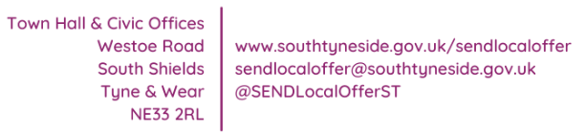
Co-Chair of the SEND Leadership Board

