Appendix Q

POOL WATER LOG SHEETS FOR ………………..……………..............................SCHOOL

Week commencing: / /

Below; 1st, 2nd, 3rd & 4th must be replaced with times | Chlorine  Free Combined Total  Residual Residual Residual  (mg/l) (mg/l) (mg/l) | Ph | Temp.  ( °C) | Filter Pressure  #1 #2 | Addition of chemicals. | Mains Water Added
Monday
1st
2nd
3rd
4th
Tuesday
1st
2nd
3rd
4th
Wednesday
1st
2nd
3rd
4th
Thursday
1st
2nd
3rd
4th
Friday
1st
2nd
3rd
4th
Please turn over to record readings for Saturday and Sunday if required and to record cyanuric acid levels

Below; 1st, 2nd, 3rd & 4th must be replaced with times | Chlorine  Free Combined Total  Residual Residual Residual  (mg/l) (mg/l) (mg/l) | Ph | Temp.  ( °C) | Filter Pressure  #1 #2 | Addition of chemicals. | Mains Water Added
Saturday
1st
2nd
3rd
4th
Sunday
1st
2nd
3rd
4th

Pools that use Chlorinated Iso-Cyanuric, only
Cyanuric Acid | Test Result | Action Taken
Date and time of test | mg/l

Weekly Tests and Balanced Water Test Results

Date: ………………………………………………………………………………….

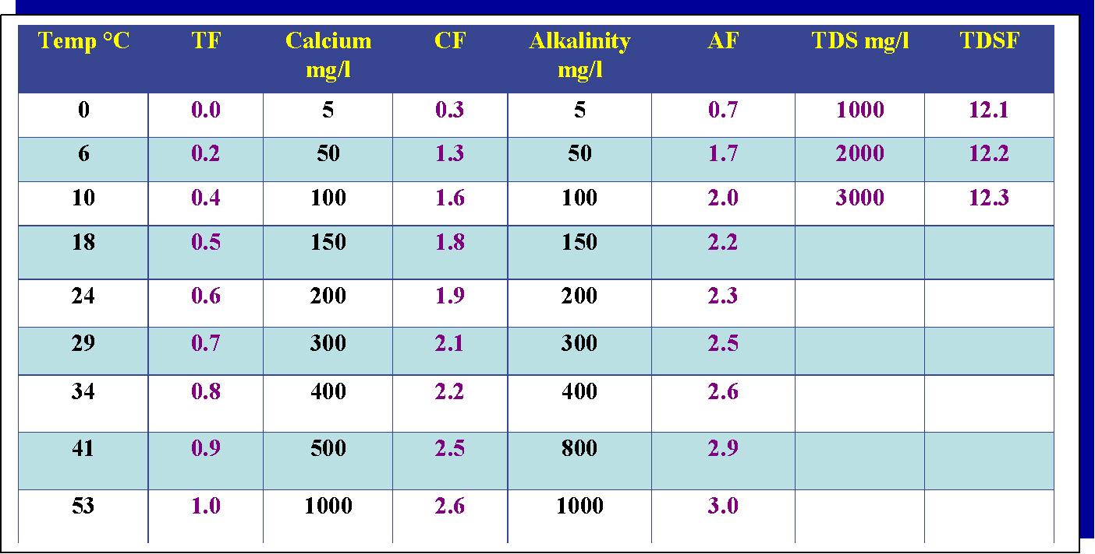

The Langelier Balanced Water Formula is:

pH + Temperature + Calcium Hardness + Total Alkalinity - Total Dissolved Solids
Factor Factor Factor Factor

pH | Total Alkalinity | Calcium Hardness | Temperature | Total Dissolved Solids | Balance Water Test Result
 | mg/l | mg/l | °C | mg/l
S.I. Factor | S.I. Factor | S.I. Factor | S.I. Factor | S.I. Factor | S.I.
Action taken: | Action taken: | Action taken: | Action taken: | Action taken: | Action taken:

