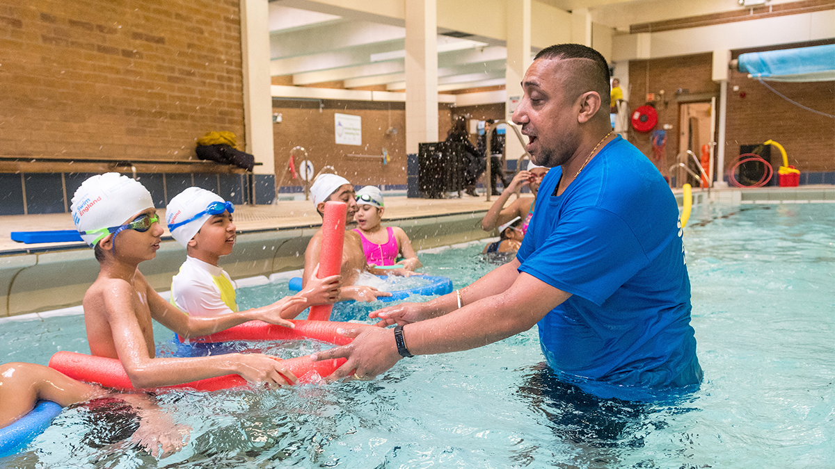

Swim England releases updated guidance to help support primary schools
19 November 2019
Swim England has published refreshed guidance to help support primary schools deliver on the national curriculum requirements for swimming and water safety.
The easier-to-read guidance has been produced in conjunction with the Department for Education and is released as hundreds of swimming teachers gather in Solihull for the Swim England Teaching and Education Conference.
The National Curriculum states that pupils should be taught to:
- Swim competently, confidently and proficiently over a distance of at least 25 metres
- Use a range of strokes effectively
- Perform safe self-rescue in different water-based situations.
The guidance has been refreshed following the Department for Education announcing the allocations for the Sport and PE Premium funding for schools at the end of October.
Despite swimming being on the national curriculum for 25 years, around one in four pupils are currently leaving primary school unable to swim – and this figure rises sharply for pupils from lower socio economic groups.
At the launch of Swim England’s Value of Swimming report, Chief Executive Jane Nickerson called on the Government to invest in school swimming.

Practical resources
Swim England offers free resources for schools to support teachers deliver swimming lessons.
Schools showing their commitment to school swimming by signing the Swim England School Swimming Charter can access additional, exclusive materials to help.
More than 7,000 schools and operators nationwide have signed up to the charter so far.
Jon Glenn, Learn to Swim Director at Swim England said: “We are committed to getting a nation swimming and offer a range of practical resources to make life easier for hard-pressed schools.
“We hope this refreshed guidance will be useful for schools in better understanding how they can meet and exceed the national curriculum requirements.
“Sadly, too many pupils are still being failed each year, especially when for thousands of children school is the only place they will have the opportunity to learn to swim and be safe around water.
“We will continue to work to support schools so that every child leaving primary school is set up for a lifetime of enjoyment in the water.
“It’s important for all school leaders to step up and take school swimming and water safety seriously.”

