Primary PE and Sport Premium Guidance

The primary PE and sport premium is a great way to help ensure all your pupils leave primary school being able to swim and know how to be safe in and around the water. The Department for Education’s guidance sets out how the premium can be used for activities to support swimming and water safety: https://www.gov.uk/guidance/pe-and-sport-premium-for-primary-schools

A number of free resources have been produced to help schools ensure their pupils are meeting the curriculum requirements for swimming, focusing on areas that have been raised as issues for schools. https://www.swimming.org/schools/resource-pack/

Can the premium be used to sign-up to the Swim England Swimming and Water Safety Charter?

Yes. The charter is a national scheme developed specifically to meet the required outcomes of the national curriculum programme of study for physical education, covering both water safety and learning to swim. Becoming a School Swimming and Water Safety Charter school can transform the lessons provided to your pupils. Members will:

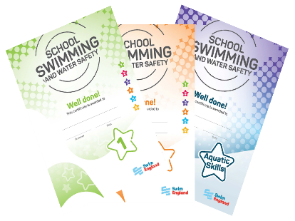 | - Gain exclusive access to an extensive set of resources and advice to help improve lesson quality and impact.  - Receive regular updates, tips and news to keep your lessons fun and exciting.  - Get a package of printed* resources each year, to help reward and recognise pupil achievement (*exclusive to schools).
“This is just what schools and swimming teachers have been waiting for. These resources will help us with planning and assessing school swimming lessons. The Charter goes a long way to addressing the challenges of teaching school pupils, some of whom may well be total non-swimmers and may only be in the water for a few weeks every couple of years.”
M.B – Swim Teacher, Cheltenham.
You can find out more about the charter, and how to sign up here: https://www.swimming.org/schools/school-swimming-water-safety-charter/
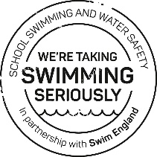
Becoming a School Swimming and Water Safety Charter School costs just £36 including VAT.

Can the premium be used to train teachers and other members of the school to help deliver swimming and water safety lessons?

Yes. Swimming lessons can be radically improved by providing additional swimming teachers. This reduces ratios and in turn improves quality by allowing for more individual communication and feedback during lessons. Reducing teaching ratios and improving quality will see significant improvements in pupil attainment levels.

Swim England provide Level 1 and Level 2 Swimming Teaching qualifications endorsed by CIMSPA - the professional development body for the UK’s sport and physical activity sector.

Swim England’s National Curriculum Training Programme for primary school staff is a specialised training package to support school staff by equipping you with the skills and knowledge to deliver high quality school swimming lessons to make sure your school not only meets but exceeds the national curriculum requirements.

Specialist swimming teachers can also be funded to enhance delivery of lessons and provide additional opportunities by working alongside primary school teachers and teaching assistants. Specialist swimming teachers can create sustainable change by upskilling the school workforce to support delivery of high quality lessons.

How can the premium be used to support pupils not meeting national curriculum expectations?
Some pupils may not be able to meet national curriculum expectations after swimming and water safety lessons in core PE. The premium can be used for Top-up Swimming. This is an intervention designed to provide additional help to those pupils who would benefit from extra support, enabling every child to achieve the key stage 2 standard in swimming and water safety at primary school.
The inability to float on either the front or the back, or travel 10 metres after ten lessons, is a useful indication that a pupil needs additional support to meet the minimum expectations.
It’s important to have a general idea of the likely number of pupils as early as possible in the year, or to identify the pupils who are struggling to be proficient swimmers in Year 5.

Early identification of pupils who need extra support to develop their skills further is very useful and may well have cost advantages to schools. Booking additional time in advance for a block period may mean pool operators are more willing to offer their facilities at a lower price.

Many schools hold their Top-up lessons during or very close to the last two weeks of the summer term. A good time to target Year 6 pupils is after the national curriculum assessments (SAT’s). If your school is planning to run Top-up lessons during the second part of the summer term, a decision on pupils should be made by the start of May.

Some schools identify pupils who won’t meet the minimum outcomes on a rolling process, offering Top-up lessons after each term.

The premium may not be used to deliver core swimming and water safety lessons.
Can the premium be used to provide a broader experience of swimming and water safety activities in school?
Yes. Schools can use premium funding to provide additional opportunities for pupils to take part in new activities, such as synchronised swimming, lifesaving or water polo. The premium can also be used to support events and challenges, such as swimming galas, Big School Swim, Swimathon or Swim Safe sessions.

What are schools required to report on for swimming and water safety?

As part of the accountability requirements for the PE and Sport Premium, schools are required to publish the swimming and water safety attainment levels of your current Year 6 cohort. This should be published on your school website and should state what percentage of pupils meet the national curriculum swimming and water safety requirements. The reporting deadline is the end of the summer term or by the 31st July 2020 at the latest.

A reporting template is available at the Association for Physical Education’s website. This template helps schools to provide the information required on the use of their premium and swimming and water safety attainment of pupils.

For more information about the PE and Sport Premium, including how it is calculated and when it is granted, visit the Department for Education website.

