Two Clocks
Sam has a rather odd clock at home.
In Sam's bedroom there is an old alarm clock which his Dad had thrown out because it had lost its minute hand. Although it has only its small hand, Sam can still tell the time using it. He can tell the hour, such as midday. He can tell when it is time to get up, time to go to school and time to turn his light out at night.
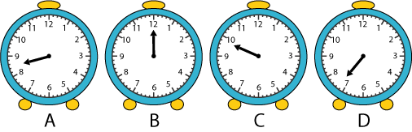
Which clock is showing it is midday?
At what time does Sam get up?
At what time does Sam go to school?
At what time is Sam supposed to turn out his light?

