Chain of Changes
Here is a set of shapes. For this problem we will call them pieces.
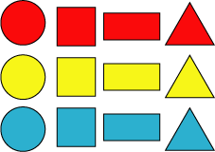
Each of these pieces is either a different colour or a different shape from all the others.

These problems ask you to arrange the pieces in a line so that you change EITHER colour OR shape in the next piece along. If we start with a blue triangle the next shape has to be either another triangle or another blue shape.
Challenge One
The first puzzle is to arrange all the shapes in such a line starting with the blue triangle and ending with the red circle. There are lots of different ways of doing it!

Challenge Two
The second problem is to arrange the pieces in the same way, starting with the blue triangle and ending with the red circle, but to change first colour, then shape or vice-versa.
If you put a yellow triangle after the blue one and so change the colour, next you must put another yellow piece and so change the shape.
You will not be able to use all the pieces in this way but the problem is to see how many you can use.
Why do you think you cannot use all the pieces?

Help Sheet
