Biscuit Decorations

Andrew decorated 20 biscuits to take to a party.
He lined them up and put icing on every second biscuit.
Then he put a cherry on every third biscuit.
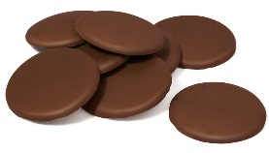
Then he put a chocolate button on every fourth biscuit.
So there was nothing on the first biscuit.
How many other biscuits had no decoration?
Did any biscuits get all three decorations?

