Shape Times Shape
The coloured shapes stand for eleven of the numbers from 0 to 12. Each shape is a different number.
Can you work out what they are from the multiplications below?
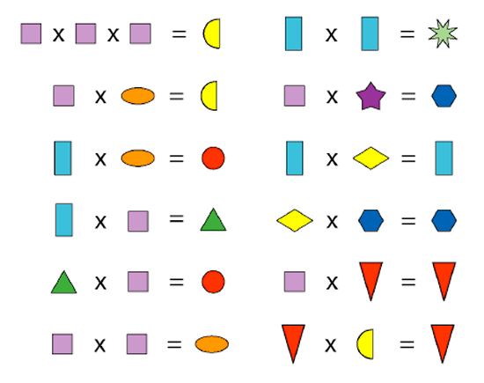
NEED HELP? Only read on if you want help. You can always return to this clue if you are stuck and need a nudge!
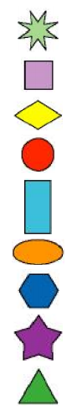
HELPFUL HINT:
Where could you start?
What can you tell from the first multiplication with three purple squares and a yellow semi-circle?
Perhaps you can use what you now know to help you with another calculation?
How will you remember what you have tried and what you have found out?
You could use this shape log to keep a note of what you think the shapes stand for.

