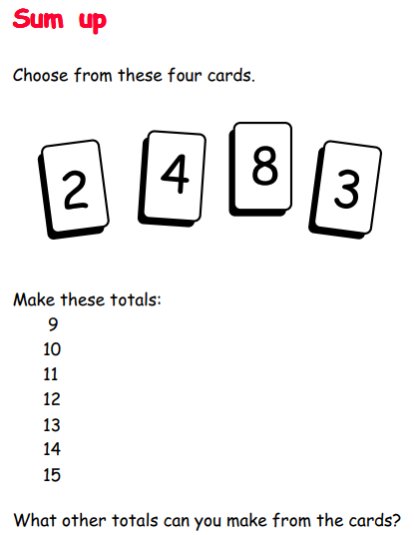
This could be a bit tricky. You might like to try different combinations of the numbers and see which totals you get rather than starting with the totals.
Would using numicon help? You could cut these out…
