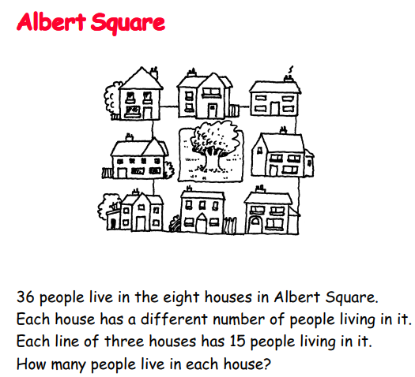
I love this puzzle BUT it is quite tricky to solve.
Top tip: Think carefully about the total of the three houses vertically and horizontally. Perhaps cut up number cards so you can move them around.

