Earth Day-Celebrating 50 years
22nd April 2020
As it is the 50th anniversary of Earth Day when people all around the world stop and think of our precious planet, come together to find solutions to make our living more sustainable and appreciate the beauty of nature surrounding us.
We thought you might like to have a go at some of these activities today.
History of earth day –  What is Earth Day and how did it start?  https://www.youtube.com/watch?v=6WA8FpGI5Sw&feature=emb_rel_pause | KS2 Art project  Every year NASA designs an Earth Day poster. This year they have used images of a river delta from space to create an image of a tree (see video link of a hippy artist!)  https://www.youtube.com/watch?v=rfirRx1zm_0  Examples of deltas:  https://science.nasa.gov/science-pink/s3fs-public/atoms/files/EarthDay2020.pdf  Use these images and try make your own poster for Earth Day. | Feed the birds  Make a bird feeder out of recycled materials  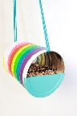  ( attached instructions to make a plastic bottle feeder) | Save water  Design a water saving device  Or design a poster that advises others on top water saving tips. | Listen to music  Earth by Hans Zimmer  https://www.bbc.co.uk/teach/ten-pieces/classical-music-hans-zimmer-earth/zh4k382
Be a civil engineer and investigate:  Wind power  https://www.youtube.com/watch?v=OMn4Sza2px8  Make a wind turbine  Plastic bottle idea  https://www.youtube.com/watch?v=NE6DKwU2df4 | STEM projects  https://practicalaction.org/schools/  This website has loads of projects that are about the environment.  Why don’t you make a Floating garden, or Regreen the desert or take the Squashed tomato challenge. | Appreciate nature  Do an Earth Day scavenger hunt.  Or  Cloud watch  Or make a nature collage in the shape of Earth. | Make a Planet Pledge  Think about small acts you can do to help protect the planet.  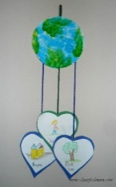  *Create an earth mobile  *Pledge tree  * Give me 5  * Be creative  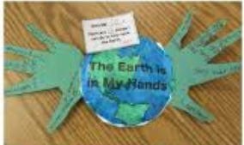 | How far does your food travel?  Investigate food packaging. Using a map, locate the country where your food was produced. Calculate the food miles travelled.  Is there a way you could make some food swaps to save food miles?  Useful website:  www.climatechangeconnection.org/ food print
Make a board game  Design and make a board game to teach others about Earth day and what they can do to help the planet.  (Templates provided if you need them) | Switch OFF challenge  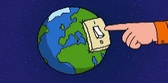  As a family decide to switch off all your devices and lights for an hour or even longer. | Ecological Handprint  Find out what your ecological handprint: thinking about what actions you already take and actions that you could do in future.  www.climatechangeconnection.org | Watch a documentary  Watch an episode of David Attenborough’s  Blue Planet or Seven Worlds One Planet and marvel at the beauty of creation and why we need to look after it. | You CHOOSE!!!  Find a way to make your Earth Day Celebration memorable and let us know what you did to mark the occasion.

