Representing Diversity in our Reading Curriculum

At Mortimer Primary, we promote tolerance and understanding through our use of quality books. We have a Diversity Collection which staff are encouraged to share with children in their class. We strive to show children what diversity looks like, and also expose them to texts that reflect their own realities.
Parents and carers are welcome to borrow books from the collection, to share with their children at home. Please speak to your child’s class teacher if there are any books you would like to read or if you have any recommendations for us to add to our collection.

Name | Author | Theme | Cover
Can You See Me? | Libby Scott and Rebecca Westcott | Disability - Autism | 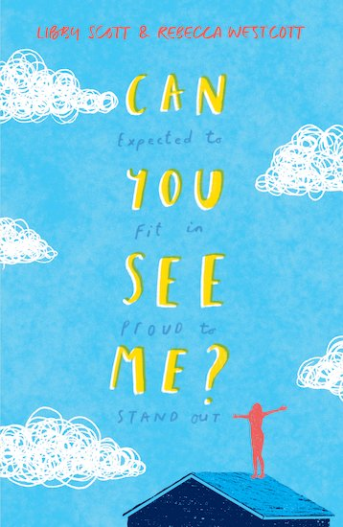
The London Eye Mystery | Siobhan Dowd | Disability - Asperger’s Syndrome | 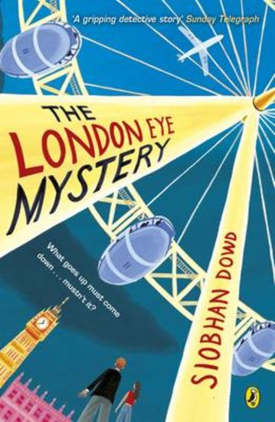
The Goldfish Boy | Lisa Thompson | Disability - OCD | 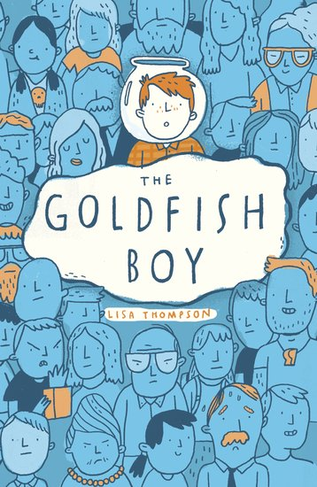
A life story: Stephen Hawking | Nikki Sheehan | Disability - Motor Neurone Disease | 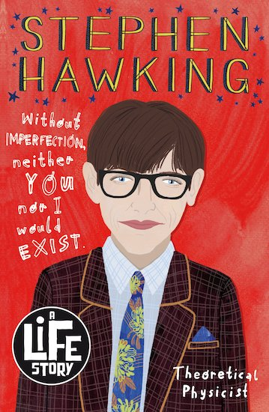
Wonder | R. J. Palacio | Disability | 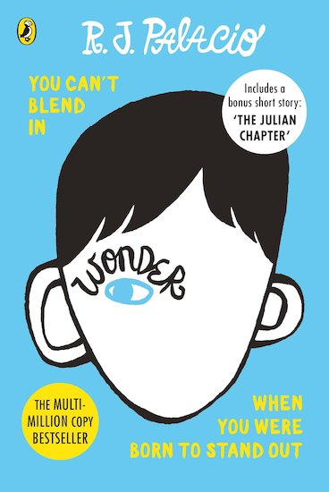
What stars are made of | Sarah Allen | Disability - Turner Syndrome | 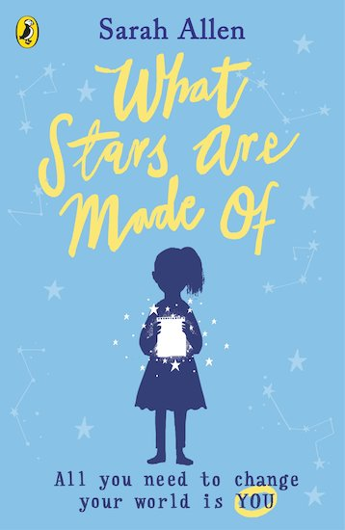
The boy at the back of the class | Onjali Q. Rauf | Refugees | 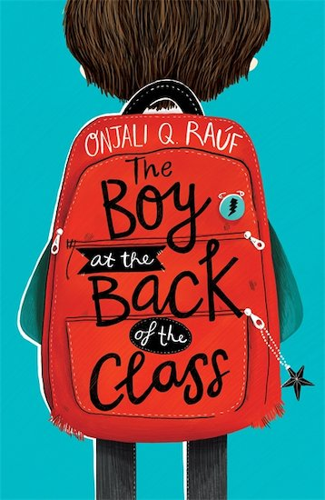
My Name is not Refugee | Kate Milner | BAME  Refugees | 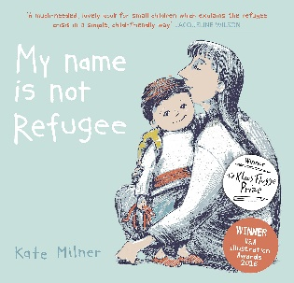
Julian is a Mermaid | Jessica Love | LGBTQ+ | 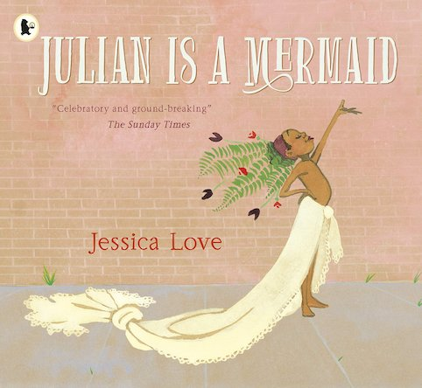
Amazing Grace | Mary Hoff | Gender  BAME | 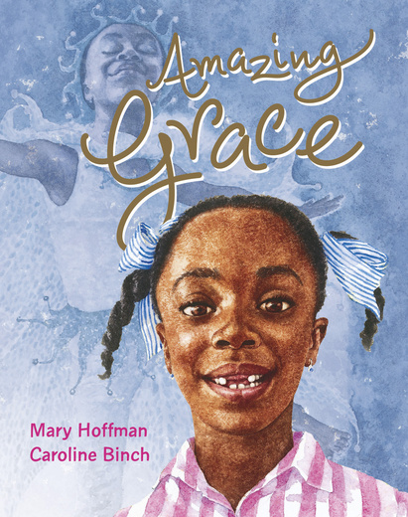
The Story of Afro Hair | K. M. Chimbiri | BAME | 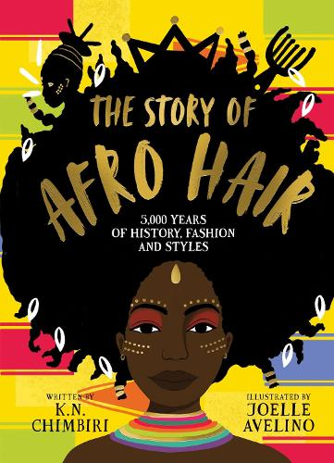
Little Leaders: Bold Women in Black History | Vashti Harrison | BAME  LGBTQ+ | 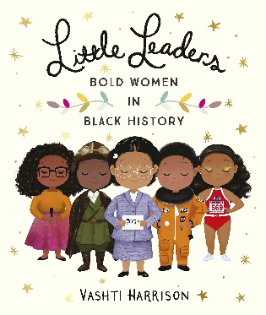
Little Leaders: Bold Men in Black History | Vashti Harrison | BAME  LGBTQ+ | 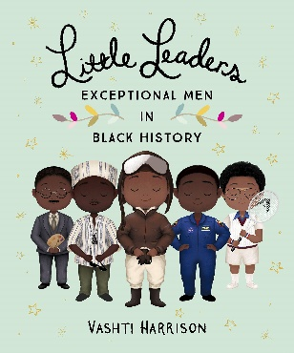
Young, Gifted and Black | Jamia Wilson | BAME | 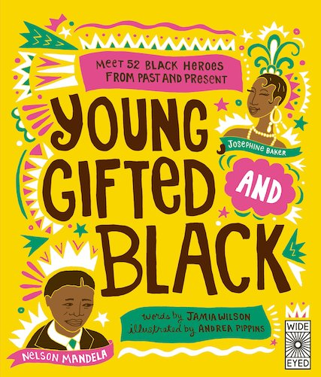
The Mega Magic Hair Swap | Rochelle Humes | BAME | 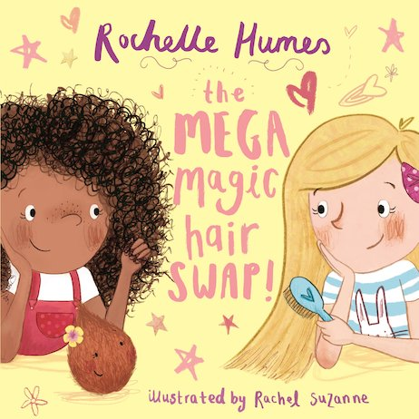
The Proudest Blue | Ibtihaj Muhammad | BAME | 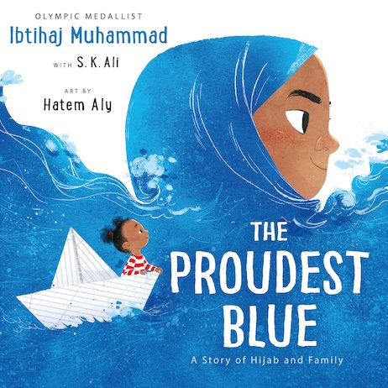
Little Heroes of Colour: 50 who made a BIG difference | David Heredia | BAME | 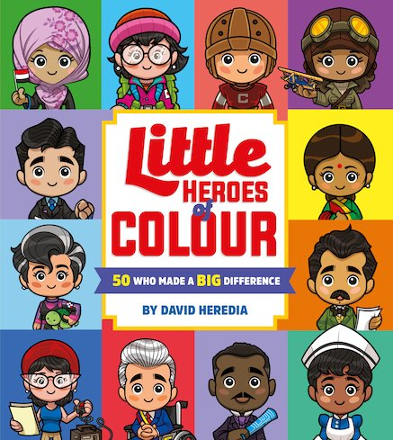
Windrush Child | Benjamin Zepheniah | BAME | 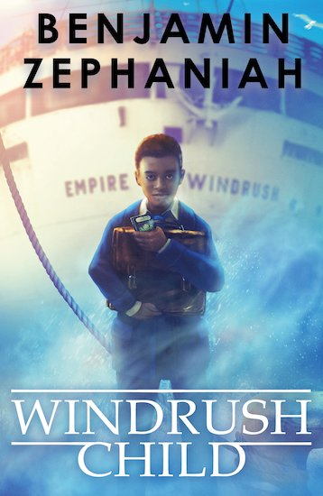
The Story of the Windrush | K. N. Cimbiri | BAME | 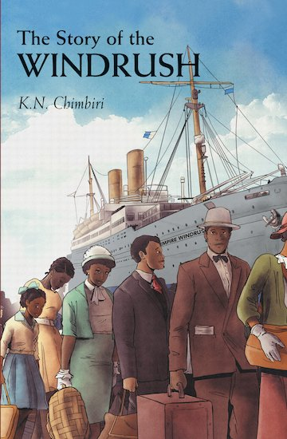
Stand Up Stand Out | Kay Woodward | BAME  Diversity  Challenging gender norms | 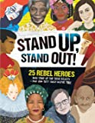
Fantastically Great Women who Changed the World | Kate Pankurst | BAME  Challenging gender norms | 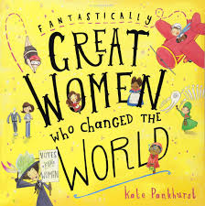
What would she do? Real-life stories of rebel women who changed the world | Kay Woodward | Challenging gender norms  LGBTQ+  BAME | 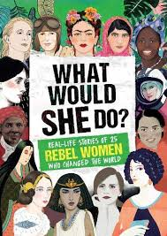
Fabulous Frankie | Simon James Green | LGBTQ+  Challenging gender norms | 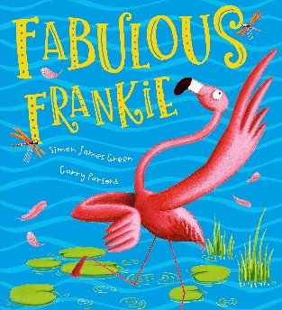
Grandad’s Camper |  | LGBTQ+ | 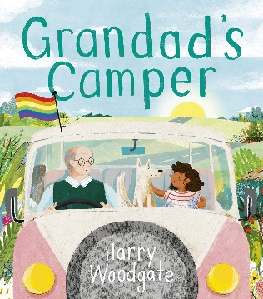
My Mums Love Me | Anna Membrino | LGBTQ+ | 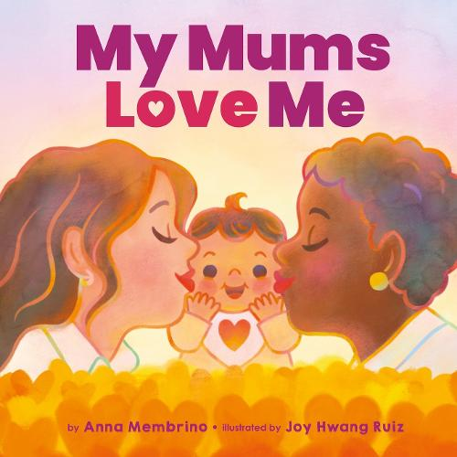
My Daddies! | Gareth Peter | LGBTQ+ | 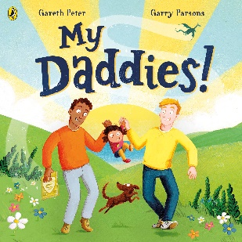
Stories for Boys who Dare to be Different | Ben Brooks | LGBTQ+  Challenging gender norms  BAME | 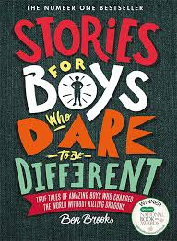
The Boy who Fooled the World | Lisa Thompson | Poverty | 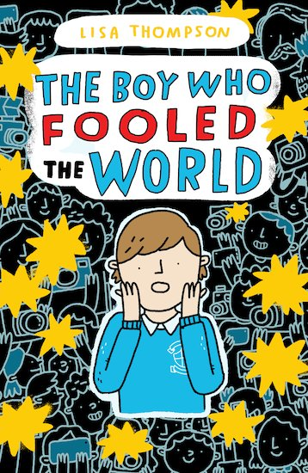
A Life Story: Alan Turing | Joanna Nadin | LGBTQ+ | 