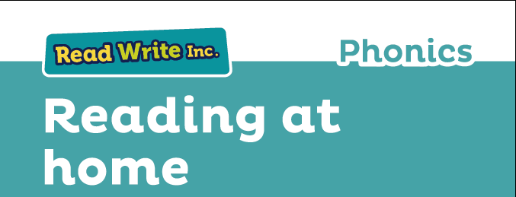

Glossary
Fred Talk – sounding out the word before reading (blending)

sound-blending – putting sounds together to make a word,
e.g. c–a–t cat

special friends – sounds written with more than one letter,
  - sh, ng, qu, ch

Speed Sounds – the individual sounds that make up words

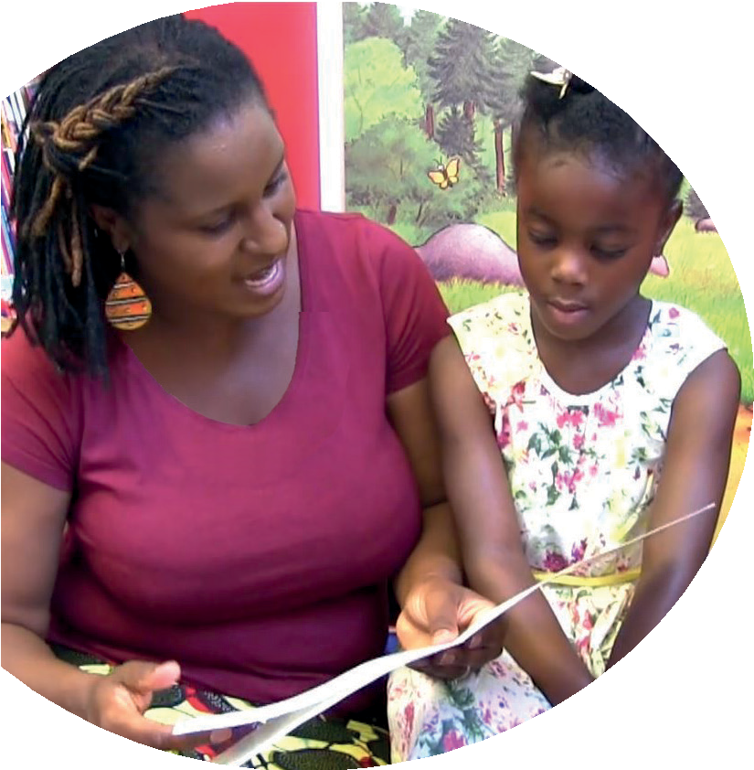
Read stories to your child with feeling! The more you love the story, the more your child will love reading.

This booklet tells you how to help your child:
- read Speed Sounds
- blend sounds into words
- read the Blending Books
- read the Read Write Inc. Storybooks.

Your child is learning to read with Read Write Inc. Phonics, a very popular and successful literacy programme. This booklet shows you how you can get your child off to a quick start.
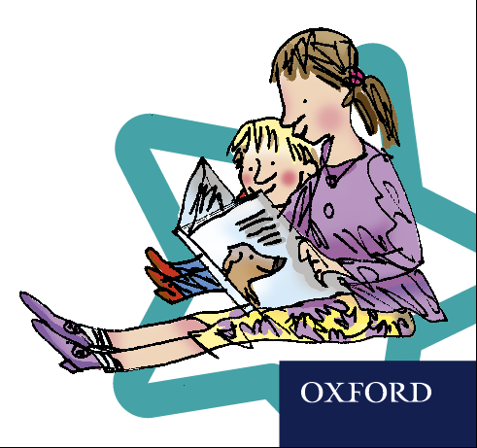
Your child will learn to read in a very simple way. He or she will learn to:
- Read letters by their ‘sounds’

Blend these sounds into words
- Read the words in a story.

www.ruthmiskin.com/parents has many videos to help you help your child.


For more information on Read Write Inc., please talk to the Read Write Inc. manager in your child’s school or visit www.readwriteinc.com.

8

1

How to listen to your child read
How will my child learn to read?

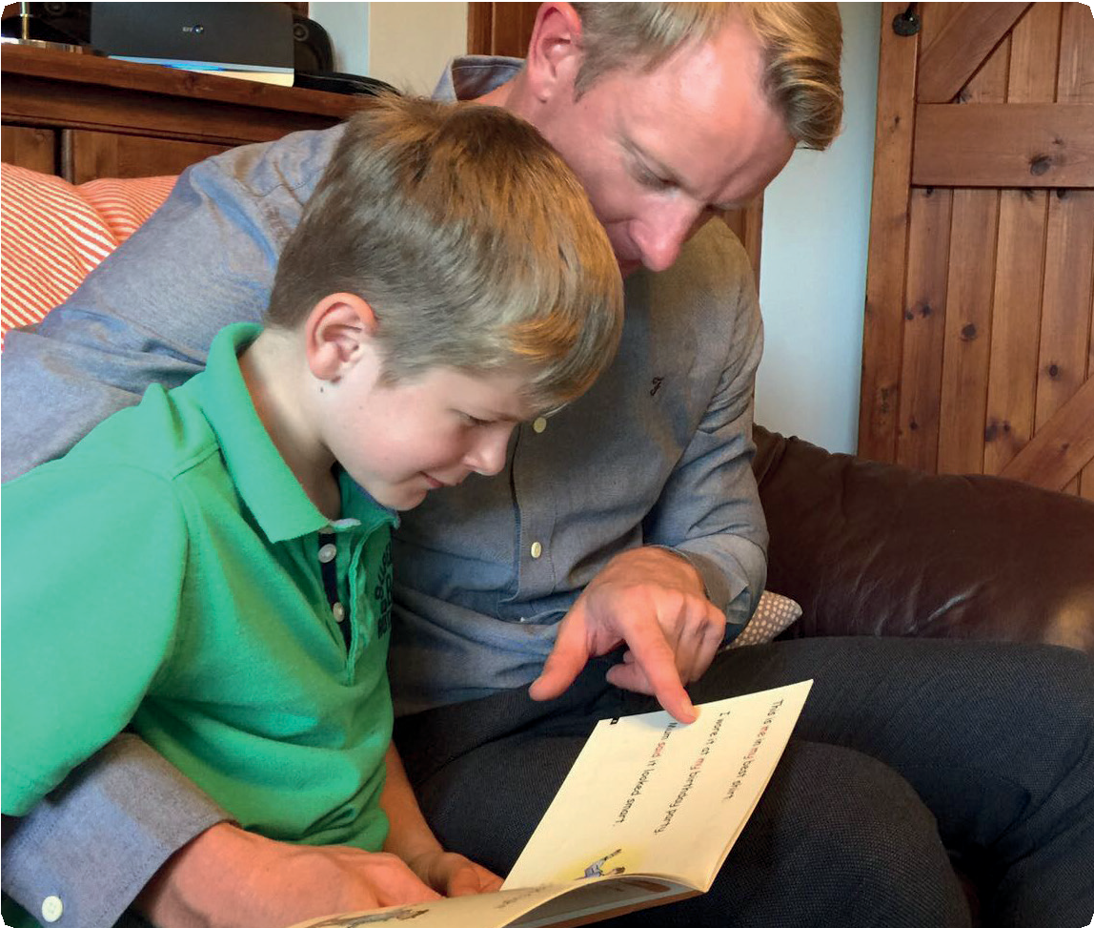
First, your child will learn to read:
- Set 1 Speed Sounds: these are sounds written with one letter:
m a s d t i n p g o c k u b f e l h r j v
y w z x and sounds written with two letters • (your child will call these ‘special friends’): sh th ch
qu ng nk ck
- Words containing these sounds, by sound-blending,
e.g. m–a–t mat, c–a–t cat, g–o–t got, f–i–sh ﬁsh,
s–p–o–t spot, b–e–s–t best, s–p–l–a–sh splash
- Blending Books and Red, Green and Purple Storybooks.

- Do not read the book aloud before your child reads it to you.
- Ask your child to read the sounds and words before he or she reads the story.
- When your child reads the story, ask him or her to sound out
- the words that he or she can’t read automatically. Don’t allow your child to struggle too much. Praise your child when he or
she succeeds.
- Read back each sentence or page to keep the plot moving. (Your child’s energy is going into reading the words not the story.)
- Do not ask your child to guess the word by using the pictures.
- Do it all with patience and love!
Second, he or she will learn to read:
- Set 2 Speed Sounds: ay ee igh ow oo oo ar or air ir ou oy
- Words containing these sounds
- Pink, Orange and Yellow Storybooks.

Third, he or she will learn to read:
- Set 3 Speed Sounds: ea oi a-e i-e o-e u-e aw are ur er ow ai oa ew ire ear ure
- Words containing these sounds
- Blue and Grey Storybooks.

We have a storytime every day at school so children develop a love of stories. We hope that you will do the same by reading a bedtime story to your child every night. We have wonderful books in school for you to borrow.
Your child will be taught to say the sound for the letter and not the letter name, so ‘m’ as in ‘mat’, not ‘em’;
‘s’ as in ‘sun’ not ‘es’.

Library Books

Our pupils visit the school library regularly. They will be given the opportunity to browse the books and take home either a fiction or non-fiction book of their choice.

These books are not reading-scheme books are therefore not matched to your child’s phonic knowledge or reading ability. They are chosen purely based on your child’s reading interests. This is an incredibly important part of developing our pupil’s love of reading.

Library books have a sticker on the front cover with the words ‘Let’s read together!’ These books are for children to enjoy with an adult at home. You will likely need to read the majority of words to your child. You can involve them by asking them to join where they can, telling you about the pictures or talking about the story.

Bedtime Story Backpacks

Each week, one child from each EYFS and Key Stage 1 class will be given a bedtime story backpack to take home for the weekend. Inside you will find a book or two to enjoy with your child, a cuddly friend to cosy up to and a suppertime treat. Make the most of reading together and make sharing a story a special part of your daily routine.


1. Help your child read the Set 1 Speed Sounds
Before you get going, visit www.ruthmiskin.com/parents to practise saying the sounds clearly. The more clearly you say the sounds, the more quickly your child will learn them.

Important: We say ‘mmmm’ not ‘muh’ and ‘lllll’ not ‘luh’ when teaching the sounds. This really helps children when they learn to blend sounds together to read words.

Your child will bring home a copy of My Set 1 Speed Sounds Book.
You’ll see that each sound is drawn in the shape of a picture. For example:
- ‘s’ is in the shape of a snake
- ‘d’ is in the shape of a dinosaur
- ‘a’ is in the shape of an apple
- ‘m’ is in the shape of two mountains.
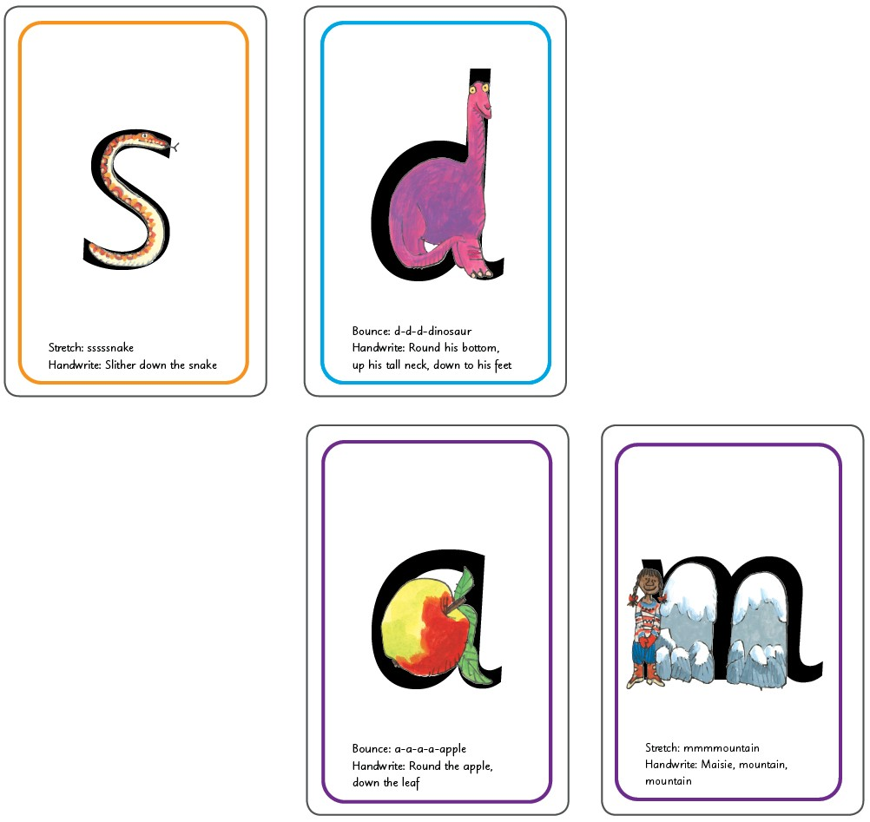

2. Help your child to blend
At school, we used Fred to help children recognise the sounds they hear and blend them together.
You can help your child to read words by playing Fred Talk games:

Fred says…
- Say: Fred says put your hands on your h-e-d. Ask children to repeat. Pause to allow children to jump in with the whole word and do the action.
- Say h-e-d. Ask children to repeat.
Repeat with b-a-k, t-u-m, l-e-g, h-a-n-d, f-oo-t, n-ee, r-u-n,
s-k-i-p, h-o-p, s-t-o-p.

Fred I Spy…
Say: Fred says, “I spy something r-e-d.” Ask children to repeat. Pause to allow children to ‘jump-in’ with the whole word and point to something red.
Say: r-e-d, red. Ask children to repeat.
Repeat with b-l-oo, g-r-ee-n, b-l-a-k, b-r-ow-n.

Fred’s House
Say: Fred has found some items from different parts of the house, What did he find?

Food cupboard: t-i-n, s-oo-p. b-ee-n-s, b-r-e-d, c-ay-k
Fridge: m-i-l-k, j-oo-s, c-r-ee-m, e-g-s, c-or-n, p-air, p-ee-z, l-ee-k
Bedroom: b-e-d, r-u-g, b-oo-k, m-a-t, l-a-m-p, l-igh-t
Wardrobe: s-c-ar-f, h-a-t, s-o-c-s, sh-or-t-s, d-r-e-ss, s-k-ir-t
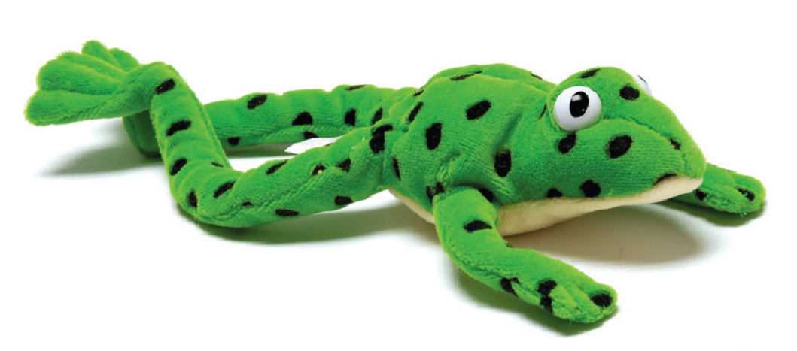

Help your child read the Sound Blending Books
Ask your child to read each word in sounds (Fred Talk) and then say the word. Then, he or she can turn over and check if they’re right.

Help your child read the Storybooks

Black and White Storybooks
As soon as your child starts to read the Read Write Inc. Phonics Storybooks, he or she will bring home a black and white Storybook. This is a copy of the colour version he or she will have read at school.
Your child will have read this story three times with their reading teacher, so should be able to read the story conﬁdently.
A brief explanation of how to follow the activities is included in the books.

Book Bag Books
Your child may also bring home a Book Bag Book. This book builds upon the ideas and many of the words in the Storybook he or she has just read. Your child will need more support in reading this book.
Again, explanations of how to use the activities are included in the books.

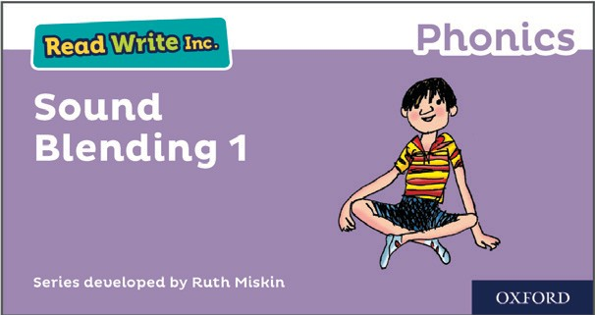

Fred says

