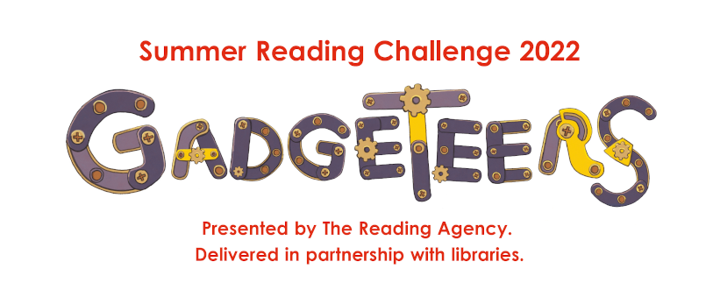

**Come and join in the Summer Reading Challenge at all our libraries.**

**There are lots of fun activities, rewards and … books**

**Science Circus**

**Wednesday 27 July, Jarrow Focus Library 11:00am-12:00pm and 2:00pm-3:00pm**

Ever wanted to know how you balance a chair on your chin, if you can juggle liquid, or how circus performers juggle with custard? StrongWomen Aoife and Maria reveal the scientific secrets behind their astounding tricks. In a fun, lively and fast-paced family circus performance, find out how jugglers, acrobats and hula hoop artists use science to create their amazing acts.

StrongWomen Science doesn’t only illustrate scientific facts. It seeks to promote enquiry, inventiveness and accessibility in science, making it open to all, in particular young women and girls. In addition to demonstrating scientific principles in fun and accessible ways, it looks at the worth of failure and the power of teamwork, both shared by science and circus

Places are bookable £2 per person, suitable for all ages

For more details: <https://www.southtyneside.gov.uk/article/76012/Science-Circus>

**Tell me a story**

**Wednesday 3 August, The Word 10:30am-11:30am & 2:00pm-3:00pm**

Nori Novelly is a famous author...WAS a famous author! For the past year they just haven't been able to decide on a good idea for a story. Nori's head is such a jumble of weird and wonderful things that they just can't put pen to paper and decide on one. Perhaps you could help? An introduction to story making! These fun and interactive workshops are delivered through facilitator in role and are designed to unleash a child’s imagination through a range of improvisation, devising and writing exercises. Explore character creation, setting and decision making. Children will be left bursting to write their own stories.

Suitable for 7-11year olds and children’s grown-ups to stay in the building whilst the session is happening. Places are bookable at £2 per person. For more details: <https://www.southtyneside.gov.uk/article/76013/Tell-Me-a-Story>

**Big Science sessions:**

**Wednesday 10 August - Jarrow Focus Library 10:30am-11:30am**

**Thursday 11 August - Hebburn Central Library 10:30am-11:30am**

**Tuesday 16 August - Cleadon Park Library 10:30am-11:30am**

**Saturday 27 August - The Word 1:30pm-2:30pm**

Come and join Big Science for an hour of fun, hands on science experiments. Every child will carry out their own fizzing, popping and colour changing reactions. There will also be some Big Science demonstrations making science look like magic, as well as getting things to fly. The sessions are designed for children aged 5 to 11 years old.

If your child is between 3- 4 years old they are welcome to attend and participate with help from their grown-up. Places are bookable at £2 per person. For more details: <https://www.southtyneside.gov.uk/article/76014/Big-Science>

**Free sessions**

**Grand Constructions: Herd Groyne Lighthouse**

**Monday 15 August at The Word 10:30am-12:00pm and 1:30pm-3pm**

Get crafting and start building a paper model of the iconic Herd Groyne Lighthouse in South Shields with Cabinet of Curiosity Studio.  All materials will be provided, including a paper toy-making kit specially designed by Cabinet of Curiosity Studio, to help participants explore the architectural and industrial grand constructions of the Northeast! At the end of the session, you will be the proud owner of your own paper toy version of the Groyne that you can take home. Family activity suitable for ages 6+. Children must be accompanied by adults.

**Arts and Crafts sessions: Come along and have a play with Air-Dry Clay.**

Monday 25th July: Jarrow Focus Library 10:30am-11:30am

Wednesday 27th July: Cleadon Park Library 10:00am-12:00pm

Tuesday 2nd August: Hebburn Central Library 2:00pm-3:00pm

Thursday 11th August: The Word 10:30am-12:30pm

**Arts and Crafts sessions: Have a go at Making a Roman Standard Bearer**

Wednesday 10th August: Cleadon Park Library 10:00am-12:00pm

Monday 15th August: Jarrow Focus Library 10:30am-11:30am

Tuesday 16th August: Hebburn Central Library 2:00pm-3:00pm

Thursday 25th August: The Word 10:30am-12:30pm

**Lego Time Drop-In Sessions 10:00am-4:00pm: Free and first come basis**

Cleadon Park Library - 26th & 29th July, 2nd, 5th, 9th, 12th, 17th, 19th, 23rd, 26th & 31st August and 2nd September

Jarrow Focus Library - 27th & 29th July, 3rd, 5th, 8th, 12th, 17th, 19th, 24th, 26th & 31st August

and 2nd September

Hebburn Central Library - 25th & 28th July, 1st, 4th, 8th, 12th, 15th, 18th, 22nd, 25th & 30th August

and 1st September

The Word - 25th & 27th July, 1st, 4th, 8th, 10th, 17th, 22nd, 24th & 31st August and 2nd September

**Family Drawing Workshop**

Come and learn the skills to create your own documentary drawings of life in the area. You will channel your creativity to create a series of images. Somewhere between an artist and a private detective, you will chase down leads, learn drawing tips and explore what makes South Tyneside special. No drawing experience required! To find out more or to book your free place at <https://theworduk.org/whats-on/south-tyneside-scribe-family-drawing-workshop/>

Monday 22nd August - Jarrow Focus Library 10:30am-12:00pm

Tuesday 23rd August - Hebburn Central Library 2:00pm-3.30pm

Wednesday 24th August - Cleadon Park Library 10:30am-12:00pm

Thursday 25th August - The Word 1:00pm-2.30pm

