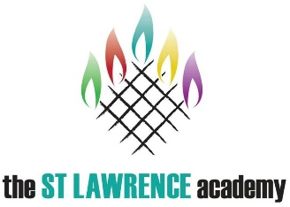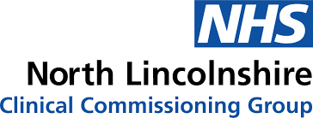
Dear Parent/Carer
www.Kooth.com 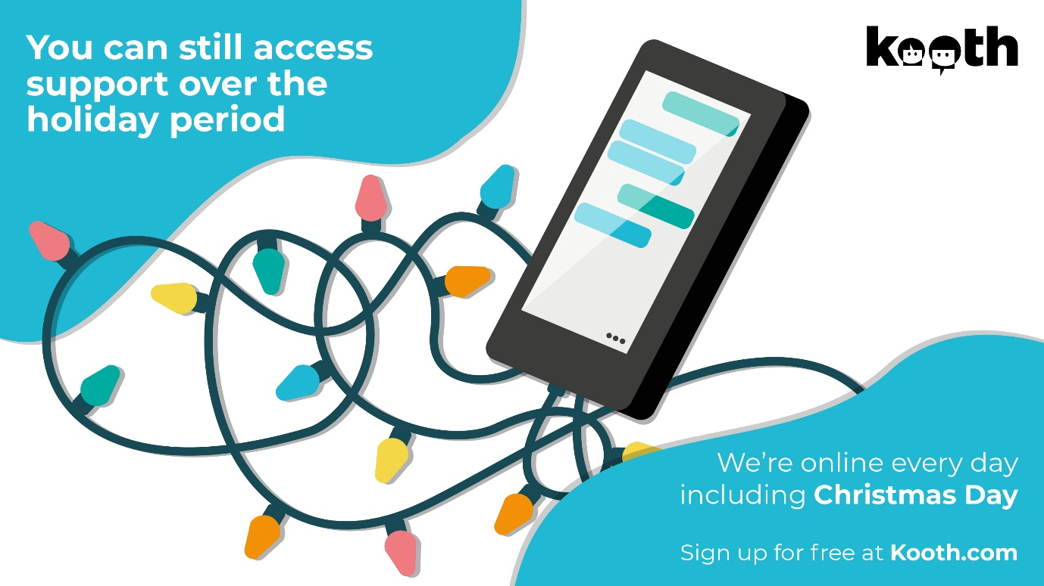
With the Festive period approaching we are writing to inform you that Kooth.com, a free, safe and confidential way for young people to receive counselling, support and advice online, will still be accessible over the break from school. We know that there are times when life can feel like a struggle and some extra support can be needed. Recognising this, Kooth has been commissioned by North Lincolnshire NHS Clinical Commissioning Group to provide support for young people aged 11- 25, who live within North Lincolnshire.
Kooth is accessible 24/7 365 days of the year and provides access to quality counselling from BACP or UKCP accredited counselling professionals via a text based format from 12noon to 10pm on weekdays, and 6pm-10pm on weekends, providing a much needed ‘out of hours’ service. Kooth is accessible from any device that can access the Internet, allowing young people to seek help and support at a time and location that is suitable for them.
In addition to the counselling, Kooth provides a fantastic, safe place for peer to peer support through forums where all contributions are moderated before being posted. Young people can also access the Magazine and Articles section where they can read approved content from individuals in similar situations to their own or even write their own articles.
Kooth is not a replacement for any in person support for a young person; rather it is an additional means of accessing further support.

