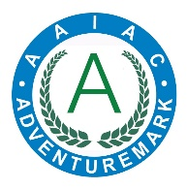
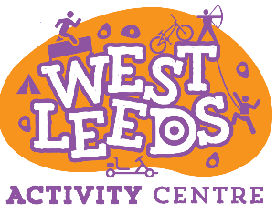
Short Breaks Club
Booking Form – February 2022

Lenhurst Ave, Armley
Leeds LS12 2RE
0113 3367414
westleedsactivitycentre@leeds.gov.uk
Child Name(s) :
Date of Birth:
Full Address and Postcode:

Email Address:
please write clearly
Phone Number: |  | Mobile Number:

I wish to request the following dates (please tick relevant boxes):
Tuesday 22nd Feb, 9:30am to 3:30pm
Wednesday 23rd Feb 9:30am-3:30pm
Does your child have any allergies or dietary requirements? |  |  |  |  | Yes No
If Yes, please provide details

The cost of the holiday club is £22 per child per day and consists of 2 activity sessions with a break for lunch and snacks (all food is provided).

Payment can be made by BACS transfer, Cash or Cheque on the day of your booking.
Please tick your preferred method of payment

BACS Cash Cheque Cheques made payable to ‘Leeds City Council’

Our preferred method of payment is by BACS.
For payment by BACS transfer, please use the following reference: 31151 / 973 / 007
Account number – 00000000 Sort Code 57-12-72
Cheques made payable to ‘Leeds City Council’

Please sign and date the form to accept the terms & condition below.

Signed (parent/guardian): Date:

How do you know about West Leeds Activity Centre? (Please Tick)
Website ☐ Facebook ☐ Twitter ☐ Instagram ☐ School ☐

School ☐ Leeds City Council ☐ Leeds for Learning ☐ Friends and Family ☐

Always known about it ☐ Other Promotional material please name -

Please tick this box if you DO NOT wish to be contacted on future events and activities

Please return this form along on with the completed consent form via email to westleedsactivitycentre@leeds.gov.uk or via post to the West Leeds Activity Centre, Lenhurst Ave, Armley, Leeds LS12 2RE

Terms and Conditions of booking – Please retain this information for your records
Full payment is required by the date of the holiday club; this is non-refundable except in extreme circumstances – the centre manager/assistant centre manager decision is final.
Our centre will make every effort to be flexible with your bookings; however, as we are in high demand, we do operate a cancellation policy. Cancellation of any Holiday Club Booking must be made in writing and shall be subject to the following cancellation fees –
(i) Between 1-3 months before the date of the Holiday Club Booking: 20% charge + vat
(ii) Between 2 weeks and 1 month before the date of the Holiday Club Booking: 50% charge + vat
(iii) Less than two weeks before the date of the Holiday Club Booking: 100% charge + vat
Payment is by cash or cheque or BACS
You must provide the name of anyone who is going to collect your son/daughter. If there is a potential of a different named person collecting your son/daughter, you will need to contact the centre immediately to obtain a code, this is for safeguarding/child protection purposes.
Time of pick up must be strictly adhered to by 3.30pm. We reserve the right to charge an extra fee if you pick up your son/daughter 15mins later than the designated time.
Drop off must not be after 10am if your child is just taking part in activities.
If your child is sick, they must not attend the sessions they are booked on until 48hours after the sickness has finished.
You or someone you trust must be available/contactable to collect your son/daughter if they become unwell or the team deem their behaviour to be unacceptable enough for them to remain on site.
Your son/daughter must be sent with appropriate clothes and footwear, we do not have any items to loan.

