 | 16+ Home Learning  Week beginning 8th March 2021  Careers Week 2021 |  | 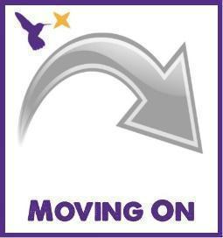
Classes in each pathway: Falcon, Lapwing, Curlew & Osprey
Maths activities |  | English activities
Level 1 & 2:  Complete the Level 1 & 2 online maths activities:  - GCSE Bitesize:  https://www.bbc.co.uk/bitesize/examspecs/z8sg6fr  - BBC Bitesize: https://www.bbc.co.uk/bitesize/subjects/zqhs34j  - BBC Bitesize: Functional Maths https://www.bbc.co.uk/bitesize/subjects/zjd8jty  - CGP Maths Online 10-Minute Tests: https://www.cgpbooks.co.uk/resources/cgp-s-free-online-10-minute-tests/free-gcse-maths-online-10-minute-tests  Level 1: Foundation  Level 2: Higher  - Maths Made Easy: https://mathsmadeeasy.co.uk/gcse-maths-revision/gcse-maths-online-tests/  - Education Quizzes: https://www.educationquizzes.com/gcse/maths/  Level 1: (f) questions  Level 2: (h) questions  - GCSE Maths Quizzes:  https://math-quiz.co.uk/gcse-maths  - GCSE Maths Revision:  https://www.bbc.co.uk/bitesize/examspecs/z9p3mnb  - Mathletics:  https://login.mathletics.com/  (Your teacher will Dojo your username and password) |  | Level 1 & 2:  Complete the Level 1 & 2 online English activities:  - GCSE Bitesize – Grammar:  https://www.bbc.co.uk/bitesize/guides/zyrn9qt/test  - BBC Bitesize: Functional English  https://www.bbc.co.uk/bitesize/subjects/zmqj2nb  - BBC Bitesize: Grammar & Punctuation  https://www.bbc.co.uk/bitesize/topics/z7vdy9q  - BBC Bitesize: Non-Fiction Texts  https://www.bbc.co.uk/bitesize/topics/zjfkscw  - BBC Bitesize: Reading Skills  https://www.bbc.co.uk/bitesize/topics/zs8nv4j  - BBC Bitesize: Writing Skills  https://www.bbc.co.uk/bitesize/topics/zywfbk7  - CGP Functional Skills English Online 10-Minute Tests: https://www.cgpbooks.co.uk/resources/cgp-s-free-online-10-minute-tests/free-functional-skills-english-online-10-minute-te  Level 1 and Level 2  - Read a book of your choice independently
Entry Levels:  Complete the Entry Levels online maths activities:  - Shopping with Money:  https://www.topmarks.co.uk/money/toy-shop-money  - Change Game (money):  https://mathsframe.co.uk/en/resources/resource/44/solve_2_step_money_problems_  - Money game:  https://www.topmarks.co.uk/money/coins-game  - Ordering Numbers:  https://www.topmarks.co.uk/ordering-and-sequencing/coconut-ordering  - Education City:  https://www.educationcity.com/  (Your teacher will Dojo your username and password)  - Mathletics:  https://login.mathletics.com/  (Your teacher will Dojo your username and password) |  | Entry Levels:  Complete the Entry Levels online English activities:  - Comic Book Editing:  http://www.scootle.edu.au/ec/viewing/L1275/index.html#  - Nouns:  https://www.childrensuniversity.manchester.ac.uk/learning-activities/languages/words/naming-nouns/  - Adjectives:  https://www.childrensuniversity.manchester.ac.uk/learning-activities/languages/words/adjective-detective/  - Synonyms and Antonyms:  https://www.arcademics.com/games/frog  - Education City:  https://www.educationcity.com/  (Your teacher will Dojo your username and password)  - Read a book of your choice independently or with a family member.
Pre-Entry: Steps 4 Life 4 – 7:  Complete the cooking and baking activities:  - Chelsea Buns: https://www.foodafactoflife.org.uk/recipes/5-11-years/chelsea-buns/  - Mini Ham and Onion Rostis: https://www.foodafactoflife.org.uk/recipes/potatoes/mini-ham-and-onion-rostis/  - Honey Cake:  https://www.foodafactoflife.org.uk/recipes/cereals/honey-cake/  - Cheese and Bacon Muffins:  https://www.foodafactoflife.org.uk/recipes/breakfast/cheese-and-bacon-muffins/  Complete the online maths activities:  - Money game:  https://www.topmarks.co.uk/money/coins-game  - Ordering Numbers:  https://www.topmarks.co.uk/ordering-and-sequencing/coconut-ordering  - Education City:  https://www.educationcity.com/  (Your teacher will Dojo your username and password)  - Mathletics:  https://login.mathletics.com/  (Your teacher will Dojo your username and password) |  | Pre-Entry: Steps 4 Life 4 – 7:  Complete the online English activities:  - Phonics:  https://www.topmarks.co.uk/phonics/balloon-phonics-cvc-game  - Sound Sayer:  https://www.ictgames.com/mobilePage/soundSayer/  - Spelling:  https://ictgames.com/mobilePage/forestPhonics/index.html  - Job Mixer:  https://learnenglishkids.britishcouncil.org/games/job-mixer  - Days of the Week: https://www.freddiesville.com/games/days-of-the-week-memory-game/  - Months of the Year: https://www.mes-games.com/months.php  - Education City:  https://www.educationcity.com/  (Your teacher will Dojo your username and password)  - Read a book of your choice with a family member
Independent Living Skills activities
All Levels:

- Independence Skills Bingo (please see page 5 of this document)
- Functional ICT Choosing Board (please see page 6 of this document)

Level 1 & 2:

Careers in the Private Sector:

- Food, Drink & Hotels: videos and worksheets: https://www.bbc.co.uk/teach/skillswise/private-sector/zkgmkmn

- Retail: videos and worksheets: https://www.bbc.co.uk/teach/skillswise/retail/zbbvxyc

Careers in the Private Sector:

- Nursing & Care: videos and worksheets: https://www.bbc.co.uk/teach/skillswise/nursing-and-care/zv6xkmn

- Environment & Cleaning: videos and worksheets; https://www.bbc.co.uk/teach/skillswise/environment-and-cleaning/zr8ky9q

- Childcare & Teaching: video and worksheets: https://www.bbc.co.uk/teach/skillswise/childcare-and-teaching/zkb36v4

Finding a New Job:

- Videos, worksheets and speaking & listening activities: https://www.bbc.co.uk/teach/skillswise/finding-a-new-job/zmwd382

CV Writing:

- Writing a successful CV: https://barclayslifeskills.com/educators/lessons/cv-skills-lesson-one-writing-a-successful-cv/

Employability – BBC Bitesize videos: https://www.bbc.co.uk/bitesize/topics/zfsycdm/resources/1

NCW 2021 Assembly: https://nationalcareersweek.com/ncw-2021-assemblies/

The NCW Dice Game: https://ncw2020.co.uk/activities/
NCW Skills Building Assemblies: https://hub.skillsbuilder.org/resources/?q=assembly

NCW Skills Builder Short Lessons: https://ncw2020.co.uk/activities/

NCW Key Qualities worksheet: https://ncw2020.co.uk/activities/

Brands Logo Quiz: https://www.kensquiz.co.uk/table-top-quizzes/picture-rounds/logos/

Fire Up Your Future: A collection of inspiring short films about ambition and work that encourages 9 to 14-year-olds to think about what they might do and who they might become.
https://www.bbc.co.uk/teach/class-clips-video/pshe-ks2--ks3-spark-fire-up-your-future/z4q2vk7

Learn a new skill: sewing, knitting, speed typing (https://www.typingtest.com), First Aid, Cook a meal, polish/ shine shoes, tie a tie, read a bus timetable, set an alarm clock

Outside activities:
- Farming activities – planting seeds, decorating plant pots etc.
- Sporting activities – athletics (running, javelin, hurdles etc.), football, netball, rugby
- Scouting activities – orienteering/ geo-caching, knot tying, den building
Entry Levels:

Employability – BBC Bitesize videos: https://www.bbc.co.uk/bitesize/topics/zfsycdm/resources/1

Employability Skills (SEND) video: https://www.youtube.com/watch?v=vGjNI16pxn8&safe=true

What’s my job? Videos: https://www.bbc.co.uk/teach/class-clips-video/pshe-ks1-ks2-what-is-my-job/zrdkt39

What is my job? quiz: https://www.youtube.com/watch?v=-pVyrW_vwaw&safe=true

What is my job? Quiz 2: https://www.youtube.com/watch?v=CQJgGIVM7GA&safe=true

Stories:
When I Grow Up – animated story: https://www.youtube.com/watch?v=hp0h_1ZI_UM&safe=true

NCW 2021 Assembly: https://nationalcareersweek.com/ncw-2021-assemblies/

The NCW Dice Game: https://ncw2020.co.uk/activities/

NCW Skills Building Assemblies: https://hub.skillsbuilder.org/resources/?q=assembly

NCW Skills Builder Short Lessons: https://ncw2020.co.uk/activities/

NCW About Me worksheet: https://ncw2020.co.uk/activities/

NCW Key Qualities worksheet: https://ncw2020.co.uk/activities/

Brand Logo Quiz: https://www.funkidslive.com/quiz/many-logos-can-get-right-logo-trivia-quiz-game/

Dance/ Movement:
- Teamwork: https://www.bbc.co.uk/teach/supermovers/ks2-pshe-teamwork-with-the-super-movers-crew/zkpdvk7

Fire Up Your Future: A collection of inspiring short films about ambition and work that encourages 9 to 14-year-olds to think about what they might do and who they might become.
https://www.bbc.co.uk/teach/class-clips-video/pshe-ks2--ks3-spark-fire-up-your-future/z4q2vk7

Learn a new skill: sewing, knitting, French words, speed typing (https://www.typingtest.com), how to draw (https://www.youtube.com/hashtag/howtodraw), how to play the keyboard/ recorder, photography, First Aid, Bake, Dance, Yoga, fasten a button, tie a tie

Preparing Food:
- Making sandwiches (https://www.bbcgoodfood.com/recipes/collection/sandwich-recipes), making hot drinks, serving peers snacks/ drinks at snack time

Outside activities:
- Farming activities – planting seeds, decorating plant pots etc.
- Sporting activities – athletics (running, javelin, hurdles etc.), football, netball, rugby
- Scouting activities – orienteering/ geo-caching, knot tying, den building
Pre-Entry: Steps 4 Life 4 – 7:

Art:
- Job pictures: https://printablefreecoloring.com/categories/jobs/
- Occupation pictures: https://coloringhome.com/pictures-of-occupations

Music:
- Hard Day’s Night – The Beatles: https://www.youtube.com/watch?v=AMSiHdrHl0g&safe=true
- 9 to 5- Dolly Parton: https://www.youtube.com/watch?v=UbxUSsFXYo4&safe=true
- Got A Job – The Miracles: https://www.youtube.com/watch?v=VJ7GltNmDbg&safe=true
- Let’s Work – Prince: https://www.youtube.com/watch?v=AqHqepF91us&safe=true
- Manic Mondays – The Bangles: https://www.youtube.com/watch?v=SsmVgoXDq2w&safe=true

Preparing Food:
- Baking – fairy cakes (https://www.bbcgoodfood.com/recipes/iced-fairy-cakes), flapjack (https://www.bbcgoodfood.com/recipes/yummy-golden-syrup-flapjacks), cornflake cakes (https://www.bbcgoodfood.com/recipes/cooking-kids-chocolate-cornflake-cakes-0)

Stories:
When I Grow Up – animated story: https://www.youtube.com/watch?v=e3wwPhMG7Js&safe=true

When I Grow Up – animated story: https://www.youtube.com/watch?v=hp0h_1ZI_UM&safe=true

Outside activities:
- Farming activities – planting seeds, decorating plant pots etc.
- Sporting activities – running, kicking a ball, catching a ball, throwing a ball etc.

Learn a new skill: shake hands, say hello/ goodbye, put on/ take off shoes/ socks/ coat, tie shoelaces, brush hair etc.
Independence Skills Bingo

Below are some National Careers Week activities.
Have a go at doing at least one thing every day.
Can you take a picture (or get a family member to take it) and send it to us on Dojo?

Google the name of the colleges in Leeds | Google what jobs could you do if you wanted to work with animals? | Google what jobs could you do if you wanted to work with children? | Can you remember this café order?  1 Latte, 2 diet Cokes and 3 scones  (Get a family member to test you) | Can you remember your:  5 times tables
Can you remember your:  2 times tables | Google what jobs could you do if you wanted to work outside? | Google what jobs could you do if you wanted to work in retail? | Google what jobs could you do if you wanted to work with food and drink? | Can you remember your:  10 times tables

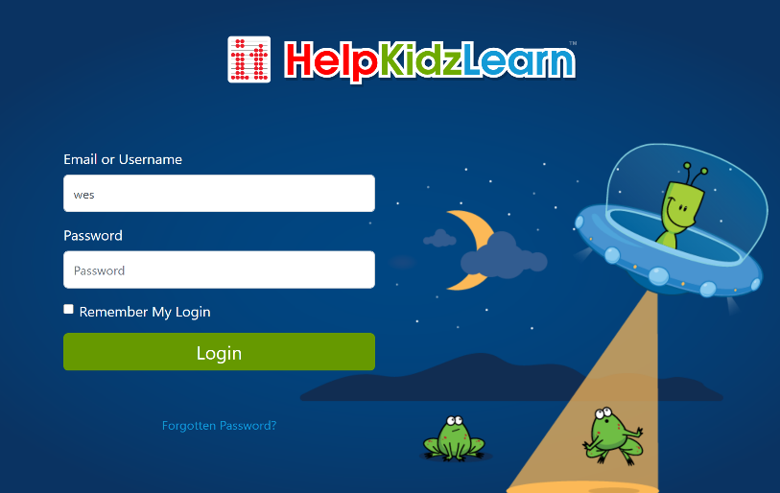
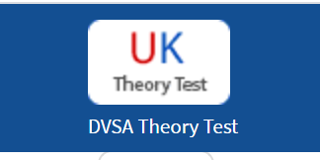
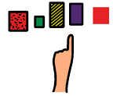
educationcity.com
helpkidzlearn.com
westoaksschool.co.uk
livechat.com/typing-speed-test
driving-theory-test.com/hazard-perception
https://www.bbc.co.uk/newsround
Functional ICT Choosing Board

