**Five-A Day**

What counts towards your five a day?

_______ tablespoons of sweetcorn

_______ plums

_______ satsumas

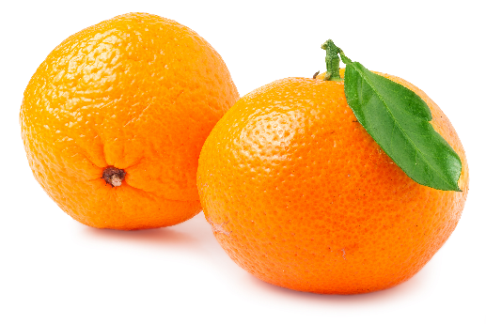

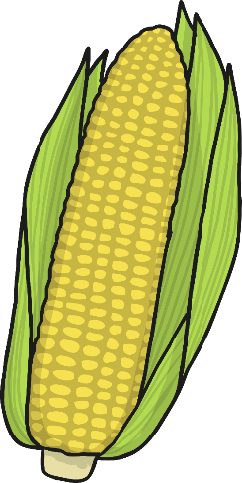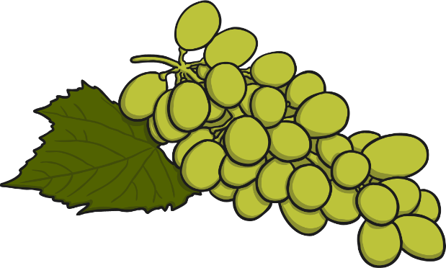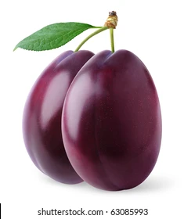

_______ handful of grapes

**Five-A Day**

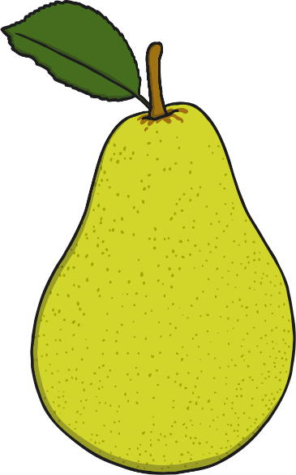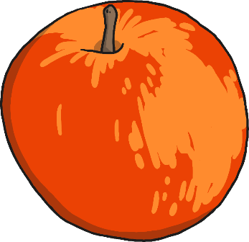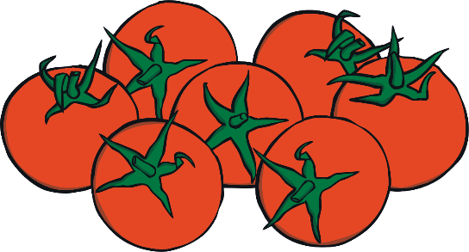What counts towards your five a day?

_______ pear

_______ apple

_______ cherry tomatoes

_______ banana