stick 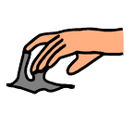

don’t like

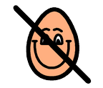

paper 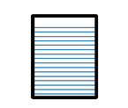

forwards 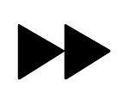

more

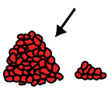

want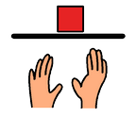

I, me, my

|  |  |  |  |  |  |  |
| --- | --- | --- | --- | --- | --- | --- |
| youC:\Users\LauraThomas\Documents\Resources\PCS Symbols\Core\y\you.png | join | up | backwards | card | lever |  |
| like  C:\Users\LauraThomas\Documents\Resources\PCS Symbols\Core\l\like.png | draw | down | pull | straight | scissors |  |
|  | cut | help  C:\Users\LauraThomas\Documents\Resources\PCS Symbols\Core\i\I need help.png | **push** | curve | finished  C:\Users\LauraThomas\Documents\Resources\PCS Symbols\Core\f\finished.png |  |