 | KS3 Stepping stones  The Circle of Life  Week commencing 08.03.2021 |  | 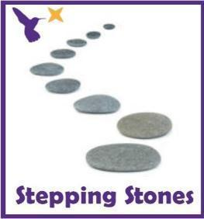
Classes in each pathway-
Woodhouse: Magpie
Boston Spa: Pipit and Wagtail
All about our projects this term:
The Circle of Life project will be delving deep into the world of animal life cycles. The ‘Tadpole’s Promise’ book will be the focus text and you can guide pupils using the Talk for Writing process but adding information text links to develop pupil’s understanding of the caterpillars, tadpoles, frogs and butterflies. During science, we will explore the lives of the human body with the focus of ‘Teeth and Eating’ and ‘Health and Growth’. Immerse the pupils into the topic of teeth and what our mouths can do? By the end of term, we would aim for our pupils to be able to show an awareness of the different elements that make a healthy body and diet. In Humanities, we will be exploring what we can see from the window and learn how to describe our immediate environment using Geographical language.
Maths (Number) |  | English activities
This week in Math we will working on our counting and comparing skills with numbers to 10. Practise your finger counting and signing of numbers to10.  Green bottles song:  Collect real plastic bottles and build a wall by setting up 10 green bottles. Each time a bottle ‘accidently falls’ ask the how many have fallen and how many are standing. Do they always have 10 in total?  *See ‘Green Bottles Resources’ on the school website*  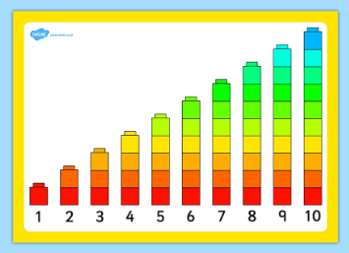  Comparing numbers to 10  Provide a selection of bricks in different sizes and shapes. Ask the pupils to make the tallest possible tower using 10 bricks. Use cubes to build towers from 1 to 10.  *See ‘Comparing Numbers’ on the school website*  Which bricks will they choose? How will they place their bricks to make the tower as tall as possible?  Can the pupils order the towers?  What do they notice?  Can they see that each number is one more than the number before?  Moving maths:  Provide a starting line. Take 9 giant steps, 9 tiny steps, 9 jumps, 9 tiptoes etc. Make harder by holding up a number card for pupils to read and count their own movements each.  Comparing games:  Use dominoes, bricks, sweets, snack and compare the number of objects each person or each plate has? Who has the most? Who has the least?  Maths related stories and songs:  How do Dinosaurs Count to 10? - Yolen & Teague  https://www.youtube.com/watch?v=IJ5z4aqle4w  One Gorilla  https://www.youtube.com/watch?v=m-sHTa8gf8c |  | Story focus: Tadpoles Promise  Read the ‘Tadpoles Promise’ book via YouTube link:  https://www.youtube.com/watch?v=DfiC8GNuD8g  Use the symbol to mat to find the characters.  *See ‘Tadpole’s promise ALD’ on the school website.  Colourful semantics:  Work on your reading skills using the Colourful Semantics symbols. Answer the ‘who’ ‘what’ ‘where’ ‘why’ and ‘how’ questions. Use the parent guidance form to support with the resources.  *See ‘Colourful Semantics Symbols’ on the school website*  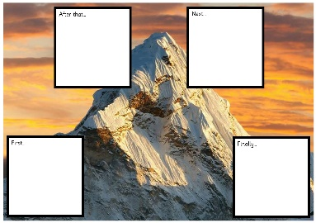  Story mapping:  Can you draw or sequence some of the story events using the story map or story mountains? You can draw an object, a character or a word as you go through the story.  *See ‘Story Mapping Worksheets and Language’ on the school website*  Ordering language:  Lay out different pictures or objects with the Talk 4 Writing words in order. For example, tadpole first, caterpillar next, butterfly then, frog finally. Develop the awareness of what these words mean.  *See ‘Talk 4 Writing Word Cards’ on the school website*  Handwriting sheets:  *See ‘Handwriting Worksheets’ on the school website*
Science |  | Physical activities
This term, we will be learning about what our bodies need to keep healthy. This week we will progress further into portions of fruit and vegetables specifically about 5 a day and portion sizes.  Exploring Fruit and veg:  Use a fruit bowl or tray to explore different fruit and vegetables. Can you name them? Can you taste them? Can you smell them?  Portion sizes:  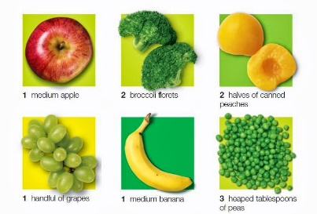  Can you look at the pictures and visuals for each portion sizes? Use a bowl or scales to explore how many of each fruit and veg are in each portion? Respond to questions like ‘Can you count out 10 grapes?’.  Extension: Can you create a tally chart for each fruit you are exploring and write down how many or a measurement for each portion?  *See ‘5 a Day Worksheet, Fruit Word Mat, Labelling Fruits and 5 a Day Poster on the school website* |  | Go noodle wake up shake challenges:  Pizza song  https://www.youtube.com/watch?v=4rm0LYLz1Wg  Fitness challenges  https://www.youtube.com/watch?v=K4DnPhR9_mo  Kidz bop dances  https://www.youtube.com/watch?v=sNog54ovi8Q  ‘Down in the Jungle’ finger exercises- (YouTube)  You might want to do some finger warm up exercises before you start your English work. Get some playdough and join along with the exercises.  https://www.youtube.com/watch?v=o9D5lfqZF3oh  PE bingo card challenges:  Can you choose a few challenges on the bingo cards for each day and see if you can complete them all by the end of the week?  *See ‘PE Bingo Cards’ on the school website*  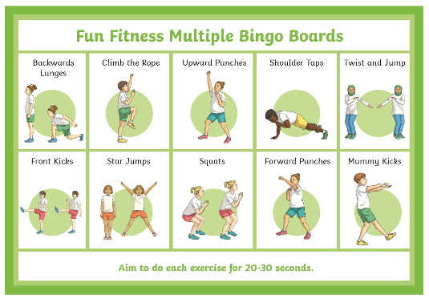
RE
In RE we will continue looking at symbols.
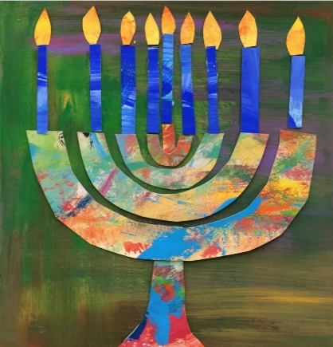
This week, we will continue to focus on a symbol linked to Judaism e.g. the Menorah.
Can you do some drawings and sketches of the Menorah?
Can you make your own Menorah artwork? Use glitter, gems, tissue, pencils, paint.
*See ‘Menorah Drawing’ on the school website*
*See ‘Menorah Template’ on the school website*

PSHE:
This week in PSHE, we will be learning about being kind.
Read ‘The Monster who lost his mean’ and explore how the monster changes to be kind or ‘loosing his mean’.
https://www.youtube.com/watch?v=9UQri5wuXzc
Explore different photos of hands doing kind things, for example holding hands, stroking, giving, washing, pointing, thumbs up, waving, blowing a kiss, writing a letter, cooking or making something for someone.
*See ‘Kind Hands Symbols’ on the school website*
Set up sensory trays or boxes for tasks for hands e.g. mark making, tapping with brushes gently, hand printing, hand chain making.
Encourage pupils to be gentle and be careful with their hands.
Enrichment activities:
Humanities
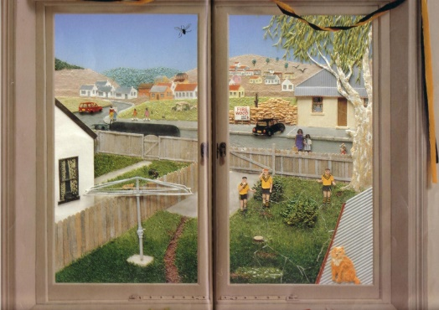
This half term we will be learning about our immediate environment and what features are visible from our windows. Read or watch to the story ‘Window’ by Jeannie Baker.
- Draw and paint key features from the windows in your house or garden windows (tree, car, garden, kitchen, field)
- Create a ‘real’ window (frame and curtains) and put different scene behind and reveal.
- Take photos of windows in your house or on a walk to see different shop windows, house windows, car windows.
- Explore windows in the book and identify some things you see?
- Play ‘what can you see’ bingo through the window?
*See ‘Window Scenes, Window Bingo and Window Story’ on the school website

Extension: Begin to use language linked to the things they can see through the window. How is the tree near or far away? What is that building for? How does the car move around? What is that person walking on?
Encourage pupils to use more sophisticated geographical language.
*See ‘Example Questions’ on the school website*

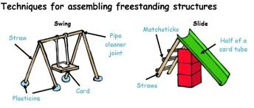
In DT, we are going to learning about freestanding structures. This week use twigs, lollipop sticks and wooden dowel to make a house or freestanding structure. You can use joining materials like tape, glue, playdough, string, plasticine.

Extension: Can you record your finding by placing a cross or tick next to the materials that worked well?

Key questions about the materials:
Are they able to join the materials together?
Can they make a structure that stands up?
What technical vocabulary are they able to use or understand? (long, short, strong, weak, heavy, light).
Take photographs of your structures and send them to your teacher to see!
*See ‘DT Language Supports’ on the school website*

Music:
In Music, we will be stringed instruments.
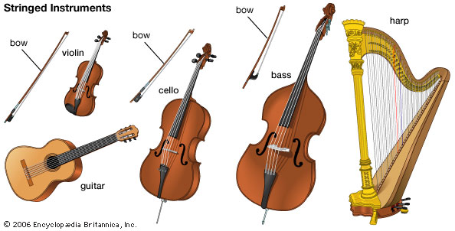
Look at real stringed instruments or videos of them on YouTube. Can you name some of the instruments? Do they sound quiet/ loud/ fast/ slow/ relaxing/ exciting?
https://www.youtube.com/watch?v=xBfBYfPNXqE
https://www.youtube.com/watch?v=wh-pBxeHE3U
https://www.youtube.com/watch?v=5q7YJhVmE08
https://www.youtube.com/watch?v=oPmKRtWta4E
Explore the sound of string and elastic bands when wrapped around cups and boxes. Does the thickness of the string or band effect the sound you hear?
*See ‘Music Language Supports’ on the school website*

Sing and sign challenges:
We’re all in this together
https://www.youtube.com/watch?v=IKMqK1cWid8&feature=youtu.be

Extra information
- We would recommend a short work session for each area listed above for up to 30 minutes per day or as much as each individual pupil would manage at home.
Feel free to share photos and achievements via class Dojo and the school Twitter page.
Email me directly with any home learning or curriculum issues or questions: elisha.stokes@westoaksschool.co.uk

