 | KS2 Stepping stones  Down on the Farm  Week commencing 08.03.2021 |  | 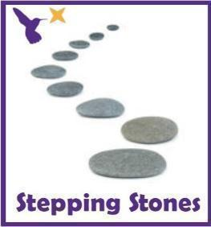
Classes in each pathway-
Woodhouse: Barn Owl, Swan and Starling
Boston Spa: Swift, Finch and Skylark
All about our projects this term:
It’s time to visit the farm! What animals will you see? What sounds will you hear? What does it feel like?
In English, we will explore the farm through the ‘Little Red Hen’. Will you help the Little Red Hen to grow the corn and bake the bread? We will learn the story through the Talk for Writing approach but also develop reading and writing skills through some simple instructions. Continue to focus on our ‘Farm’ topic in art using pencil control and farmyard illustrations and make a farmyard lever books in DT! In Humanities, we will be exploring what we can see from the window and learn how to describe our immediate environment using Geographical language.
Maths (Number) |  | English (Reading)
This week in Math we will working on our counting and comparing skills with numbers to 10. Practise your finger counting and signing of numbers to10.  Green bottles song:  Collect real plastic bottles and build a wall by setting up 10 green bottles. Each time a bottle ‘accidently falls’ ask the how many have fallen and how many are standing. Do they always have 10 in total?  *See ‘Green Bottles Resources’ on the school website*  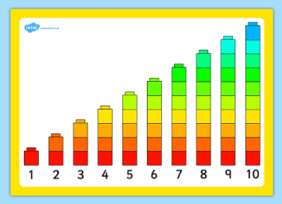  Comparing numbers to 10  Provide a selection of bricks in different sizes and shapes. Can they make the tallest possible tower using 10 bricks. Use cubes to build towers from 1 to 10.  *See ‘Comparing Numbers’ on the school website*  Which bricks will they choose?  How will they place their bricks to make the tower as tall as possible?  Can they order the towers?  What do they notice?  Can they see that each number is one more than the number before?  Moving maths:  Provide a starting line. Take 9 giant steps, 9 tiny steps, 9 jumps, 9 tiptoes etc. Make harder by holding up a number card for pupils to read and count their own movements each.  Comparing games:  Use dominoes, bricks, sweets, snack and compare the number of objects each person or each plate has? Who has the most? Who has the least?  Maths related stories and songs:  How do Dinosaurs Count to 10? - Yolen & Teague  https://www.youtube.com/watch?v=IJ5z4aqle4w  One Gorilla  https://www.youtube.com/watch?v=m-sHTa8gf8c |  | Story of the Term:  ‘The Little Red Hen’  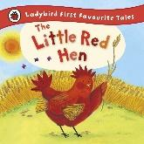  Read through the adapted PowerPoint and practise saying the words or phrases.  You can also watch the story of The Little Red Hen on YouTube or on Twinkl.  Colourful semantics:  Work on your reading skills using the Colourful Semantics symbols. Answer the ‘who’ ‘what’ ‘where’ ‘why’ and ‘how’ questions. Use the parent guidance form to support with the resources.  *See ‘Colourful Semantics Symbols’ on the school website*  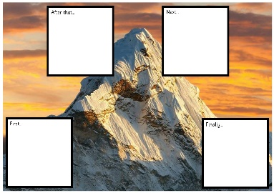  Story mapping:  Can you draw or sequence some of the story events using the story map or story mountains? You can draw an object, a character or a word as you go through the story.  *See ‘Story Mapping Worksheets and Language’ on the school website*  Use a tractor toy or car toy to drive through a flour or sand tray. Can you retell some events or name some characters as you drive through the story? Lay out different pictures or object with the Talk for Writing words in order.  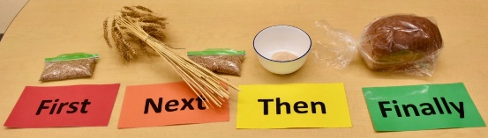  Handwriting sheets:  *See ‘Handwriting Worksheets’ on the school website*
Science |  | Physical activities
This term, we will be learning about what our bodies need to stay healthy. This week we will progress further into portions of fruit and vegetables and teach pupils specifically about 5 a day and portion sizes.  Exploring Fruit and veg:  Use a fruit bowl or tray to explore different fruit and vegetable. Can you name them? Can you taste them? Can you smell them?  Portion sizes:  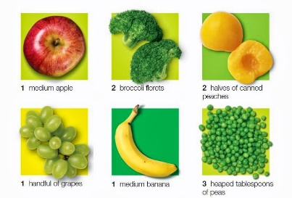  Can you look at the pictures and visuals for each portion sizes? Use a bowl or scales to explore how many of each fruit and veg are in each portion? Respond to questions like ‘Can you count out 10 grapes?’.  Extension: Can you create a tally chart for each fruit you are exploring and write down how many or a measurement for each portion?  *See ‘5 a Day Worksheet, Fruit Word Mat, Labelling Fruits and 5 a Day Poster on the school website* |  | Wake up shake up songs:  Wake up song  https://www.youtube.com/watch?v=1gUbdNbu6ak  Lazy town exercises  https://www.youtube.com/watch?v=eD7zbsGjFo4  Dinosaur stomp  https://www.youtube.com/watch?v=Imhi98dHa5w  ‘Down in the Jungle’ finger exercises- (YouTube)  You might want to do some finger warm up exercises before you start your English work. Get some playdough and join along with the exercises.  https://www.youtube.com/watch?v=o9D5lfqZF3oh  PE bingo card challenges:  Can you choose a few challenges on the bingo cards for each day and see if you can complete them all by the end of the week?  *See ‘PE Bingo Cards’ on the school website*  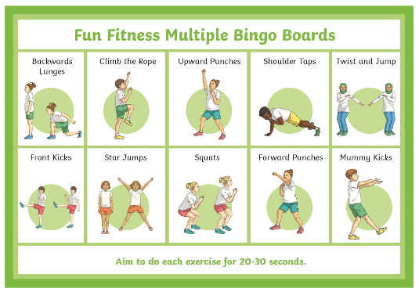
RE
In RE we will continue looking at symbols.
This week, we will continue to focus on a symbol linked to Christianity e.g. the Ichthys fish.
Can you do some drawings and sketches of the Ichthys fish?
Can you make your own fish artwork? Use glitter, gems, tissue, pencils, paint.
*See ‘Ichthys Fish Drawing’ on the school website*
*See ‘Ichthys Fish Template’ on the school website*

PSHE:
This week in PSHE, we will be learning about being kind.
Read ‘The Monster who Lost his Mean’ and explore how the monster changes to be kind or ‘loosing his mean’.
https://www.youtube.com/watch?v=9UQri5wuXzc
Explore different photos of hands doing kind things, for example holding hands, stroking, giving, washing, pointing, thumbs up, waving, blowing a kiss, writing a letter, cooking or making something for someone.
*See ‘Kind Hands Symbols’ on the school website*
Set up sensory trays or boxes for tasks for hands e.g. mark making, tapping with brushes gently, hand printing, hand chain making.
Encourage pupils to be gentle and careful with their hands.

Creative projects
Humanities
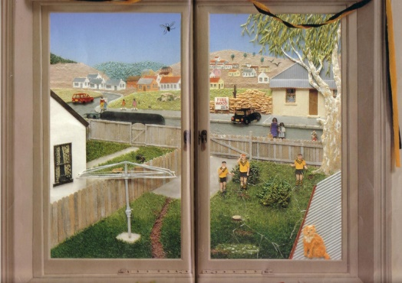
This half term we will be learning about our immediate environment and what features are visible from our windows. Read or watch to the story ‘Window’ by Jeannie Baker.
- Draw and paint key features from the windows in your house or garden windows (tree, car, garden, kitchen, field)
- Create a ‘real’ window (frame and curtains) and put different scene behind and reveal.
- Take photos of windows in your house or on a walk to see different shop windows, house windows, car windows.
- Explore windows in the book and identify some things you see?
- Play ‘what can you see’ bingo through the window?
*See ‘Window Scenes, Window Bingo and Window Story’ on the school website*

Extension: Begin to use language linked to the things they can see through the window. How is the tree near or far away? What is that building for? How does the car move around? What is that person walking on?
Encourage pupils to use more sophisticated geographical language.
*See ‘Example Questions’ on the school website*

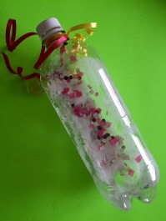
Music
In Music start with the animal sounds song linked to our topic. Join in with some of the animal sounds..
https://www.youtube.com/watch?v=RmFpOP7Z2ww
or play listening game 4
https://www.youtube.com/watch?v=o3MJ1tFNYE0
This week make your own shaker instruments. Explore different materials you can use to create a shaking sound e.g. rice, buttons, clips, scrunched up paper.
You could wrap bottles in paper and hide different materials inside so pupils can’t see and guess what they can hear shaking?
*See ‘Music Language Supports’ on the school website*

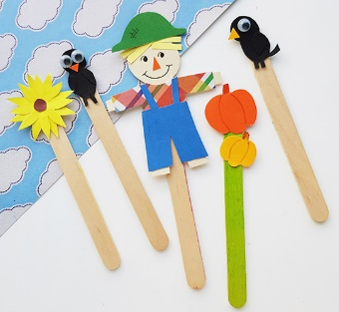
DT and Art
This week we will explore levers again in more depth. Look at levers in moving picture books and how they move. This week make a different moving puppet or character linked to your story focus or a pop-up book you have at home. Try attaching it to a lollipop stick, straw or spoon and place between a slit in paper and card to use as your background. Let pupils explore it moving up and down or side to side like you can in the book.
https://www.youtube.com/watch?v=PsZ-VTk98Ec
https://www.youtube.com/watch?v=x00f-rcsBYk
*See ‘DT Language Supports’ on the school website*
Over the term, for our DT project you will need:
- Scissors
- Glue
- Card and paper
- Straws or lollipop sticks
- Pens, pencils or paints.
Extra information
-We would recommend a short work session for each area listed above for up to 30 minutes per day or as much as each individual pupil would manage at home.
-Please share your express week photos, work and achievements via my email address, class Dojo and the school Twitter page.
-Email me directly with any home learning or curriculum issues or questions: elisha.stokes@westoaksschool.co.uk
-Education city log in:
Username- 383westoaks
Password: 555637

