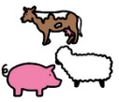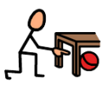

Can you find the animals?

|  |  |
| --- | --- |
| A silhouette of a dog  Description automatically generated with low confidencehorse |  |
| sheep |  |
| frog |  |
| duck |  |
| cow |  |
| pig |  |

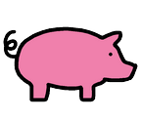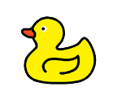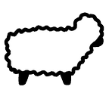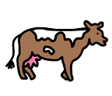

pig

cow

duck

frog

sheep

horse