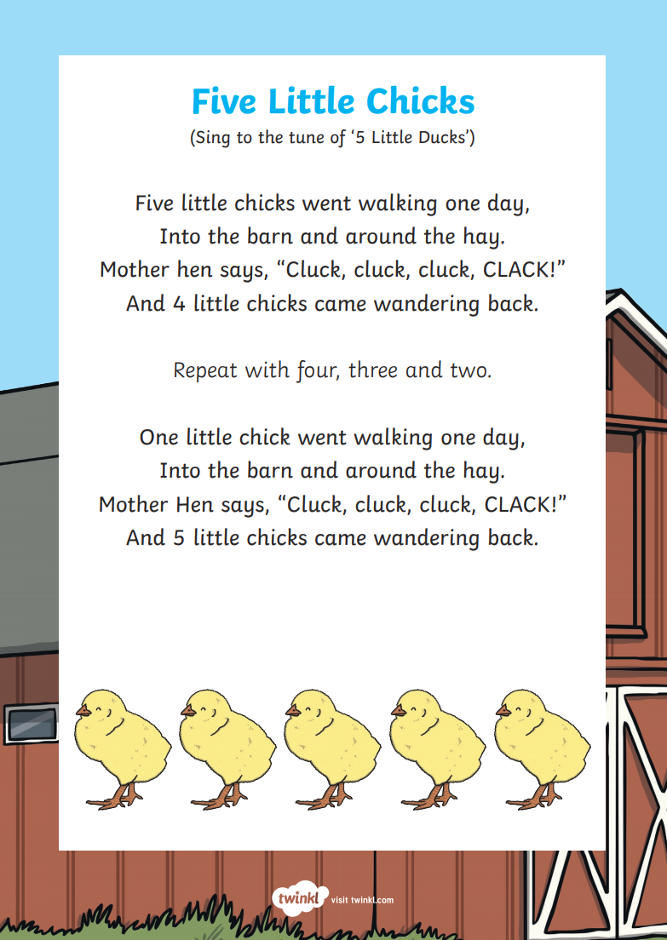

Cut out the chicks and position them on the barn. After each verse, encourage your child to pick up one of the chicks and put it with the hen picture. Help them to count how many chicks are left in the barn by touching each one as you count out loud.

