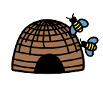

5 little bumblebees buzzing round the hive,

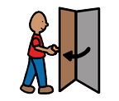 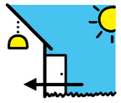

One opened the door and went inside.

*Encourage your child to pick up one of the bumblebees and put it onto the hive picture. Help them to count how many bees are left by touching each one as you count out loud.*

4 little bumblebees buzzing round the hive,

 

One opened the door and went inside.

*Repeat until all the bees are in the hive*



