 | Week commencing: 8/3/21  Unit theme: How does it grow?  Story: First the Egg  Weekly theme: Cows |  | 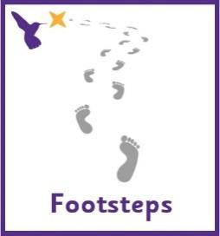
Wren (Boston Spa Learning)
Communication activities |  | Cognition (Maths-based) activities
Help your child to engage with fun stories and musical activities through actions and signs  This half term, our focus skill is: Following instructions.  The learning intention is:  To be able to listen to communicative partners  To be able to process information and respond  Activity ideas  - Reading  Read the story ‘First the Egg’ (See ‘First the Egg Story’ PowerPoint on the school website). Encourage your child to follow instructions to turn the page (if printed) or click onto the next slide (if reading on a computer). Support them to point out characters in the story and to copy the Makaton signs – See ‘First the Egg Makaton Signs’ and ‘First the Egg Story Symbols’ resources on the school website.  The sign of the week is ‘cow’ – move both hands upwards from the ears to create a horn shape.  - Tactile  Support your child to follow the instructions on the ‘Cow Sensory Bag’ resource on the school website, to make a lovely tactile resource.  - Craft  Use the ‘Cow Craft’ resource on the school website for some ideas on cow themed crafts.  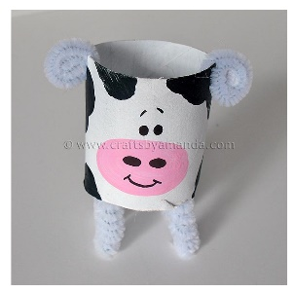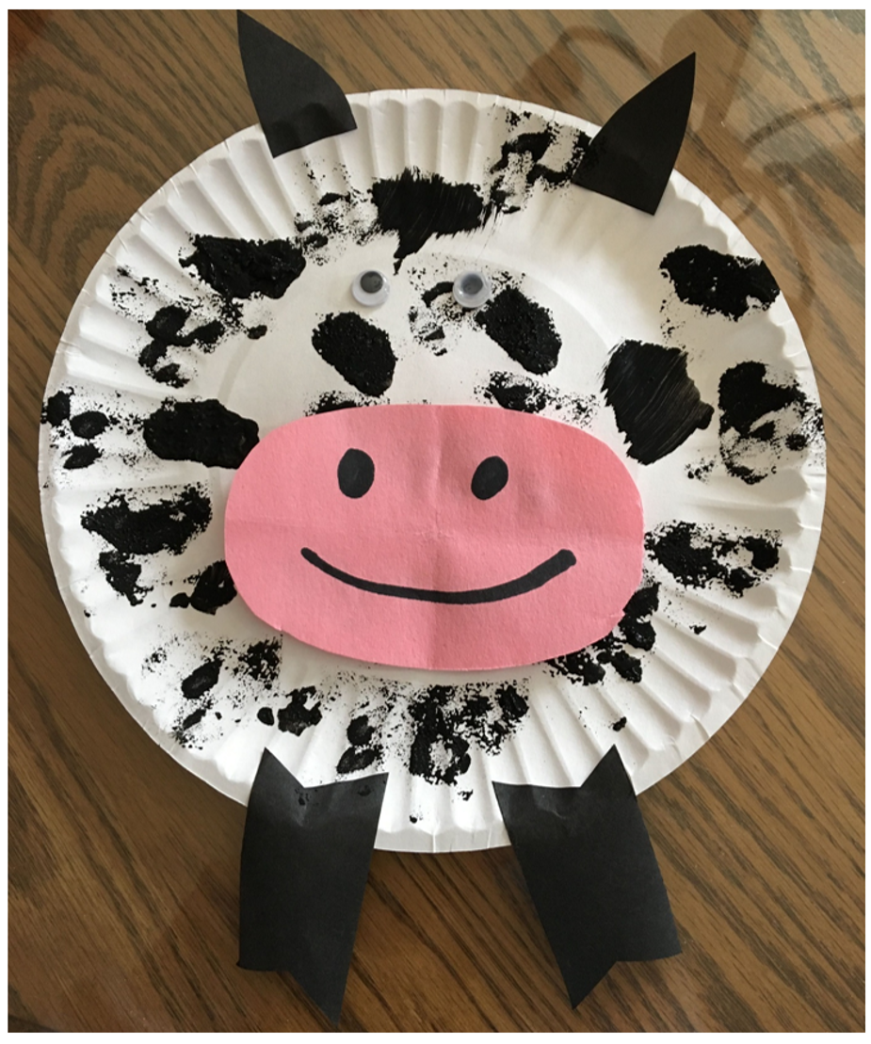 |  | There are lots of ways to learn about maths around the house. Doing puzzles, playing games and exploring house equipment are all great ways to practise maths skills.  This half term, our focus skill is: Object permanence.  The learning intention is:  To develop a wider understanding of the world around us by making links between past learning and immediate experiences.  Activity ideas  - Finding missing objects needed for a task  Using the ‘Make a Milkshake’ resource on the school website, encourage your child to find kitchen equipment and ingredients. This could be taken from central box or from their usual place, e.g. in a cupboard or drawer.  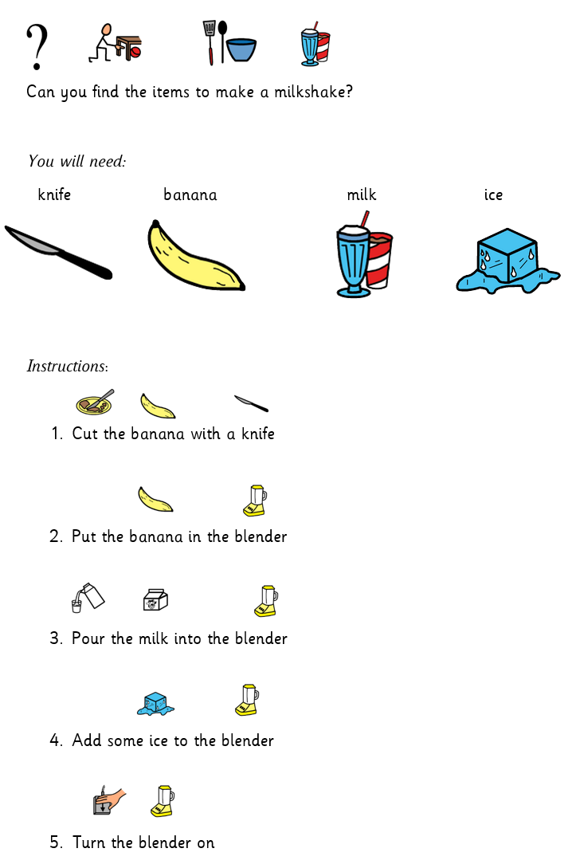  - Hide and seek  Using motivating toys, test your child’s ability to follow and find hidden objects by placing them under a cup or container. You can start easy by using one see-through container then build this up to using opaque containers or having more than one container to choose from. If you have any animal toys to fit in with the farm theme, there is an animal checklist to tick off the animals as you find them – See ‘Animal Checklist’ on the school website.  - Locating objects around the room  Using the ‘Finding Toys’ resource on the school website, encourage your child to find toys to play with. This could be taken from central box or from their usual place, e.g. in a cupboard. You can edit the list based on your child’s preferences, please contact school if you need any symbols emailing to you to support this.
Sensory activities |  | Physical activities
Sensory activities can be extremely motivating, develop attention skills and help your child to self-regulate.  Activity ideas  - Cooking  Skill: Tasting different food  Make some tasty edible cows! See ‘Cow Cooking’ resource on the school website for ideas.  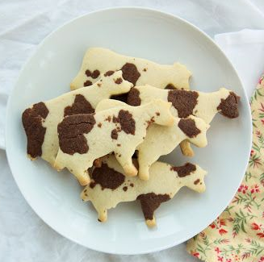  - Tactile  Skill: Fine motor movements  Make a farm sensory bin and encourage your child to develop their fine motor skills by using their fingers to pick up small object, post and thread. This could include building a pen for the animals out of Duplo, or  cleaning the muddy animals – roll in paint and clean with soapy water.  You can make taste-safe mud by mixing cornflour and water with decaf coffee or gravy granules.  https://learningforlittles.com/how-to-create-a-farm-themed-sensory-table/  See the ‘Milk the Cow’ resource on the school website.  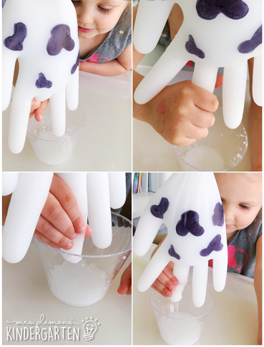  - Art  Skill: Exploring shapes  Make your own cow from playdough - see ‘Playdough Cow’ resource on the school website. Follow the link below for a recipe to make taste-safe playdough https://www.pinterest.co.uk/pin/5840674504572923/ |  | Physical activity is great to keep our minds active and burn lots of energy!  Activity ideas  - Gross motor  Skill: Proprioception/Body awareness  Giving proprioceptive input can be great for calming and regulating children with sensory processing issues, see website below for more information.  https://www.theottoolbox.com/proprioception-sensory-activities/  You could try activities such as wheelbarrow walking or a heavy lifting relay race to give lots of input to the body.  - Skittles  Skill: Throwing underarm  Make your own bowling alley using favourite toys. Encourage your child to throw a ball or beanbag to knock down the toys.  - Jumping  Skill: Body awareness  Encourage your child to jump on the spot, forwards, backwards and sideways! See printable resource ‘Jumping Visuals’ on the website.  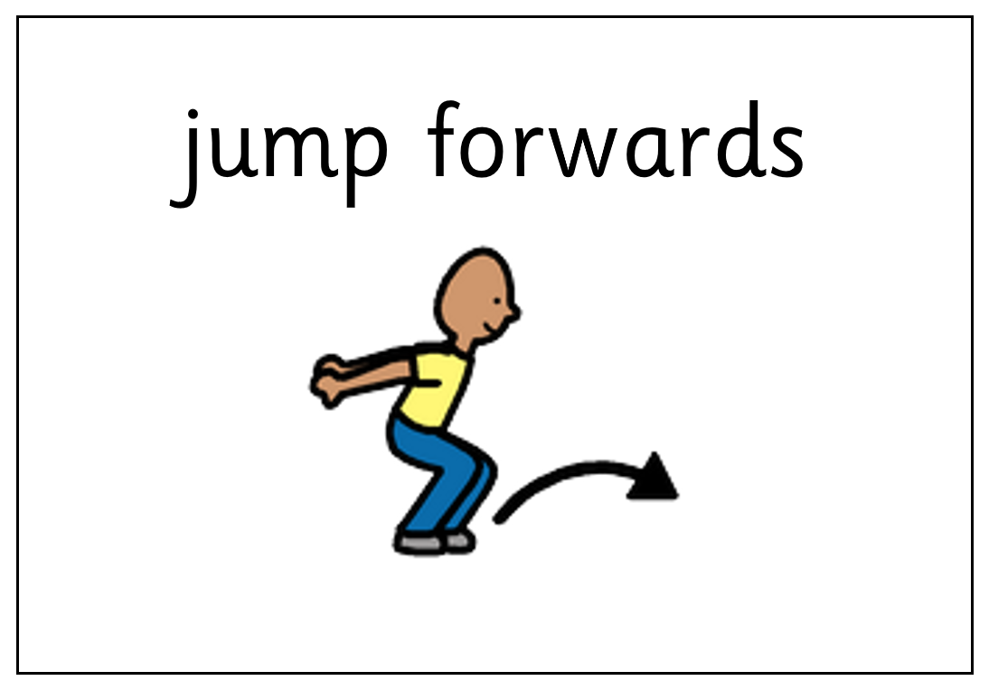  - Dance  Skill: Gross motor movements  Listen to songs about the farming! Encourage your child to choose which song to listen to by clicking on the pictures in the ‘Farm Songs’ PowerPoint on the school website or print off the symbols on the first page to use for PECS.  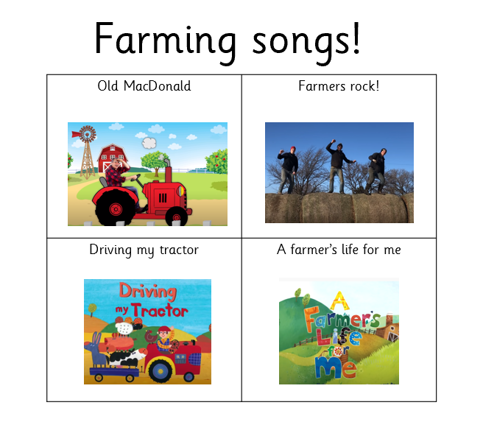
Additional learning links
- Start the day with a ‘good morning’ routine – See example PowerPoint on the school website (Click ‘enable content’ when opening the PowerPoint to ensure videos will open)
- Search on YouTube for educational songs, e.g. ‘Barefoot Books’ or ‘The Learning Station’
- Cbeebies.com – games, TV shows and songs. ‘Something Special’ is great for teaching children (and the rest of the family!) Makaton signs.
- TACPAC – See information sheet and example PowerPoint on the school website. Click on the musical notes symbol for links to songs.
- Follow ‘Gina Davies Autism Centre’ on Facebook to find out more about the Attention Autism programme that we use in school and get tips on how you could replicate this at home, either by watching the videos with your child or creating your own session https://www.facebook.com/ginadaviesautism/posts/
- Yoga/relaxation session – See PowerPoint on the school website
Other information
- We have put together an example timetable to help you structure your day – See ‘Footsteps Daily Routine Example’ on the school website. Please adapt this for your child and include as much or as little of the content as you feel appropriate. Symbols can be printed out and used with the ‘Now and next’ board to support your child to understand their routine.
- Please feel free to share any photos or achievements on Dojo or the school Twitter page.
- If you need any further information, or would like a pack of these resources delivered to your home, you can email me at jessica.arnold@westoaksschool.co.uk

