 | Week commencing: 8/3/21  Unit theme: How does it grow?  Story: The Gardener’s seeds  Weekly theme: Flowers |  | 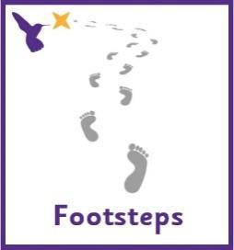
Jay (Woodhouse Learning)
Communication activities |  | Cognition (Maths-based) activities
Help your child to engage with fun stories and musical activities through actions and signs  This half term, our focus skill is: Making choices.  The learning intention is:  To be able to communicate preferences.  Activity ideas  - Reading  Read the story ‘The Gardener’s Seeds’ (See PowerPoint on the school website). Encourage your child to follow instructions to turn the page (if printed) or click onto the next slide (if reading on a computer). Support them to point out characters/objects in the story and to copy the Makaton signs – see ‘The Gardener’s Seeds Makaton Signs’ resource on the school website  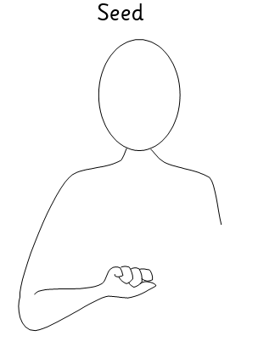  - Flower art  Use the ‘Flower Art’ printable resource on the school website to get creative! Encourage choice-making by offering different art media and colours – whatever you have available to you. You could make a collage by cutting pictures of flowers out of magazines, or try out different printing techniques using kitchen roll tubes or real flowers. Follow the link below for a recipe to make taste-safe paint.  https://rainydaymum.co.uk/baby-play-finger-painting/  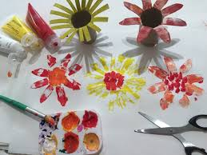  - Music  Listen to songs about farming! Encourage your child to choose which song to listen to by clicking on the pictures in the ‘Farm Songs’ PowerPoint on the school website, or print off the symbols on the first page to use for PECS.  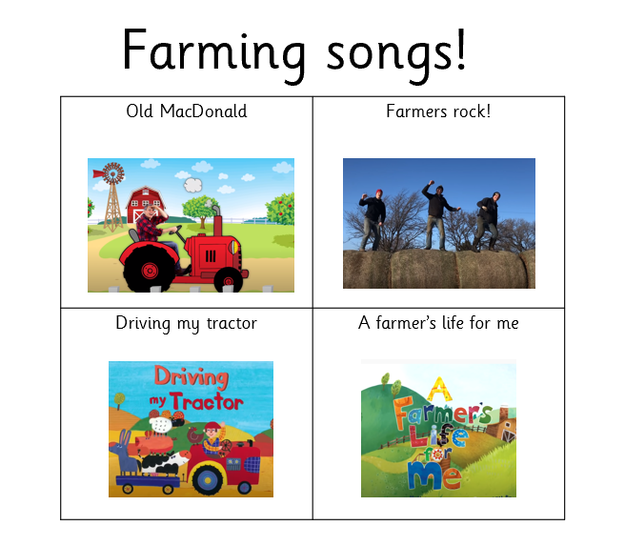 |  | There are lots of ways to learn about maths around the house. Doing puzzles, playing games and exploring house equipment are all great ways to practise maths skills.  This half term, our focus skill is: Measure – Capacity.  The learning intention is:  To be able to make comparisons between objects.  Activity ideas  - Online game  Press the screen to help the flowers grow. This game is also a great way to practice turn taking.  Log into HelpKidzLearn:  Go to ‘Creative’ and scroll down to ‘Watering can’.  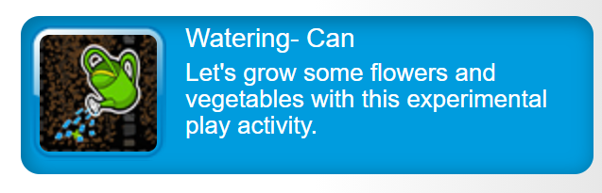  - Water play  Water play can be very motivating for our pupils and great way to support them to explore capacity. Use any outdoor space you have to get really messy, or you could incorporate water play into bath/shower time by having a range of different containers to fill with water. If you have the resources/space to plant some real seeds then this is a great activity to explore different containers, such as watering cans, jugs, cups, bottles, etc.  Key vocabulary to focus on: full, empty, more, less.  - Sensory cooking  Cooking can also be a great way to engage children with exploring objects of different shapes and sizes. Encourage your child to experiment with filling bun cases up with different types of food by pouring or scooping with a spoon (great for developing fine motor skills). Ingredients that tend to be popular for sensory play in school include flour, rice, pasta and lentils. See blog post below for tips on sensory play at home.  https://dayswithgrey.com/blog/one-year-old-for-sensory-play/  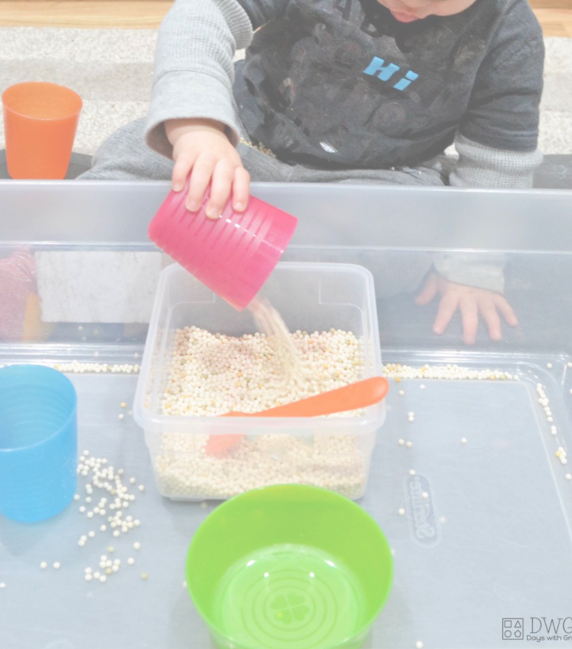
Sensory activities |  | Physical activities
Sensory activities can be extremely motivating, develop attention skills and help your child to self-regulate.  - Art  Skill: Using different equipment  In the story the gardener gives her friend flowers to celebrate her birthday. Have a go at these celebration themed activities.  - Painting with balloons  https://niftythriftydiyer.com/balloon-pop-painting/  - Making party hats  Use the printable ‘Party Hat Template’ on the school website to make and decorate your own celebration accessories.  - Tactile  Skill: Fine motor movements  Make a flower sensory bin and encourage your child to develop their fine motor skills by using their fingers to pick up small object, post and thread.  - ‘Flower Soup’ sensory play  http://taminglittlemonsters.com/flower-soup-spring-sensory-bin/  - ‘Frozen Flowers’ sensory play  https://www.craftsonsea.co.uk/frozen-flowers-sensory-ice-play  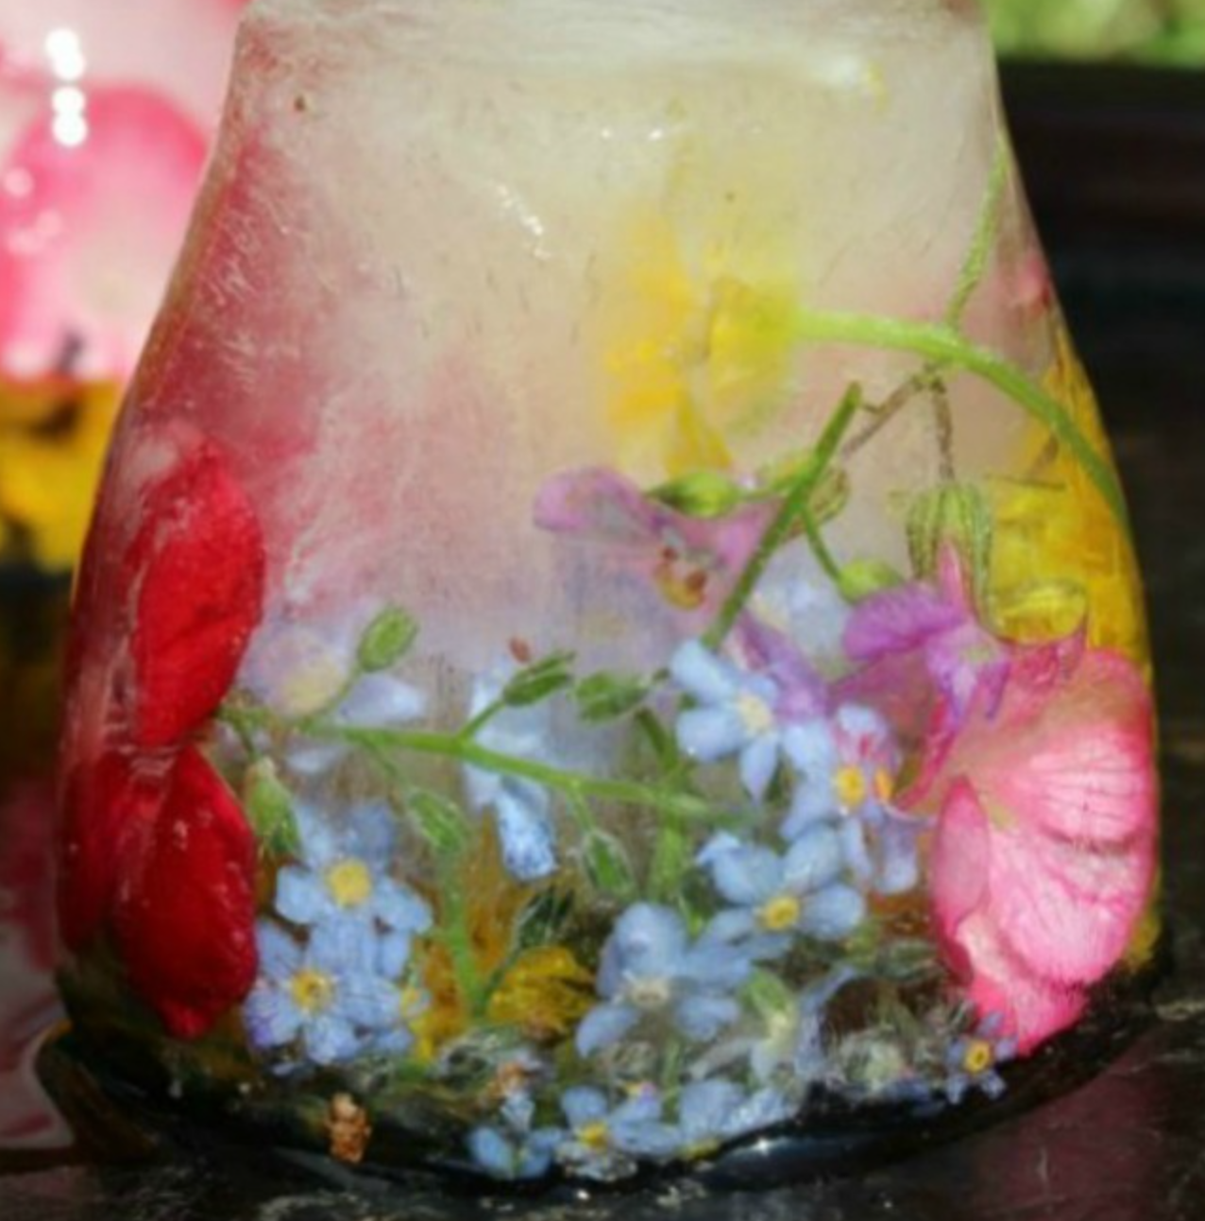  - Sensory walk  Skill: Exploring the environment  Enjoy some time out in the fresh air and see if you can find everything on the ‘Flower Hunt’ printable resource on the website.  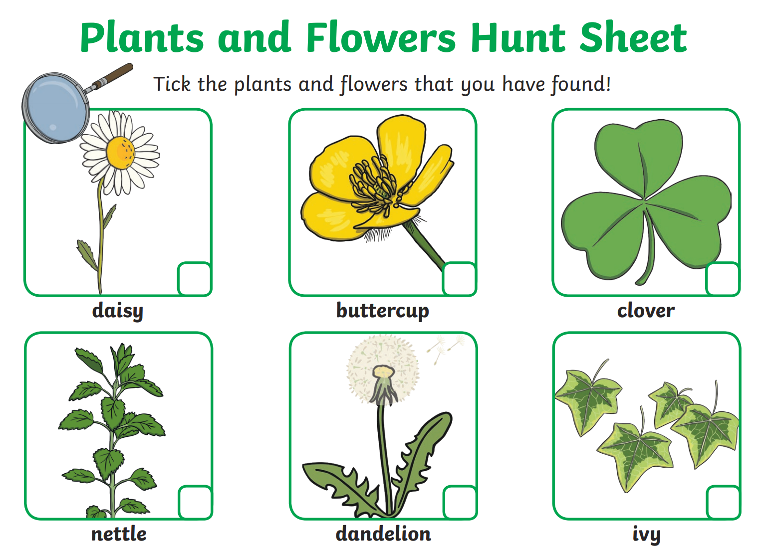 |  | Physical activity is great to keep our minds active and burn lots of energy!  - Party games  Skill: Copying actions  Encourage your child to join in with a game of Simon Says by copying your actions, or let your child be ‘Simon’ and make up action for you to copy! Or you could play musical statues by dancing and stopping whenever the music stops to develop listening skills.  Use the ‘Simon Says Actions’ resource on the school website or follow the link for a simple ‘Simon says’ song https://www.youtube.com/watch?v=OxRfqmLJCXw  - Dance  Skill: Gross motor movements  Encourage your child to copy the actions to this fun insect dance! Search on YouTube for ‘Learn to dance: Can you Plant a Bean’ https://www.youtube.com/watch?v=LCKEdDEr82k  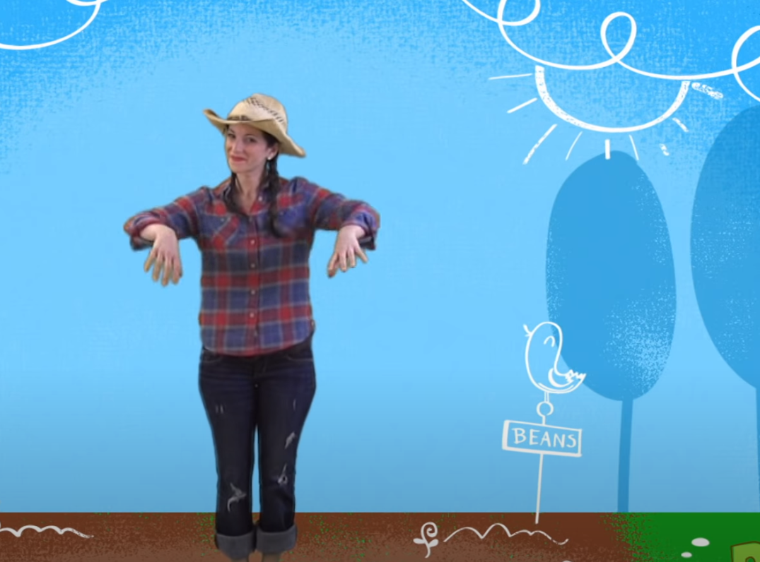  - Jumping  Skill: Body awareness  Encourage your child to jump on the spot, forwards, backwards and sideways! See printable resource ‘Jumping Visuals’ on the website.  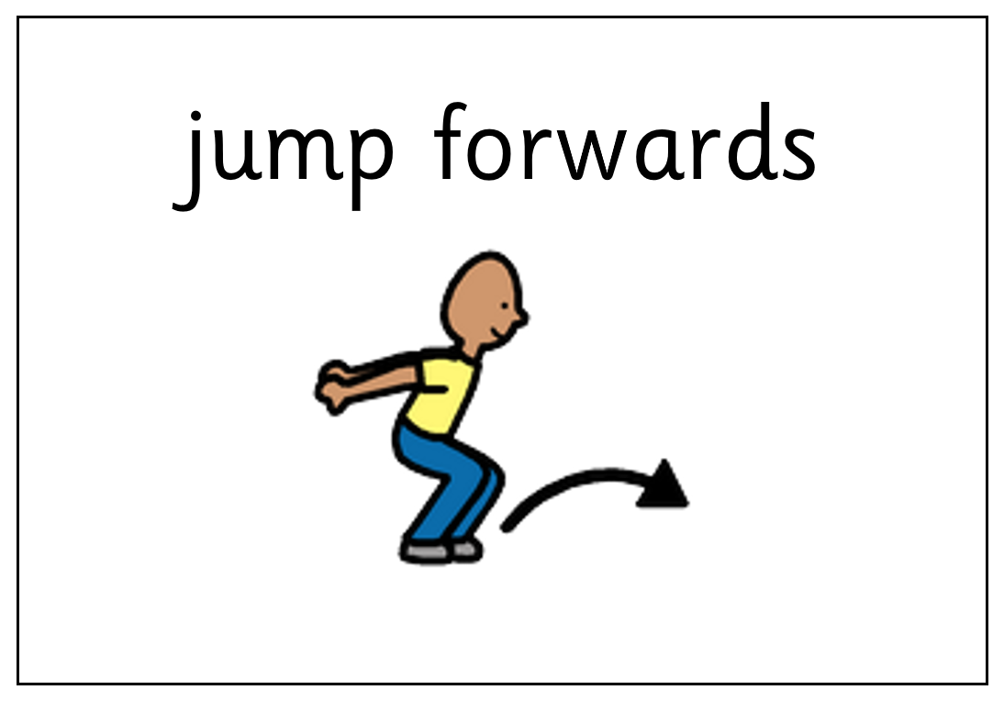
Additional learning links
- Start the day with a ‘good morning’ routine – See example PowerPoint on the school website (Click ‘enable content’ when opening the PowerPoint to ensure videos will open)
- Search on YouTube for educational songs, e.g. ‘Barefoot Books’ or ‘The Learning Station’
- Cbeebies.com – games, TV shows and songs. ‘Something Special’ is great for teaching children (and the rest of the family!) Makaton signs.
- TACPAC – See information sheet and example PowerPoint on the school website. Click on the musical notes symbol for links to songs.
- Follow ‘Gina Davies Autism Centre’ on Facebook to find out more about the Attention Autism programme that we use in school and get tips on how you could replicate this at home, either by watching the videos with your child or creating your own session https://www.facebook.com/ginadaviesautism/posts/
- Yoga/relaxation session – See PowerPoint on the school website
Other information
- We have put together an example timetable to help you structure your day – See ‘Footsteps Daily Routine Example’ on the school website. Please adapt this for your child and include as much or as little of the content as you feel appropriate. Symbols can be printed out and used with the ‘Now and next’ board to support your child to understand their routine.
- Please feel free to share any photos or achievements on Dojo or the school Twitter page.
- If you need any further information, or would like a pack of these resources delivered to your home, you can email me at jessica.arnold@westoaksschool.co.uk

