 | 16+ Home Learning  Week beginning 1st March 2021 |  | 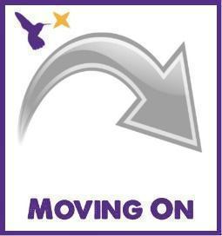
Classes in each pathway: Falcon, Lapwing, Curlew & Osprey
Maths activities |  | English activities
Level 1 & 2:  Complete the Level 1 & 2 online maths activities:  - GCSE Bitesize:  https://www.bbc.co.uk/bitesize/examspecs/z8sg6fr  - BBC Bitesize: https://www.bbc.co.uk/bitesize/subjects/zqhs34j  - BBC Bitesize: Functional Maths https://www.bbc.co.uk/bitesize/subjects/zjd8jty  - CGP Maths Online 10-Minute Tests: https://www.cgpbooks.co.uk/resources/cgp-s-free-online-10-minute-tests/free-gcse-maths-online-10-minute-tests  Level 1: Foundation  Level 2: Higher  - Maths Made Easy: https://mathsmadeeasy.co.uk/gcse-maths-revision/gcse-maths-online-tests/  - Education Quizzes: https://www.educationquizzes.com/gcse/maths/  Level 1: (f) questions  Level 2: (h) questions  - GCSE Maths Quizzes:  https://math-quiz.co.uk/gcse-maths  - GCSE Maths Revision:  https://www.bbc.co.uk/bitesize/examspecs/z9p3mnb  - Mathletics:  https://login.mathletics.com/  (Your teacher will Dojo your username and password) |  | Level 1 & 2:  Complete the Level 1 & 2 online English activities:  - GCSE Bitesize – Grammar:  https://www.bbc.co.uk/bitesize/guides/zyrn9qt/test  - BBC Bitesize: Functional English  https://www.bbc.co.uk/bitesize/subjects/zmqj2nb  - BBC Bitesize: Grammar & Punctuation  https://www.bbc.co.uk/bitesize/topics/z7vdy9q  - BBC Bitesize: Non-Fiction Texts  https://www.bbc.co.uk/bitesize/topics/zjfkscw  - BBC Bitesize: Reading Skills  https://www.bbc.co.uk/bitesize/topics/zs8nv4j  - BBC Bitesize: Writing Skills  https://www.bbc.co.uk/bitesize/topics/zywfbk7  - CGP Functional Skills English Online 10-Minute Tests: https://www.cgpbooks.co.uk/resources/cgp-s-free-online-10-minute-tests/free-functional-skills-english-online-10-minute-te  Level 1 and Level 2  - World Book Day 2021:  - Decorate your bedroom door in the style of your favourite book.  - Record a video of you doing a review of your favourite book  - Record a video of you reading your favourite book.  - https://www.worldbookday.com/events/  - https://www.youtube.com/c/WorldBookDayUK?safe=true
Entry Levels:  Complete the Entry Levels online maths activities:  - Bingo: Number Pairs  https://www.mathplayground.com/bingo-number-pairs.html  - Telling the Time:  https://www.mathplayground.com/puzzle_pics_clocks.html  - Direction:  https://www.mathsisfun.com/games/direction-nsew-.html  - Capacity:  https://ictgames.com/mobilePage/capacity/index.html  - Coordinates:  https://www.mathsisfun.com/data/click-coordinate.html  - Multiplication:  https://mathsframe.co.uk/en/resources/resource/572/Multiplication-Tile-Crash  - Area:  https://phet.colorado.edu/sims/html/area-builder/latest/area-builder_en.html  - Education City:  https://www.educationcity.com/  (Your teacher will Dojo your username and password)  - Mathletics:  https://login.mathletics.com/  (Your teacher will Dojo your username and password) |  | Entry Levels:  Complete the Entry Levels online English activities:  - Grammar: Prepositions  https://www.gamestolearnenglish.com/prepositions-game/  - Grammar: Too and To  https://learnenglishkids.britishcouncil.org/grammar-practice/too-big-too-small  - Grammar: This, That, Those  https://learnenglishkids.britishcouncil.org/grammar-practice/these-those  - Grammar: Future Predictions  https://learnenglishkids.britishcouncil.org/grammar-practice/will-future-predictions  - Grammar: Adjectives  https://learnenglishkids.britishcouncil.org/grammar-practice/adjectives  - Spelling: Look, Cover, Writes  https://ictgames.com/mobilePage/lcwc/index.html  - Education City:  https://www.educationcity.com/  (Your teacher will Dojo your username and password)  - World Book Day 2021:  - Decorate your bedroom door in the style of your favourite book.  - Record a video of you doing a review of your favourite book  - Record a video of you reading your favourite book.  - Dress up as your favourite character from a book and send a picture on Dojo to your teacher.  - https://www.worldbookday.com/events/  - https://www.youtube.com/c/WorldBookDayUK?safe=true  - Podcasts:  https://www.worldbookdaysocial.com/podcasts/
Pre-Entry: Steps 4 Life 4 – 7:  Complete the cooking and baking activities:  - Courgette and Cheese Muffins: https://www.foodafactoflife.org.uk/recipes/11-14-l2c/courgette-and-cheese-muffins/  - Dutch Apple Cake: https://www.foodafactoflife.org.uk/recipes/11-14-l2c/dutch-apple-cake/  - Hot Cross Buns:  https://www.foodafactoflife.org.uk/recipes/cereals/hot-cross-buns/  - Pizza Scones:  https://www.foodafactoflife.org.uk/recipes/cereals/pizza-scones/  Complete the online maths activities:  - Measuring in cm:  - https://www.topmarks.co.uk/maths-games/measuring-in-cm  - Symmetry Matching:  https://www.topmarks.co.uk/symmetry/symmetry-matching  - Area:  https://www.mathsisfun.com/numbers/choose-larger-block.html  - Counting to 100:  https://www.mathsisfun.com/numbers/counting-table.html  - Money:  https://www.mathsisfun.com/money/money-master.html  - Numbers:  https://www.gamestolearnenglish.com/numbers/  - Education City:  https://www.educationcity.com/  (Your teacher will Dojo your username and password)  - Mathletics:  https://login.mathletics.com/  (Your teacher will Dojo your username and password) |  | Pre-Entry: Steps 4 Life 4 – 7:  Complete the online English activities:  - World Book Day 2021:  - Decorate your bedroom door in the style of your favourite book.  - Record a video of you listening to your favourite book being read.  - Dress up as your favourite character from a book and send a picture on Dojo to your teacher.  - Create a cosy reading area in your bedroom.  - https://www.worldbookday.com/events/  - https://www.youtube.com/c/WorldBookDayUK?safe=true  - Audio Books: https://www.worldbookday.com/world-of-stories/  - Podcasts:  https://www.worldbookdaysocial.com/podcasts/  - Education City:  https://www.educationcity.com/  (Your teacher will Dojo your username and password)
Independent Living Skills activities
All Levels:

- Independence Skills Bingo (please see page 6 of this document)
- Functional ICT Choosing Board (please see page 7 of this document)

Level 1 & 2:

- Make your breakfast, lunch and tea/ dinner.
- Do the washing up/ fill and empty the dishwasher.
- Clean your bedroom – make your bed, hoover, polish and tidy away your belongings.
- Clean the bathroom.
- Do your laundry.

Preparing Food:

Mexican Pockets: https://www.foodafactoflife.org.uk/recipes/healthy-eating-week/mexican-pockets/

Beef & Mozzarella Meatballs: https://www.foodafactoflife.org.uk/recipes/meat/meaty-eats/beef-and-mozzarella-meatballs/

Pork Jambalaya: https://www.foodafactoflife.org.uk/recipes/meat/meaty-eats/pork-jambalaya/

Marble Pear Tray Bake: https://www.foodafactoflife.org.uk/recipes/11-14-l2c/marble-pear-tray-bake/

Online Safety:

Phising: https://barclayslifeskills.com/i-want-to-get-to-grips-with-money-and-my-payslip/school/what-is-phishing-and-online-fraud/

Staying Safe Online: https://barclayslifeskills.com/i-want-to-get-to-grips-with-money-and-my-payslip/school/how-to-stay-safe-online/

BBC Bitesize: https://www.bbc.co.uk/bitesize/guides/z9p9kqt/revision/1
Entry Levels:

- Help to make your lunch.
- Help to make your tea/ dinner.
- Help to wash up/ fill and empty the dishwasher.
- Help to clean your bedroom: make your bed, hoover, polish and tidy away your belongings.
- Help to clean the bathroom.
- Help to do the laundry at home.

Preparing Food:

Scones: https://www.foodafactoflife.org.uk/recipes/3-5-years/scrummy-scones/

Raisin & Banana Cookies: https://www.foodafactoflife.org.uk/recipes/cereals/raisin-and-banana-cookies/

Sausage & Tomato Frittata: https://www.foodafactoflife.org.uk/recipes/breakfast/sausage-and-tomato-frittata/

Pizza Wheels: https://www.foodafactoflife.org.uk/recipes/5-11-years/pizza-wheels/

Online Safety:

BBC Bitesize: https://www.bbc.co.uk/bitesize/guides/z9p9kqt/revision/1

Online Gaming: https://www.childline.org.uk/info-advice/bullying-abuse-safety/online-mobile-safety/online-gaming/

BBC Own It: https://www.bbc.com/ownit/curations/staying-safe
Pre-Entry: Steps 4 Life 4 – 7:

- Help to make your lunch at home.
- Help to make your tea/ dinner at home.
- Help to do the washing up at home.
- Help to clean your bedroom at home.
- Help to make your bed at home.
- Help to do the laundry at home.

Self-Care:

Cleaning your teeth properly: https://www.bbc.co.uk/bitesize/clips/z3dgkqt

Drying yourself properly: https://www.bbc.co.uk/bitesize/clips/zt3hyrd

Wearing clean clothes: https://www.bbc.co.uk/bitesize/clips/zpgn34j

Washing your hair: https://www.bbc.co.uk/bitesize/clips/zscfgk7

Independence Skills Bingo
Below are some functional skills activities that will contribute towards your qualifications. Have a go at doing at least one thing every day.
Can you take a picture (or get a family member to take it) and send it to us on Dojo?

What social media platform is this?  __________________ | Can you put a bandage on your knee? | Can you lock your front door? | What social media platform is this?  __________________ | Can you find the stop tap in your house?
Can you write a letter to a family member? | Can you walk a mile?  Watch: https://youtu.be/  njeZ29umqVE | What social media platform is this?  __________________ | Can you speak on the phone to a family member? | What are these called?  __________________
Can you Google the phone number for West Oaks Woodhouse Learning?  __________________ | Can you put someone into the recovery position?  Watch - St John’s Ambulance video:  https://youtu.be/  GmqXqwSV3bo | What is the weight of a standard tin of beans?  __________________ | Can you post the letter you have written to your family member? | What social media platform is this?  __________________
Can you dial the number of a family member on a phone? | Can you find your ankle?  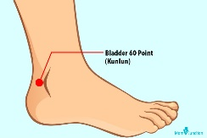 | Can you cook a frozen pizza using the oven? | Can you Google the phone number for West Oaks Boston Spa?  __________________ | Can clean inside your fridge?

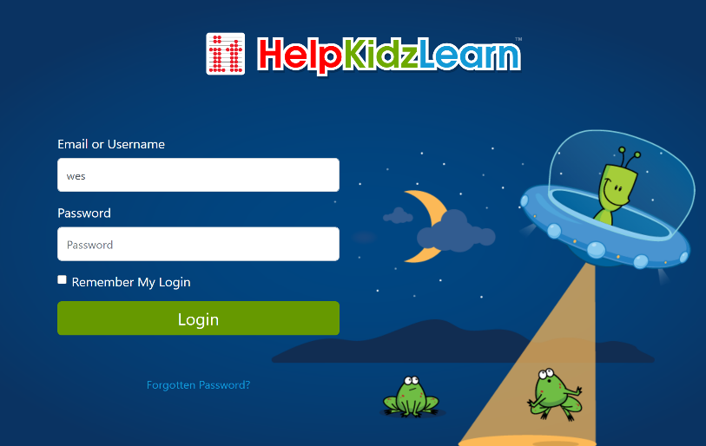
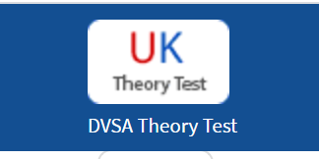
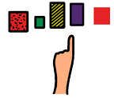
educationcity.com
helpkidzlearn.com
westoaksschool.co.uk
livechat.com/typing-speed-test
driving-theory-test.com/hazard-perception
https://www.bbc.co.uk/newsround
Functional ICT Choosing Board

