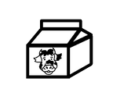
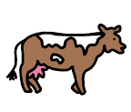
Can you milk the cow?
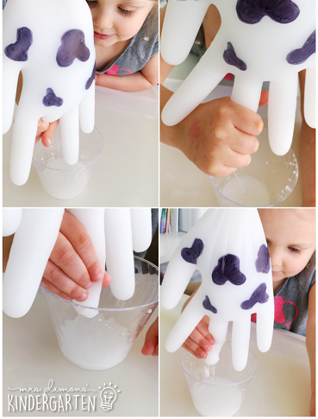

- Draw a cow pattern onto a plastic glove
- Fill the glove with liquid – shaving foam works really well for this as it comes out slowly.
- Cut a small whole in the end of the fingers and squeeze out the ‘milk’

