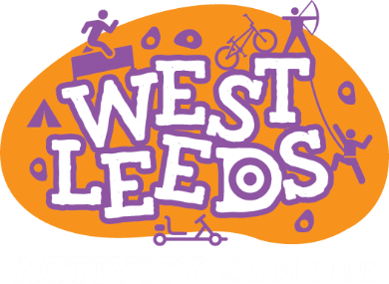

We are currently planning to continue with our Shortbreaks provision every Thursday and during holidays periods please see dates below. Transport will not be available though from next Thursday (26th March Onwards).
18th and 19th February 2021
We are following advice and guidance from Leeds City Council and will keep you updated if anything changes.
Please do not hesitate to get in touch should you require any information.
westleedsactivitycentre@leeds.gov.uk
or
0113 336 7414
or
Message us on social media

South Leeds Youth Hub are still running at limit of 6 young people to attend.
They run on Tuesdays, 4:30pm-7pm.
It is £5 per session and a light snack is included! They provide a variety of indoor and outdoor activities including: Arts and Crafts, Cooking, Team Games and Dance/Music sessions.
Address:
South Leeds Youth Hub, Middleton Rd, Belle Isle, Leeds, LS10 3JA
If you would like any further information on this group:
Tel: 0113 3367772
Email: southleedshub@leeds.gov.uk

Endorphins are still able to run some of their weekend sessions for 8 young people per session!
Geek Rooms will be running 9.30am-11.30am
LS10 will be running 10am – 2.30pm
The Vinery Centre session is currently not running.
Endorphins run groups across Leeds and include activities such as: Arts and Crafts, Music, Games, Sports and allows young people who attend to socialise!
Sessions run Saturdays each week, to apply visit https://www.endorphins.uk, you don’t have to commit to attend each week! Tickets for the sessions will open on a Saturday at 5pm and close on a Thursday at 12.30pm each week.
Registration forms.
Please fill in all questions and give details of your child needs and disabilities. The forms can be filled in on a computer, laptop, tablet or phone.
Registering
- Click onto the tab MEMEBERS
- General information
- About your child/young person
- Medical
- Communication
- Personal care
- Signature (mouse, finger, tack pad)
- Date
- Submit
Once we have customers details, parents and careers will NOT need to fill in the documents again.
Addresses:
LS10: Unit 1, Kitson Road, Hunslet, Leeds, LS10 1NT
Geek Rooms: Armley Court, Armley Rd, Armley, Leeds, LS12 2LB
If you would like any further information on this group:
Tel: 0330 1332642
Email: info@endorphins.uk
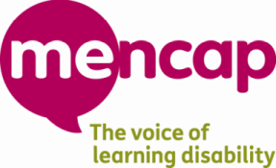
Mencap Playscheme currently are still planning on going ahead February Half Term as half days.
(15th to 19th February 2021)
The playschemes are mostly about having fun, trying new experiences and activities and having time with friends. They also help children to maintain skills and confidence that can be affected over the long summer holiday break.
We have a Changing Places toilet and staff who undertake any training needed around feeding or personal care to make it possible for all children and young people to be included. We ask anyone new to the playscheme to come for a visit first so that we can get to know more about what your child needs to be able to come along safely and for you to understand how we will support your child and keep them safe.
Address:
The Vinery Centre, 20 Vinery Terrace, Leeds, LS9 9LU
If you would like any further information on this group:
Tel: 0113 235 1331
Email: info@leedsmencap.org.uk
If you are interested in any of these groups, need any support with any forms/applications or would like more information on Targeted Short Breaks, please contact Annie Smith in Family Support:
Tel: 0113 3235871
Email: annie.smith@westoaksschool.co.uk

