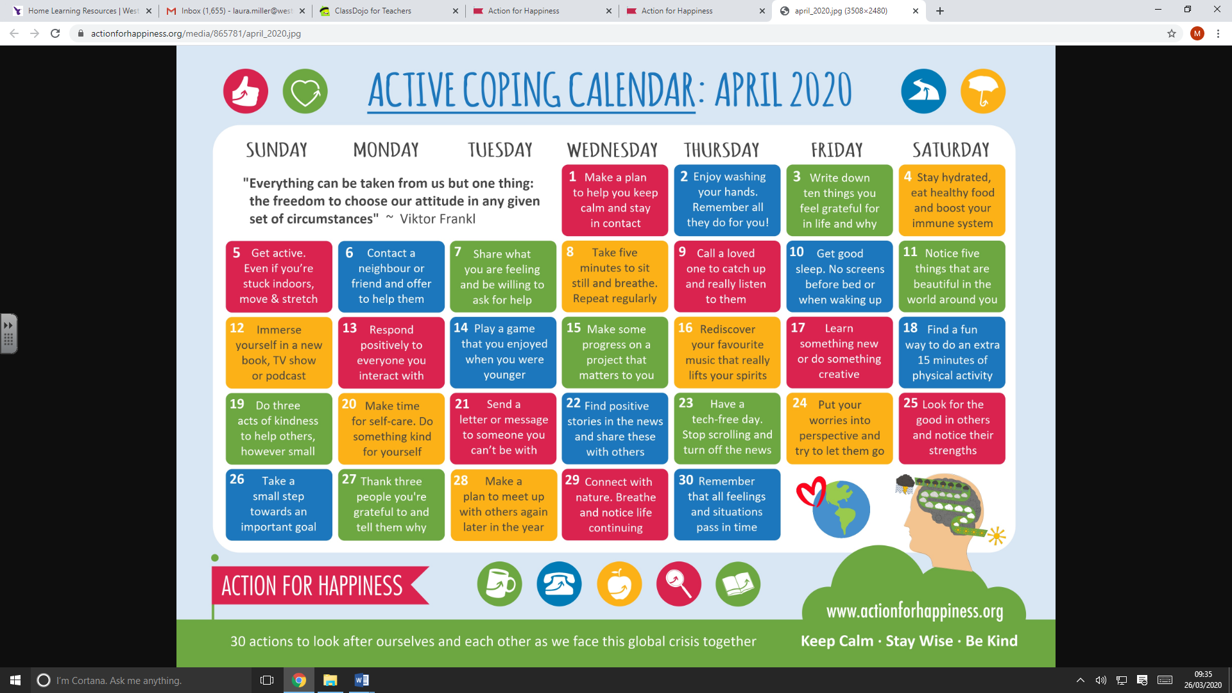
Mindfulness and Wellbeing
Mindfulness activities for children
Blissful Kids
Calm for Kids
Kidsrelaxation.com
www.twinkl.co.uk- mindfulness activities
Flamingo Chicks
Space Theme: https://www.youtube.com/watch?v=Zxhu2oh--8c
Cinderella/Chemistry Theme: https://www.youtube.com/watch?v=yXwBd856qKI&feature=youtu.be

Over the phone support

https://www.citizensadvice.org.uk/

1 in 5 children and young people suffer from mental health illness in any given year. At Kooth, we believe every young person has the right to thrive and to access high quality mental health care.
Kooth.com is commissioned by the NHS, Local Authorities, charities and businesses to provide anonymous and personalised mental health support for Children and Young People. With over 4000 logins per day, we provide end to end support whatever the need.
https://www.kooth.com/
https://www.leeds.gov.uk/domesticviolence/Pages/default.aspx

www.nspcc.org.uk
https://selfharm.co.uk/ is a project dedicated to supporting young people impacted by self-harm, providing a safe space to talk, ask any questions and be honest about what's going on in your life. These pages will tell you a bit about us as well as pointing you in the right direction if you need to contact us or find out more about our policies and procedures.
www.mind.org.uk/information-support/coronavirus-and-your-wellbeing/
Report a child protection concern
You can call Children’s Social Work Services on 0113 222 4403
(Weekdays, 9am to 5pm, except Wednesdays when we're open from 10am).

National Self-Harm Network is the lead UK charity offering support, advice and advocacy services to people affected by self-harm directly or in a care role.
https://www.nshn.co.uk/

MindEd: Self-Harm & Risky Behaviours FREE Online Training
This session is aimed at a universal audience and provides the background to self-harm in children and teenagers, common associated conditions, and the optimal approach to managing it in the community.
https://www.minded.org.uk/Component/Details/445676

Telephone Support
30 minute sessions
Days: Tuesday and Wednesdays
Times: 3pm-6pm
Tel: 0113 2461659
11-17 year olds can ring or book an appointment on the day.
18-25 year olds can ring on the day.
Drop Ins
11-25 Drop In sessions have been replaced with phone calls due to lockdown. They only have limited places for so please check you will be able to take the call before booking.
Drop In is open Mondays, Thursdays and Fridays (2:30pm-5:30pm) and Saturdays (2pm-4pm).
You can ring on the day but it is recommended you book an appointment.
Website: https://www.themarketplaceleeds.org.uk/

Calm Harm is an app designed to help people resist or manage the urge to self-harm. It's private, password protected and is based on the principles of dialectical behaviour therapy (DBT). The app provides tasks that encourage users to distract themselves from urges to self-harm and help manage their "emotional mind" in a more positive way. Please note, the app is an aid to treatment, but does not replace it. The app is free to download from the App Store and Google Play.
https://www.nhs.uk/apps-library/calm-harm/

Headspace has one mission: to improve the health and happiness of the world.
You can try Headspace for yourself and learn the essentials of meditation and mindfulness with our free Basics course. If you enjoy it, then it’s time to subscribe. Once you do, you’ll have bite-sized minis for when you’re short on time, exercises to add extra mindfulness to your day, and hundreds of meditations on everything from stress to sleep.
Learn about the different CBT strategies, including writing thought journals, challenging yourself with belief experiments, building fear ladders, and doing comfort zone challenges. Listen to calming audio to reframe your thoughts, practice mindfulness, and stay grounded.

'For Me' is the iOS app that puts Childline in your pocket. It's free, it's secure and it's designed by young people for young people.
From advice to message boards, you can now get everything you need from Childline in an app. It's quick, easy and you can lock it with a PIN. You can use it to talk to us whenever - and wherever - you need to.
This is your place to do what you want. Young people from the Childline community helped us design the app - from choosing images to testing - to make sure we got it right.

Your emotions change. That's why MyLife offers a personalized mindfulness solution tailored to how you’re feeling right now.
Let MyLife™ recommend the activities that are right for you. Whether you’re anxious, sleepless, hopeful, angry, or anything in between, we’re here for you.
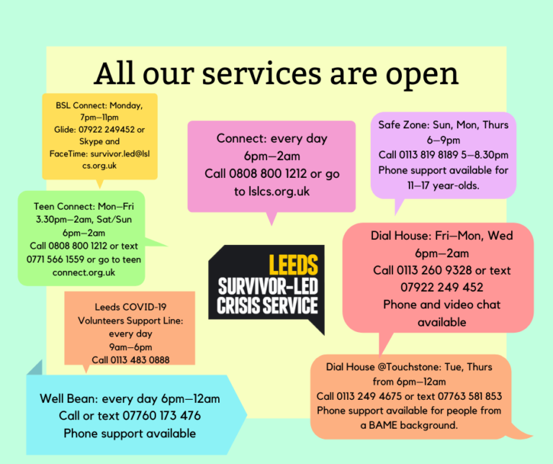

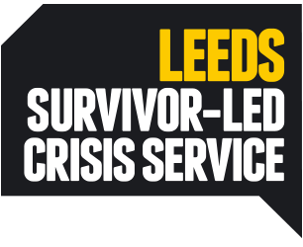
Dial House
Dial House, the Leeds voluntary sector Crisis Service is open 6pm–2am on Mondays, Wednesdays, Fridays, Saturdays, and Sundays.
Mondays, Fridays, and Sundays phone and video support (via Zoom, FaceTime, Skype etc.) is available.
We are picking up the telephone all night (this is a change from our recent practice of only taking referral calls up to 9:30pm). That means, you can call us much later at night on 0113 260 9328 and a trained crisis support worker will be able to speak to you for up to 1 hour. (Alternatively text us on 07922 249 452).
Wednesdays and soon Saturdays Dial House itself will be open for visits, with priority given to those who have not been able to access remote support this year. Referrals made as normal.
For more information please contact Barry Cooper, Dial House Manager on: 0113 260 9328 (office hours Monday, Tuesday and Thursday), or email barry.cooper@lslcs.org.uk

Dial House@Touchstone
Dial House, the Leeds voluntary sector Crisis Service for people from a black or minority background, is open 6pm–12am on Tuesdays and Thursdays.
Phone support is currently available under lockdown, as it has not yet been determined that the normal service can be resumed safely.
To make an referral, call 0113 249 4675 or text 07763 581 853.
For more information please contact Carol Gatewood, Manager on 0113 260 9328 or via carol.gatewood@lslcs.org.uk.

Connect
The Connect helpline is running every day, 6pm–2am as normal.
Support is available over the phone or online.
Call 0808 800 1212 to request a call back and we’ll get back to you as soon as we can. Let us know a latest time for a call back or if you have any preferences for your support worker, such as gender.
To talk to someone online, click the button at the top of the screen when it says Online, or go here: https://www.lslcs.org.uk/services/connect-helpline/. We’ll get to you as soon as we can. If there’s no one available when you go online, we may ask for a mobile number to text you when someone is free. As above, let us know your latest time and any preferences and we’ll do our best to accommodate you.
While the team is working from home, we’re using our own mobile phones and withholding numbers.
Phone supports are up to 30 minutes and online supports up to 45 minutes currently.

Teen Connect
Teen Connect helpline is running every day as normal. Monday to Friday it is open 3.30pm–2.00am, at the weekend 6pm–2am.
Teen Connect is now available to ages 11-18.
Support is available over the phone, online, or by text.
Call 0808 800 1212 for a call back and we’ll get back to you as soon as we can. Let us know any preferences for your support.
Text us on 0771 566 1559 and a member of staff will let you know when someone will be available to talk with you.
To talk to someone online, click the button at the top of the screen when it says Online, or go here: https://www.lslcs.org.uk/support-consent/?teen=1
Supports can be up to an hour long.

